Hemlockery of Northern Wisconsin: A Compilation of Newspaper
Accounts and Other Data by Robert P. Rusch.

Updated to September 30, 2018
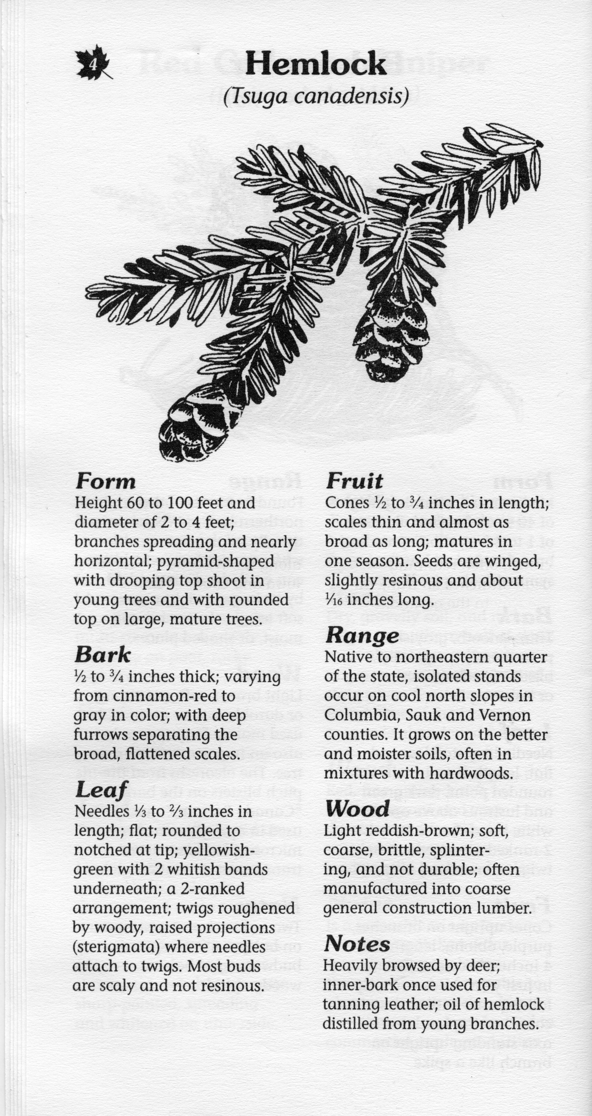
Copyrighted by Robert P. Rusch
I. INTRODUCTION: This is a publication of the Rib Lake Historical Society, LLC, prepared by its manager, Robert P. Rusch. Today it is popular to refer to northern Wisconsin as the “pinery.” While this is appropriate regarding areas of sandy soils on which pines dominated the virgin forest, much of northern Wisconsin was the hemlockery.

Hemlocks, tsugacanadensis¸thrive on loam soils. It is the most shade tolerant of Wisconsin trees. This feature made hemlock, in combination with yellow birch and sugar maple, the predominant tree on high ground in Taylor County, including Rib Lake, Wisconsin.

The size of the hemlockery of north Wisconsin is beautifully illustrated in the University of Wisconsin Extension map “Original Vegetation Cover of Wisconsin.” It was painstakingly prepared using the field notes of U.S. government surveys. A copy of this map is image #18377 in the Photo & Document Collection on the website of the Rib Lake Historical Society, LLC, www.riblakehistory.com.

A modified version of the map described in the paragraph above entitled “Early Vegetation of Wisconsin,” was prepared by the Wisconsin Geological and Natural History Survey, G.F. Hanson, Director, in 1965. It is image #21031B in the Photo & Document Collection of the Rib Lake Historical Society. A copy is included in this document under the date of 1864, which was the year the United Government survey of what was to become Taylor County took place.

Former head Wisconsin state forester, Milton E. Reinke, estimated pine made up about 5% of the virgin forests of Taylor County in volume.

There is no denying that pine was the darling of the first loggers and entrepreneurs when Taylor County was created on 3/4/1875. Pine floated well and made exceptionally high quality lumber that was much in demand.

But the supply of pine in Taylor County was small and markets for hemlock developed. Hemlock had one great value over pine; tannic acid could be extracted from hemlock, i.e., “tan bark.” By 1892, Taylor County had three large tanneries buying tan bark, while the peeled logs went to the sawmills. The local financial benefits of having both hemlock logs and bark to sell was enormous. There was no other tree in Wisconsin where both its logs and were saleable.

The heyday of hemlock in Taylor County was mirrored by the period of operations of the tannery in Rib Lake, 1892 to March 1922. On April 4, 1896, the Wisconsin Central Railroad wrote in its “Land Handbook:” “Taylor County is known as the great hemlock county of the state.” On January 8, 1904, the Rib Lake Lumber Company declared itself “the largest hemlock manufacturer in the world.” Its mill at Rib Lake sawed 25,000,000 feet of hemlock lumber in that season, 1903-1904.

II. Document format. This document uses four vertical columns.

The first column gives the date of the news article or news source.
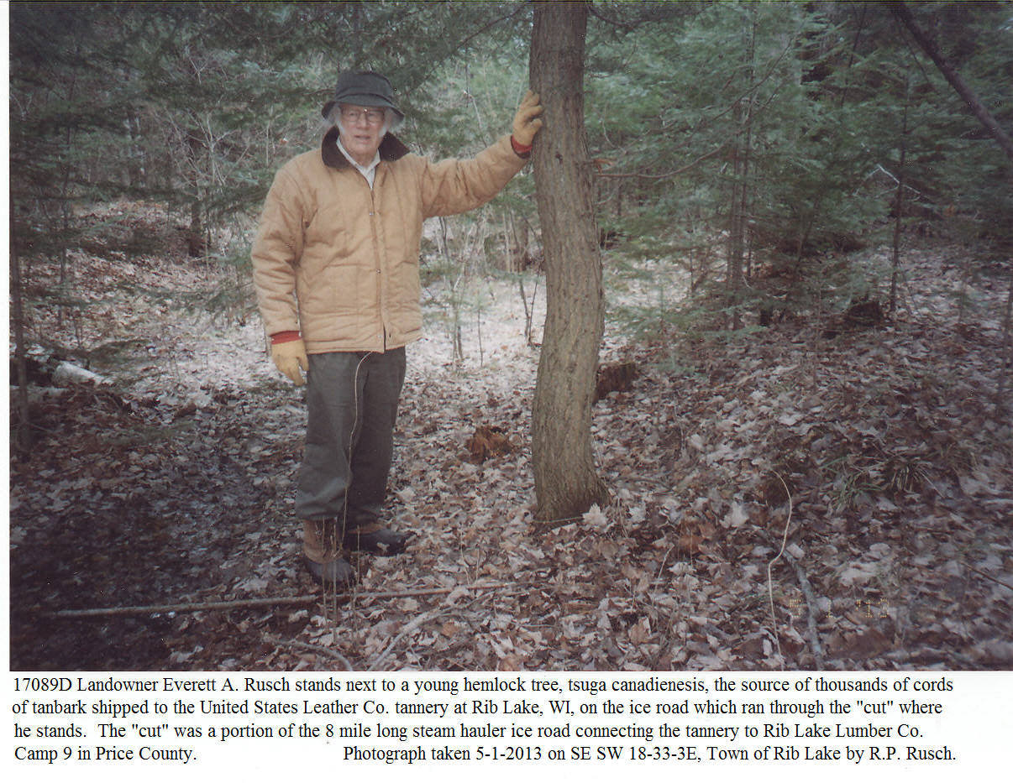
The second column identifies the newspaper or information source.

The third column usually quotes the document. Alternatively, it may provide a copy of a news article, writing, or photograph. Captions in capital letters frequently appear. The captions were written by R.P. Rusch unless inside quotation marks, which are meant to show the caption is from the original source.

The fourth and final column is on the extreme right. It consists of annotations and cross references by Robert P. Rusch.

III. Contact us. Readers are encouraged to provide feedback. Robert P. Rusch can be emailed at rprusch@riblakehistory.com or by snail mail at N8645 CTH C, Rib Lake, WI 54451-9427.

IV. Abbreviations:
CTH – County Trunk Highway
et. Al. – and others
et. Ux. – and wife
FDS – Fayette Delos Shaw
JJK – John J. Kennedy
RLHSoc – Rib Lake Historical Society, LLC
RLLC – Rib Lake Lumber Company
RPR – Robert P. Rusch
STH – State Trunk Highway
TC – Taylor County
TRL – Town of Rib Lake
VRL – Village of Rib Lake
USLC – United States Leather Company

Date of Document | Source Name | Quotes are indicated by quotation marks.  Captions written in capital letters were made by Robert P. Rusch | Comments by Robert P. Rusch
c. 1864 | Map: Original Vegetation of Wisconsin | The light green color denotes areas of virgin forest dominated by hemlock, sugar maple and yellow birch.  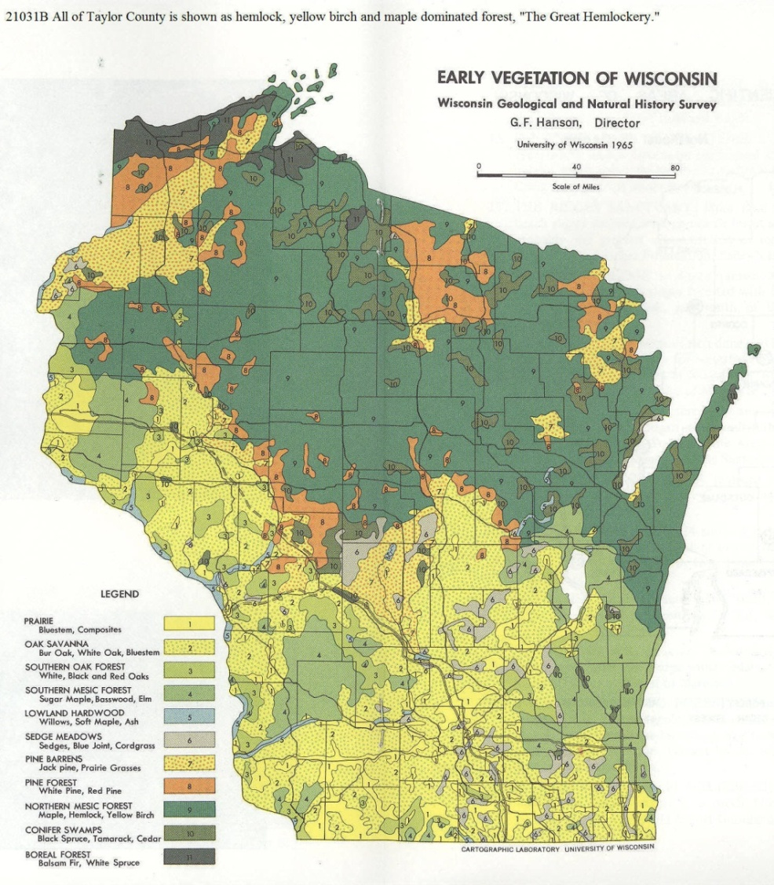 | Wisconsin State Forester Milton Reinke estimated to R.P. Rusch that white pine (pinusstrobis) constituted only approximately 5% of the virgin forests in Taylor County, Wisconsin, by volume.  The forest types shown on this map was based on the notes of US Government Surveyors laying townships and sections. In what was to become Taylor County that survey for Rib Lake occurred in 1864.
1862 | A “Corner Perpetuation Record” prepared by Taylor County Surveyor David E. Tlusty on 2/26/1991 and recorded in Vol. 3 Page 460 at Taylor Co. Register of Deeds Office | 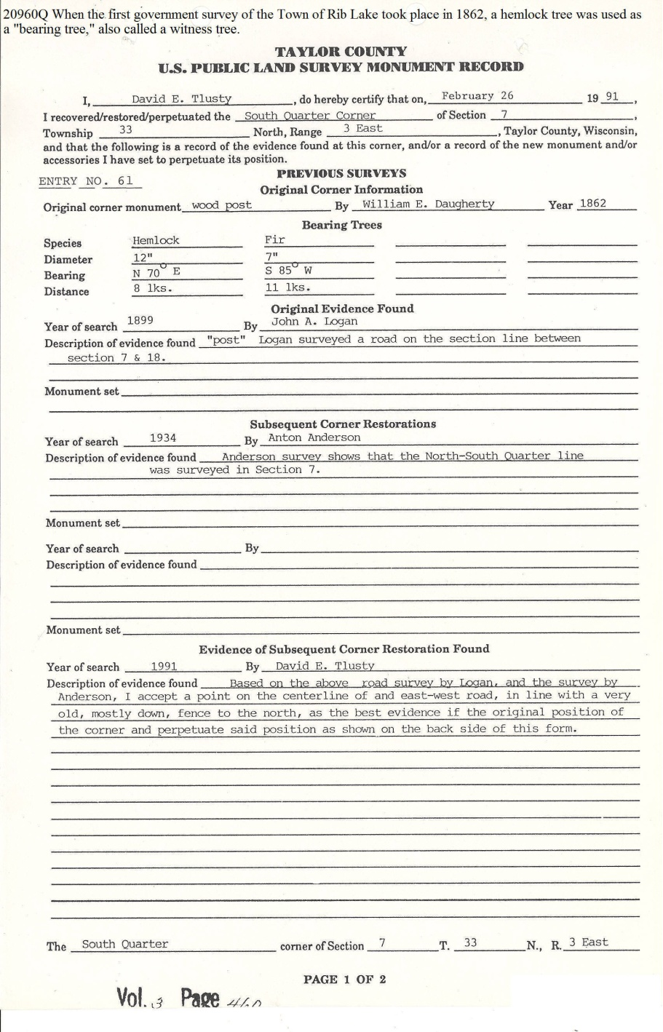 | In 1991 Registered Land Surveyor David Tlusty found it necessary to his survey work to verify the south quarter corner of Section 7, Town 33 North, Range 3 East in the Town of Rib Lake. This caused him to check the 1862 survey work by William E. Daugherty who was hired by the US government to do the very first survey work in the township in preparation for government sale of the land. Daugherty notes revealed that he set a “wood post” at the south quarter corner and at a distance of 8 links and a bearing of N 70 degrees was a hemlock tree.
6/1/1876 | TC STAR AND NEWS | HEMLOCK BARK  “Those who are desirous of getting out tanners’ bark, and delivering it to the railroad, can learn particulars in regard to price, terms, etc., by inquiring of Ogden and Adams or W. E. Lockerby.” | This is the first comment within this Medford newspaper that a market existed for hemlock bark.  The June 8 edition of the News under Chelsea News reports: “Hemlock bark is now the shipping product here. William Seeger [a Medford merchant] is loading [rail] road cars for points south every day. Contracts for considerable quantities have been made by Messrs. Kinney, Jones and others with the “Milwaukee Leather Co.” of Milwaukee, and several gangs are now peeling or getting ready to do so. The trade in this material promises to get good this season. At no point on the line of the railroad are there such facilities for an extensive trade in hemlock bark.”  The railroad line mentioned in the preceding paragraph was the Wisconsin Central. Its original mainline started in Menasha, ran westward through Stevens Point to Marshfield, where it turned north, ending at Ashland.  TAYLOR COUNTY WAS HEMLOCK HEAVEN; hemlock bark was peeled by the Rib Lake Lumber Company and shipped by rail to Milwaukee tanneries as late as the 1940’s.
8/2/1879 | TC STAR AND NEWS | HEMLOCK BARK  “The shipment of hemlock bark from Little Black, Medford, Chelsea and Westboro will aggregate 125 car loads, averaging 11 cords per car; this makes nearly 1,400 cordsof bark at an average price on the car of $2.50 per cord, making the total receipts for bark nearly $3,500…”
1879 | Withee Memories “From Logging Trails to Super Highways” | VILLAGE OF “HEMLOCK,” CLARK CO, WISCONSIN  “Niram Haskell Withee was born June 21, 1827, in Maine. He moved to Wisconsin in 1852 and was one of the pioneer settlers in La Crosse County. In 1870 he moved to Clark County and worked in lumbering, logging and building and operating flood dams along the Black River.  “At Hemlock [his village and dam site on the Black River in Clark County] he built a grist and sawmill and cleared up a large farm. The grist mill was finished in 1879 and was supplied with three run of stone. It was a wood-frame, four stories high. The sawmill was also a wood frame, two stories high and furnished with a rotary and upright saw.  “The [Hemlock] settlement was connected to Neillsville by telephone, erected in 1879 at a cost of $800. A large dam was also built by the Black River Logging Co. in 1879 at a cost of $21,000. By 1918 nothing remained of this enterprise except abandoned buildings and the ruined dam.” | The photo & document collection of the Rib Lake Historical Society contains pictures of the Hemlock dam washing out.  The primary purpose of the dam was to allow loggers to manipulate the flow of water in the Black River. The Black River starts at Black Lake two miles west of the Village of Rib Lake. The river was extensively used to drive pine logs and, later, hemlock logs to downstream sawmills.  In 1884, my great-grandfather, August Steiner, bought land for a farm near Whittlesey. The pine on his land had not only been floated down the Black River, but also the Mississippi. The logs were milled at Clinton, Iowa.
6/11/1881 | TC STAR AND NEWS | TANBARK  “Hemlock bark will be shipped from every station on the [Wisconsin Central] line the coming summer.” | There was already a market for hemlock bark. A Medford store offered to buy it for $7.00 a cord in trade. Much of this “tanbark” went by rail to Milwaukee, which had several large tanneries. See, for example, the Albert Trostel Tannery.
7/30/1881 | TC STAR AND NEWS | RAILROAD TIES 14 CENTS  “10,000 railroad cross ties wanted by J. B. Thompson of the village [Medford], for which 14 cents will be paid. They are to be of hemlock or rock elm and to be delivered on the right-of-way anywhere between Dorchester and Westboro.” | Surprisingly, hemlock was a preferred species.  As late as 1940, the Damm Brothers sawmill at Stetsonville made up to 3500 railroad ties per season from hemlock. See photo #19595 in the Document & Photo Collection at www.riblakehistory.com.
2/5/1887 |  | HEMLOCK  “Isaac Gay [of Westboro] has contracted with the Chicago Lumber Company of Omaha, Nebraska, through their agent, Mr. Firkus, to furnish 50 [railroad] car loads of sawed hemlock ties at 22 cents apiece.  He has also taken a contract of another company (we could not learn its name) to furnish 50 at 22 ½ cents apiece. Ike is bound to get there if stick-to-it-ive-ness will do it.” | Isaac Gay operated a small sawmill 1 mile east of Westboro on the SW SW 5 33 2E, according to Bob Lucia.  Note that hemlock was being used for railroad ties. Normally, hardwood was used because of its strength.  There were then three sawmills in or near Westboro… The oldest was the John Duncan mill, originally the Duncan, Taylor & Ritchie. The second constructed was on Silver Creek and owned by C. C. Palmer; the Star & News just reported that a siding from the Wisconsin Central Railroad is about to be built to the Palmer mill; in 1902 it would become the Westboro Lumber Co. Finally, Isaac “Ike” Gay had his small mill east of town. It was one mile south of the county line, on the east side of Lucia Road at “Gaytown.”
11/26/1887 |  | HEMLOCK  “N.B. Holway, of La Crosse, and James Hewitt of Neillsville, spent the first 3 days of the weeks in Medford and vicinity. They were arranging to buy logs to be put in the Black River and run to La Crosse, where the first named gentleman owns a large sawmill. He has contracted FOR A LARGE AMOUNT OF HEMLOCK, and left a man here, named Marcus Sievers, to look after his interests.” (emphasis added) | The Black River flows through Medford to the Mississippi River, which it joins just north of La Crosse.  Here is a purchase of hemlock logs that has already been felled and stripped of its tanbark.  The tanbark may have been purchased by the Nystrum tannery in Medford; it was operating at the time and had been running for the past 3 years.
8/3/1889 | TC STAR AND NEWS | KENNEDY& HEMLOCK – J.J. Kennedy of Rib Lake was in town [Medford] yesterday. Like a sensible man, KENNEDY IS BEGINNING TO EMANCIPATE HIMSELF FROM THE PINE SLAVERY, AND IS NOW PREPARED TO APPRECIATE THE EXCELLENCE OF HEMLOCK and other Northern Wisconsin timbers.  There was a time when a Wisconsin lumberman was timber blind to everything but pine. MR. KENNEDY SAYS HE BELIEVES THERE IS MORE MONEY IN HEMLOCK AND HARDWOODS of Northern Wisconsin, than there ever was in pine. And he also says that his belief is gaining ground. He is right, of course, and the time is coming, and coming right soon, when a man who has a good crop of timber on his land, even if it is not pine, will have an investment that will pay better than bonds. (emphasis added) | The unknown author of this article in the Star News of Medford uses strong language, i.e., emancipation “from pine slavery…” While there is no doubt that white pine made wonderful lumber and was much sought-after, its local supply was all but exhausted. In the case of Rib Lake, a small quantity of pine had been cut and floated down the Rib River prior to Kennedy opening his Rib Lake mill in 1881 and sawing its first board on Dec. 25.  While it took only a decade to exhaust the supply of pine near Rib Lake, hemlock would be the major timber sawn at Kennedy’s Rib Lake mill until he sold it in 1900. Hemlock continued to be the primary timber source at the mill operated by Kennedy’s successors until its last log was sawn on June 3, 1948.
11/30/1889 | TC STAR AND NEWS | HEMLOCK LUMBER – Our friends, the lumbermen, are talking very blue these days. They say that the yellow pine of the south (e.g. Alabama) has made sad havoc with the market, and many firms are carrying larger stocks over than ever before. The southern lumbermen are paying little or nothing for stumpage, and when the northern white pine lumberman pays $5 and upwards stumpage it is very difficult to compete with his southern brethren. This is true, and the day when the pine tree was sole king is likely to wane.  There is another kind of timber in northern Wisconsin, however, that can be manufactured as cheaply and will make as good lumber as the yellow pine in the South, AND THAT IS HEMLOCK. This country is noted for the vast quantities of hemlock, and the owners of land will be willing to sell the stumpage at very reasonable figures. Hemlock, when properly handled, that is, when handled with the same care and consideration given to pine—makes good lumber, and finds a ready sale in the market. If the lumber is carelessly piled and put upon the market undressed, it does not sell well, but we have the word of one of the best lumbermen in Wisconsin, one who speaks from experience, that it sells readily when properly handled.  This being the case, there is no reason why the hemlock industry should not be developed in this country where it abounds beyond all reason. Now that Medford has a tannery capable of using the bark from 6 to 10 million feet of logs yearly, it is probable that more hemlock lumber will be sawed here than formerly. Many of the farms in Taylor County are entirely timbered with hemlock, and if the farmer can peel his bark in the spring and haul his logs the following winter, this industry will prove a source of revenue to him while aiding him to clear his farm.  It has been the practice heretofore to cut down the hemlock timber and burn, bark and all, in a log pile [in order to clear land for farming]. It does not cost any more to cut down a tree to peel than it does to cut one to burn, and the cutting has to be done only once, even if the logs are hauled to a mill.  We understand that the Medford [saw] mill will be stocked with hemlock this coming winter. That is very good as it gives the farmers a chance to sell their logs to a firm that will manufacture them at home, and not run them down the river to be sawed in La Crosse. We learn, also, that there is a move a foot to form a company to purchase the mill, or site, and build another [saw mill] of increased capacity. That is better; the more lumber manufactured here the better for the city. THERE IS MORE HEMLOCK IN TAYLOR COUNTY THAN THERE EVER WAS OF PINE, and if the timber is properly handled it will result in more benefit to the country than the pine ever did. HEMLOCK FOREVER. (emphasis added) | This powerful and prophetic article was written, apparently, by the editor Edgar Wheelock. He held J.J. Kennedy in high regard and was referring to him when citing the unnamed, but “one of the best lumbermen in Wisconsin…” J.J. Kennedy was one of the pioneers in milling hemlock.  The term $5 means the lumberman had to pay $5 per 1,000 board feet for pine stumpage, i.e., the right to harvest pine on another’s land.
6/28/1890 |  | HEMLOCK LOGS – Notice by Davis & Starr Lumber Co. – Notice is hereby given to all parties interested, that hereafter, in buying hemlocksaw logs, whether the quantity is small or large, we will require on each contract the following percentages and lengths, viz:  15% 12 ft. 3 inches long  15% 14 ft. 3 inches long  35% 16 ft. 3 inches long  10% 18ft. 3 inches long  10% 20ft. 3 inches long  5% 22ft. 3 inches long  5% 24ft. 3 inches long  5% 26ft. 3 inches long | This lumber company had a market for longer lumber.  This is the first advertisement published in the Taylor County Star & News for hemlock logs It signals the end of the local pine era.  While the Davis & Starr mill was on the Little Black River at Little Black, it was also on the Wisconsin Central Railroad that had a spur to its mill pond. This meant hemlock logs could be conveniently railroad shipped there.  Note the requirement for logs to be cut in feet plus 3 inches. The 3 inches guaranteed that the finished product would be of proper length; the lumber was cut to proper dimensions in the mill.
c. 1891 | Statement to “J.J. Kennedy, Dr. dealer in and manufacturer of Lumber, Timber, Lath & Shingles, also dealer in general merchandise.”  Image 18670 | Image #18670 evidences a sale of hemlock logs by Ernst Gerstberger to J.J. Kennedy: “Hem 6120 b. ft. @3.00 [per thousand] totaling $18.60;  The same document demonstrates that basswood logs sold for $5.50 per thousand and white pine for $7.00 per thousand board feet. | Image 18670 was a pre-printed form entitled Statement: the second line read Rib Lake, Wis. ________189_. The third line of the form had the letter M following by a long blank; presumably to indicated Mr. or Miss following by a surname.  THE FORM DEMONSTRATES THAT WHITE PINE HAD A COMMERCIAL VALUE IN EXCESS OF 100% ABOVE HEMLOCK.  Image 18670 was given to RPR in c. 1975 and presumably covered a transaction by Ernest’s father, Edward Gerstberger.
1/31/1891 | TC STAR AND NEWS | HEMLOCK – MEDFORD TANNERY LACKS BARK – Ad: “$4.00 per cord will be paid for bark at the [Medford] Tannery until further notice.” | This big jump in the price paid for tan bark followed an article in the Start & News reporting that the lack of snow made sleighing very difficult; sleighing was the dominant way to convey the bark from the woods to the tannery.  T., F. M. & F. D. Shaw have commenced constructing its third tannery in Taylor County; it will be in Perkinstown on Section 33, Town 32 North, Range 2 west; the new tannery stood on the east shore of Kathryn Lake.
2/7/1891 | TC STAR AND NEWS | HEMLOCK – NEW TANNERY UNDER CONSTRUCTION AT PERKINSTOWN – As a starter toward a city of industry, the Shaws have concluded to plat village lots on section 3-31-2 w, Town of Grover, this section being the one adjoining the new tannery site. The first plat will contain 36 lots, lying in 2 blocks. The dimensions of the lots will be 66x165 feet.  Surveyor Walrath will commence work on the platting next week, and then the lots will be put on the market. ONE FEATURE OF THIS PROPOSED VILLAGE IS A NOVEL ONE FOR THIS COUNTRY, AND THAT IS THAT EVERY EVENLY NUMBERED LOT WILL BE GIVEN AWAY, the only charge being a nominal one to cover the expense of surveying and making the deed. The odd numbered lots will be reserved, and sold later.  The only condition that goes with the gift is that the one getting the deed must put up a substantial building thereon. A name has now yet been chosen for this village.  Work at the tannery site is progressing satisfactorily, and it is probable that before the end of another week the saw mill will be ready for business. (emphasis added) | What an ingenious idea—to give away a residential lot with the requirement that the one had to build a substantial building, i.e., a house. The land itself had little or no value. The gift induced settlers to move to the far away place where they had little choice but work in the tannery.  The village would be named Perkinstown for Albert J. Perkins, Taylor County businessman and first mayor of Medford.  Note the reference to the saw mill under construction; the Shaws announced that they would build a small saw mill at the village site to saw the lumber needed to construct the tannery buildings.  Perkinstown is the site of the third Shaw tannery in Taylor County. The first was built in Medford and the second in Rib Lake.
5/9/1891 | TC STAR AND NEWS | HEMLOCK – Rib Lake Tannery – Mr. J.J. Kennedy has, through the exercise of his well known liberality, arranged with the Shaws to build a tannery at Rib Lake this present season. Arrangements have been made to transfer Mr. Drake from Perkinstown to Rib Lake in July, to commence building operations there. In the meantime, arrangements have been made at Rib Lake to peel a stock of bark the present season.  We understand that the Shaws were intending to build on a point on the Soo [rail] road, i.e., [an east-west railroad running from Minneapolis through Prentice to Sault Ste. Marie, Michigan] but that Mr. Kennedy has induced them to change their location as indicated above. Mr. Kennedy deserves our thanks for keeping the business in Taylor County. The only regret we have in the matter is that this increase in business on the part of the Shaws could not have been in Medford instead of Rib Lake, as we have reason to believe that at one time it was the intention of the Shaws to double their business in this place [Medford]. We are, however, thankful for what we have, and hope that the business here may never be less than it is at present, and, especially, that we do not lose it altogether. We wish success to the Rib Lake enterprise. | In 1898 the Shaw family built a large tannery in Medford. In 1899 they constructed a second tannery in Perkinstown using Mr. Drake as their lead designer and builder. Recently, the Star and News reported that the Medford tannery had run out of tanbark.  While I do not know whether all the terms of the Shaw-Kennedy deal regarding the Rib Lake tannery were ever made public, many of them are spelled out in the deed by which J.J.K deeded the property to Fayette Delos Shaw in Rib Lake. A strong argument can be made that John J. Kennedy got the better of the deal. The deed required Shaw to buy Kennedy tanbark and tanbark from Rib Lake area “settlers”. J.J.K knew that the same settlers selling tan bark to Shaw would be looking for someone like Kennedy to buy the hemlock logs.  The Shaw tannery would be up and running in 1891 and ran until 1922. Shaw sold the Rib Lake tannery to the United States Leather Co. of New York, New York, in 1901. In 1906 the U.S. L. C. bought the Rib Lake Lumber Co. making it the owner of both the Rib Lake tannery and the village’s largest saw mill.  The volume and quality of hemlock around Rib Lake was superlative. Hemlock was the dominant tree in the area’s original, virgin forest. The rich loam soil of Rib Lake was perfect for hemlock. In 1904, the Rib Lake Lumber Co. claimed to be THE LARGEST HEMLOCK MANUFACTURER IN THE WORLD; see January 8, 1904 Rib Lake Herald headlines.  The three agreements between John J. Kennedy, et ux, and Fayette D. Shaw were all dated 6/25/1891: each is available to the public at www.riblakehistory.com within the Photo & Document collection at Doc. 15231ff.
10/24/1891 | TC STAR AND NEWS | HEMLOCK – Hemlock Used In New Home of Frank Perkins  C. M. Perkins has moved his family into his new house [in the City of Medford]. The lower part of their new house is finished in red birch, with birch floors in the dining room, kitchen, bath room and pantries, and a birch wainscot also adorns those rooms.  THE CHAMBERS ARE FINISHED IN HEMLOCK, A NEW DEPARTURE, BY THE WAY, AND ALL WHO HAVE BEEN PROFANELY SCOFFING AT HEMLOCK SHOULD HOLD THEIR PIECE UNTIL THEY HAVE EXAMINED THIS WOOD IN PRACTICAL USE.  Frank and his estimable wife now have a home that they may be proud of, as it is beautifully and conveniently arranged. The cost of the house when completed will be in the neighborhood of $2,500. | The article’s writer, Edgar Wheelock, deals directly with the prejudice and scorn held by most toward the use of hemlock as lumber.  Frank was a son of Medford Mayor Albert J. Perkins.
2/13/1892 | TC STAR AND NEWS | “… [Taylor County] has 3 large tanneries so placed, at different parts of the county, that all the hemlock bark can be delivered to them and capable of consuming from 20 to 40 thousand cords per year, for which a fair price is paid in cash.”  “TAYLOR COUNTY IS THE CENTER OF THE HEAVIEST HEMLOCK TIMBER IN THE NORTHWEST. HEMLOCK LUMBER IS WORKING ITS WAY INTO THE MARKET, AND EVEN NOW IT PAYS TO LOG IT.” (emphasis added) | The 3 tanneries then operating were at Medford, Perkinstown and Rib Lake. Later a small tannery opened in Westboro, built by John Duncan.
7/23/1892 | TC STAR AND NEWS | AT RIB LAKE – The writer visited Rib Lake Friday last on a missionary errand, and took note of the improvements which are numerous. The enlargement and improvement of Mr. J.J. Kennedy’s mill have been mentioned in these columns before, but one who has not visited the mill since the changes can not appreciate the increased facility with which lumber is made and handled. The planning mill is busy dressing and preparing last years cut for shipment but it will take until autumn to complete this task.  The most marked change at Rib Lake since last year is, of course, the F. D. [Fayette Delos] Shaw Tannery, and the collection of spic and span new houses that have grown up around it. The tannery is a model, PROBABLY THE BEST OF ITS SIZE IN THE WORLD. When nature molded the earth’s surface at that site the probable location of a tannery must have been taken into account, as the slopes and ravine, the water supply and drainage are all perfectly natural. This tannery is about the same size as the Medford tannery, but they are doing more work there [at Rib Lake] than here [at Medford]. [The Rib Lake tannery puts out] …550 sides of hides each day into the vats.  [Building] lots have been laid out near the tannery and many houses have been built where workmen with families reside. There is a boarding house for the single men, also. E. C. Getchel is book keeper and the first lieutenant to Mr. Fayette Shaw who manages the entire enterprise.  Among the new things at the lake is the new M. E. [Methodist Episcopal] church, the foundation of which has been laid. The building will be small but tasty in design. The size of the main lecture room will be 30x40 on the south end, opposite the platform will be a classroom 15x20, connected with the main room by folding doors. The money for this building has all been raised, and there will be no debt as an ornament when completed.  Chris. Wollesen has taken the contract for the work [of building the church] for $600, material furnished on the ground and, as Christ is a good workman, there is no question about the church being well built. He expects to have it ready for services in September. | The tannery site in Rib Lake is worth a visit; Tannery Lane runs north from Fayette Avenue through the site.  Two blocks north of Fayette Ave is tannery pound; it is a 7 acre lake created by damming tannery creek. The pond supplemented wells in meeting the needs of the tannery for water.  In 2012, solid concrete pillars 3 to 4 feet high still stand in rows along Tannery Creek; the pillars supported a huge vat house over 300 feet long built over the creek. Wastes were dumped into the creek which served as a convenient sewer; “out of sight—out of mind.”  In 2012 two original tannery buildings remain; the former “pan” house is now a home. The former boiler house/power plant is a concrete two-story residence at 248 Tannery Lane.  Without question the most impressive remnant of tannery days in Rib Lake is easily seen on Fayette Ave just north of its junction with McComb Ave. Seven former company houses once occupied by tannery laborers stand side-by-side on the north side of Fayette Ave. While some have been remodeled, their classic 1½ story size and rectangular shape declare to the world that they are classic company houses.  The M. E. Church is the proud home of United Methodist Church on Church street in 2012. It is as neat and well maintained as when constructed 120 years ago.
2/25/1893 | Ditto | “A year ago owners of large tracts of hemlock timber did not consider their property of very great value; andoffers were made to sell one tract in Taylor County, of about 20,000 acres for $1 per acre.”  “During the past year, however, lumbermen have been turning their eyes to hemlock stumpage, as that lumber has become an important factor in the western lumber world. “  “The result is that nearly every owner of hemlock lands has been inspired with the idea that he had struck a gold mine and, although all land owners who are not lumbermen are willing to sell, they are pulling the price way out of sight. The tract referred to above that was offered for $1 per acre, is now held at $5.00.” (emphasis added) | The John Duncan Lumber Co. of Westboro in 1893 announced this winter would be the last it would log pine; the company’s pine had all been cut. The editor of the Star and News opined that the company could continue operations if it sawed hardwood and hemlock.
2/25/1893 | TC STAR AND NEWS | “The Wisconsin Central Railroad lands in Taylor County have been withdrawn from the market for the present, and none will be sold until a new examination has been made.”  “This examination will include a careful examination of all timber, PARTICULARLY HEMLOCK, AS WELLAS A MORE CAREFUL REPORT ON SOIL.” (emphasis added)  “Then, when the data has been secured upon which to base a scale of prices, the lands will be returned to the market.” | The Wisconsin Central Railroad received a land grant from the US Government of every other section of land for 18 miles on either side of its track. This was an inducement and reward for constructing its railroad.  As a result of this land grant, the Wisconsin Central owned a huge swath of land throughout the eastern portion of Taylor County, as well as some of the other counties through which it ran from Menasha, Outagamie County, until the end of track in Ashland, Ashland County, Wisconsin.  Not only was the end of pine logging being experienced in Taylor County, but 3 new tanneries had been constructed by the Shaw family. The tanneries in Medford, Perkinstown and Rib Lake were hungry for immense quantities of hemlock bark. Anyone looking at these tanneries could tell the Shaws were successful businessmen and that they were here to stay. This meant a long time demand for hemlock bark, and, consequently, for hemlock lands.  The Shaws built and operated large tanneries in Price County at Prentice and Phillips. Its Mellon tannery in Ashland County was claimed to be the largest tannery in the world.
6/10/1893 | TC STAR AND NEWS | NEW TANNERY AT PHILLIPS  “Herb Drake went up to Phillips this week to superintend construction of the new tannery to be built in that place by Mr. Fayette Shaw. The new tannery will be about the same size as the three in this [Taylor] county and will be run in the name of William F. Kimball, who is the Co. in the firm name of T., F. M. & F. D. Shaw & Co.”  “The City of Phillips donated the site.” | Kimball was a son-in-law of Fayette M. Shaw.  Thaxter Shaw, born 1837, and Fayette M. Shaw, born 1824, were brothers. Thaxter’s son was Fred M. Shaw. Fayette’s son was Fayette Delos Shaw.  The initials in the firm name stood for three persons. T. for Thaxter Shaw. F.M. for Fred M. Shaw. F. D. for Fayette Delos Shaw, the sole owner of the Rib Lake tannery.  When Fayette Delos Shaw died in 1941, he was living with a daughter in Phillips, Wisconsin; he was buried there.  The June 10, 1893 edition of the Taylor County Star & News reported: FAYETTE DELOS SHAW and IDA AUGUSTA KRAUTH were made one flesh, according to the laws of God and the state…at the residence of Mr. and Mrs. Fayette Shaw, in this city [Medford] by the Rev. While, a Universalist pastor from Chicago.  The groom is a member of the firm of T., F. M., & F. D. Shaw & Co. The new Mrs. Shaw has been a teacher for two years in our city [Medford] school, and is a general favorite among Medford’s young society…
6/10/1893 | TC STAR &NEWS | JOHN J. KENNEDY, A/K/A J.J. KENNEDY  “The Minnesota Lumberman[a magazine] thus speaks of J. J. Kennedy, the man who does the heaviest lumbering business in Taylor County today, and who does not fall far below the largest lumbering firms in North Wisconsin:”  “J. J. Kennedy of Rib Lake, Wis., is one of the pioneer lumbermen of the Badger State. He has been in the lumber business since his youth, and has grown up with it in every detail, and at his pleasant home at Rib Lake, has one of the finest manufacturing plants in this section. “  “He spent his early years in New York state, where he contracted for telegraph poles for the Western Union Telegraph Company. Mr. Kennedy came west and settled at Spencer, Wisconsin, over twenty years ago, remaining there some five years, lumbering for himself. Finally he gave up the operating of his sawmill at Spencer, and cut logs on contract for mill men.”  “While in the logging business, Mr. Kennedy met the Curtis Brothers of Clinton, Iowa, and Mr. J. E. Carpenter, the head of the company, and took a contract to cut logs for them near Ogema, Wisconsin. Some three years later Curtis Brothers & Co. purchased a tract of central Wisconsin pine, bearing some 250,000,000 feet, and Mr. Kennedy took the contract for cutting it for Curtis Brothers & Co.”  “For the past twelve years he has been engaged in this work, his mill at Rib Lake turning out some 22,000,000 feet of pine, 15,000,000 feet of hemlock and 20,000,000 shingles.”  “The mill consists of two De Groat, Giddings & Lewis bands [band saws], an Allis rotary and Egan band resaw, Perkins ten blocks and a hand saw shingle mill. The plant is located six miles from Chelsea on the Ashland branch of the Wisconsin Central road, which is about 10 miles in length. There is about two miles of track in the yard, which gives them the best possible facilities for loading, as a track runs at the rear of each [lumber] pile.”  “The cut runs well to uppers (sic), as the mill is located in the heart of one of the finest bodies of pine and hemlock in the northwest. The company now has in pile at this place about15, 000,000 feet of pine, 8,000,000 feet of hemlock and 10,000,000 shingles. During the time Mr. Kennedy has been cutting for Curtis Brothers & Co. he has picked up considerable pine here-and-there throughout the state, and has before him a supply for his mill for a number of years to come.” (emphasis added) | This highly complementary article confirms Kennedy’s close business relationship with Curtis Brothers & Co. The Curtis firm owned the sawmill, built in Rib Lake in 1881, until 1893, when Curtis sold to J. J.  Note the text: “…his mill at Rib Lake turned out 22,000,000 feet of PINE, [AND] 15,000,000 FEET OF HEMLOCK…” (emphasis added)  This is a major revelation. While most sawmill owners refused to cut hemlock until the very last of their pine was cut, Kennedy saw the realities of limited amounts of pine and the greater quantities of hemlock; his solution: simultaneously cut both!. Kennedy early on made the transition to hemlock—a transition that some lumbermen refused to make, and most lumbermen resisted. Note, for example, 2/4/1893 TC STAR AND NEWS re John Duncan of Westboro: “John Duncan is cutting his LAST pine this winter, about 6,000,000. THE MILL MAY!!! RUN ON HARDWOOD OR HEMLOCK AFTER THIS YEAR, BUT THE PINE IS ALL GONE.” (emphasis added)
8/12/1893 |  | A Safe INVESTMENT [From Eau Claire Daily Leader] & HEMLOCK – In these days of panic and insecurity, when banks are forced to close merely because depositors have lost faith…. The question naturally arises: where can I put my money and be assured that it will be safe?  The answer is hemlock timber lands. There are vast forests of this kind of timber, heretofore despised by lumbermen, in Northern Wisconsin, and before many months these lands will increase in value. Until very recently the lumbermen of Wisconsin have been inflicted with pine madness. The pine tree was over all and above all the grandest and most majestic tree that grew in the woods, because pine boards had brought dollars to many. The hemlock was despised because it was not understood.  But times are changing: lumbermen have been running short of pine, and have been forced to turn their attention to something else. Four or five years ago, N. B. Holway of La Crosse invested all the money he could raise in hemlock lands. He was laughed at by his associates, but persisted in his plans. Last year he died, having made thousands out of his investment. He made hemlock lumber, treated it with respect by properly handling and dressing it, and with it he went into the yards of Iowa, South Dakota and other western states and found a ready market.  When properly cured, hemlock lumber is lighter, both in color and weight, than pine, and for some purposes, it is far better. The farmers of the west prefer hemlock to pine for building granaries because it is rat proof; it holds a nail better than pine and lasts longer.  MR., J.J. KENNEDY OF RIB LAKE, IN TAYLOR COUNTY, WAS ANOTHER PIONEER IN THE HEMLOCK LUMBER BUSINESS, AND HE MANUFACTURERS ABOUT TEN MILLION FEET OF IT YEARLY. Until the prevailing shut down in the lumber markets came, he found as ready a sale for his hemlock as for his pine, of which he manufactures about twenty-five million feet each year. Other lumbermen have commenced to look into this matter, and nearly all enterprising manufacturers of lumber have posted themselves thoroughly on this industry.  Within the past four years four large tanneries have been built in Taylor and Price counties, a fifth is now being built in Phillips, Price County. THESE TANNERIES USE THE BARK FROM ABOUT FIFTY MILLION FEET OF LOGS EACH YEAR, AND THE LOGS THEY UNCOVER ARE THEN READY FOR THE MILL.  This being true, can any sane man doubt that hemlock timberlands will be valuable in a very short time. The time has come when men will respect the hemlock tree, and part with his good money in order that he many possess it. One who has studied the matter tells the writer that THERE IS MORE MONEY NOW IN HEMLOCK THAN IN PINE LANDS, FOR THE SIMPLE REASON THAT PINE HAS REACHED ITS LIMIT, AND ALL LARGER TRACTS ARE NOW OWNED BY WEALTHY LUMBERING FIRMS WHO WOULD NOT SELL AT ANY FIGURE.  To confirm what has been said herein, it is only necessary to point to the hemlock trade in the East, in Maine, New York and millionsof money that has been made from the timber. Now the eastern tanners are coming west. The four tanneries mentioned above being only the advance guard of others, who will be forced to move by the scarcity of timber, and the man who invests his surplus money now in hemlock lands is the man who will reap the reward. For the supply is limited and the market is just on the point of rising. | I capitalized parts of the article.  The author’s claim that hemlock was disrespected is true. There were many reasons for the disrespect: first, the old saying “familiarity breeds contempt” applied. Hemlock was literally all over Taylor County; with yellow birch, it was the most common tree in Rib Lake’s virgin forests.  Second, old hemlock trees are frequently hollow. This means that a logger must throw away at least the butt log—the log which if sound, would produce the best knot free lumber and profit.  Third, its limbs were much tougher than pine; delimbing a hemlock with an ax was much more work than pine; axes went dull fast and often had their cutting edge broken off.  Fourth, hemlock lumber is generally inferior to pine.
1889-1890 | “Commemorative Biographical Record” | “ALBERT A. GEARHART Arrived in Chelsea, Wis., in 1883….from 1889 to 1899 operated a sawmill there (Chelsea) IN WHICH HE PRODUCED THE FIRST HEMLOCK LUMBER ON THE LINE OF THE WISCONSIN CENTRAL RAILROAD.” (emphasis added) | This does not tell us when Gearhart began cutting hemlock lumber except for a ten-year time frame.  JJK MAY HAVE BEAT GEARHART. Nota bene: 8/3/1889 Star News:  “J. J. Kennedy of Rib Lake is beginning to emancipate himself from the pine slavery, and is now prepared to appreciate the excellence of hemlock and other N. Wis. Timbers.”  “There was a time when a Wis. Lumberman was timber blind to everything but pine, Mr. Kennedy says he believes there is more money in the hemlock, tamarack and hardwoods of northern Wisconsin than there ever was in pine, and he also says that this belief is gaining ground.”  “He is right, of course, and the time is coming, and coming right soon, when a man who has a good crop of timber on his land, even if it is not pine, will have an investment that will pay better than bonds.”  Read the TC Star and News accounts c 1892. John Duncan of Westboro has one more season of pine to mill and then he is forced to go to hemlock.  NOTE THE TC STAR AND NEWS c. 1892 REPORT THAT JJK HAS CUT 22,000,000 FEET OF PINE AND 15,000,000 FEET OF HEMLOCK. [JJK DID NOT WAIT TO CUT HEMLOCK UNTILONLY AFTER THE PINE RAN OUT]
c. 1894 | Rib Lake Historical Society | 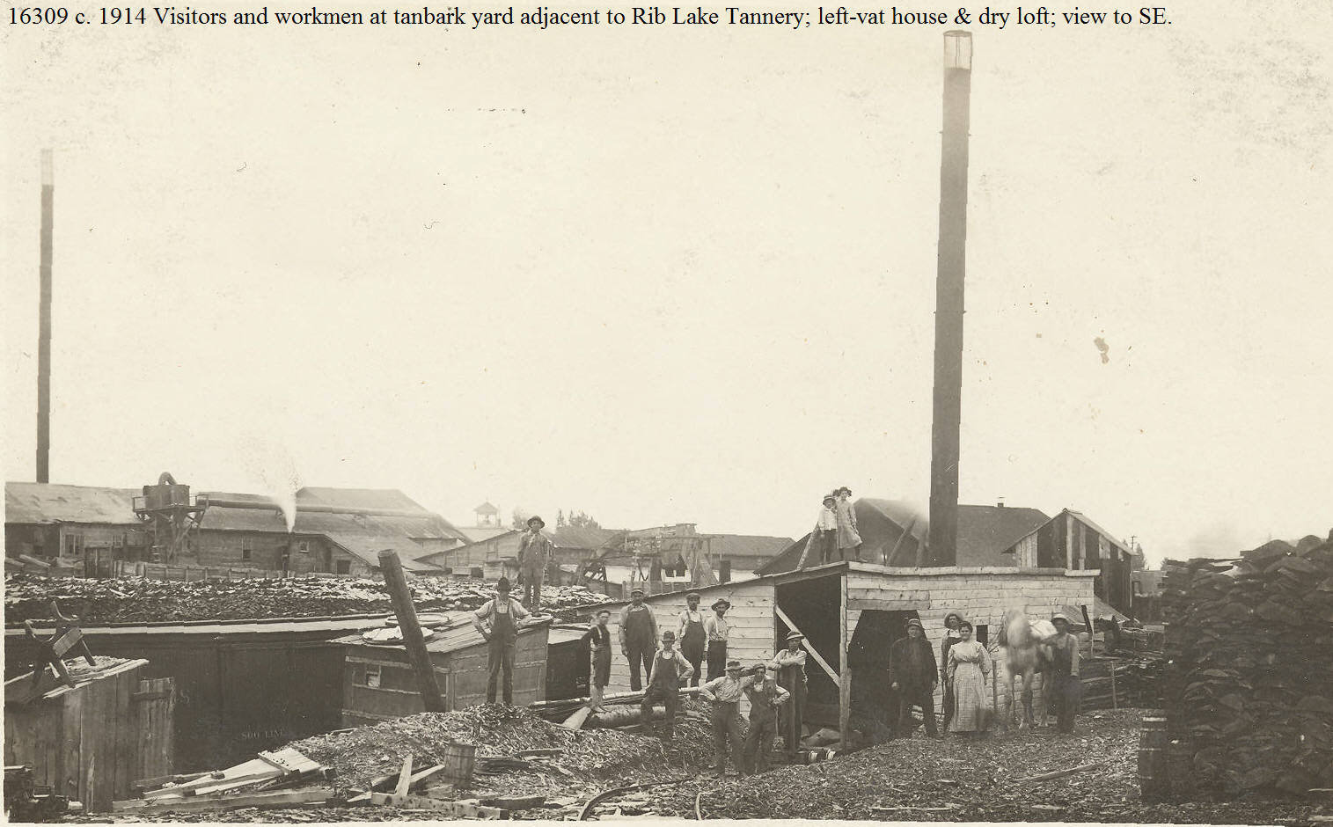  #16309 | Two children stand atop a ramshackle wood-frame building, apparently providing shelter and storage space for the yard crew at the Rib Lake tannery. An 8-foot high pile of tanbark stands at right.  In the foreground, a narrow gauge railroad track connects the extensive yard where tanbark was stored to the tannery complex.  This photo is shortly after the construction of the Rib Lake tannery in 1890-91. Over the years, and especially after its acquisition by the United States Leather Co., the haphazard collection of buildings shown here were replaced by well-designed, massive new structures.  In 2017 the former power plant building built for the Rib lake tannery still stands. It is a well-built concrete two-story building, now a private residence.
1894 | 87 Wisconsin Reports 185 | SCHAFER VERSUS SHAW, et al: a decision of the Wisconsin Supreme Court; see image #21198 for entire text. | Schafer was an owner of a dairy farm in Taylor County through which the Black River flowed. In 1889 Fayette Shaw and his partners built a tannery for the manufacture of leather in the city of Medford. On 9/3/1892 Schafer sued the defendants claiming that the defendants “by operating said tannery, had caused hair and decomposed matter and noxious water to flow in [the Black River] and upon and over a portion of the plaintiff’s premises, to his damage in the sum of $1,800.”  “On October 11, 1892, amended his complaint. On November 10, 1892, defendants disputed the complaint and the matter was set for trial during the regular term of court in April, 1893, at the Taylor County Courthouse.” On 4/5/1893 the tannery owners asked that the trial date be adjourned “by reason of the absence of witnesses.” The court adjourned the trial.  When the case came up for trial at the adjourned date, the defendants asked the court to move the place of trial to a place other than Taylor County claiming that jurors in Taylor County would be prejudiced against them: “That many citizens of [Taylor] county were prejudiced against the defendants and their methods of conducting the tannery business: that many believed the defendants had secured numerous roads to be built at public expense for their own private benefit; that the city of Medford had issued bonds in aid of the construction of such tannery, and that $9000 of bonds remained unpaid; and that many claimed they were illegal and opposed to the payment of the same.”  The trial court denied the motion for change of venue and the Supreme Court agreed with the trial court, citing statutory authority.  Unfortunately, the decision does not report who won the lawsuit.
1/20/1894 | TC STAR & NEWS | Large Loads of Bark&HEMLOCK – Two weeks ago we published the scale of a load of bark hauled to the Medford tannery by one of Chas. B. Powell’s teams, and since that time the evolution of bark loads has been very satisfactory. The Milwaukee Sentinel copied the scale of the Powell load, and last Thursday in a published letter from T., F. M. & F. D. Shaw to the effect that the prize load had been hauled at Perkinstown, and weighed 21, 720 pounds. The letter stated that the load was hauled a distance of 6 miles by one of the company’s teams, and that the team weighed, with harness, only 2,330 [pounds].  All these facts we had on our copy hook for publication in this week’s paper but, since privilege of first publishing this local news item is denied us, we take great pleasure in giving the weight of the RIB LAKE heavy load, which, weighed 23,300 pounds net, and was hauled a distance of 3 miles by a two horse team driven by HUGH KENNEDY.  THE RIB LAKE RECORD FOR LAST FRIDAY IS SOMEWHAT REMARKABLE. ON THAT DAY THREE LOADS WERE HAULED THAT ARE WORTHY OF MENTION. THE FIRST WAS HAULED BY WALTER B. PATRICK’S TEAM, AND WEIGHED 15,660 NET; THEN CAME CHAS. PINKERTON WITH 17,220 POUNDS NET; FOLLOWED BY HUGH KENNEDY WITH HIS 23,300 POUNDS NET.  Last Saturday the largest load delivered to the Medford tannery was brought in by one of the company’s teams driven by Pemberton, a distance of six miles, the net weight of which was 19,040 pounds. This load was hauled out of the woods to the mail road by a team weighing only 2,250 pounds, driven by Elmer Lane.  NOW, IF FRED SHAW PERSISTS IN ROBBING US OF OUR NEWS ITEMS, WE WILL WRITE TO HUGH KENNEDY THAT WE WANT HIM TO PRODUCE A TWENTY TON LOAD AND HE WILL DO IT. (emphasis added) | There are multiple layers of competition here. First, you have the weights of the loads. Second, there are rivalries among Rib Lake, Medford and Perkinstown. Third, you have the egos of the teamsters.  This is the first mention in these newspapers that J.J. Kennedy’s brother is in Rib Lake. The brother was Hugh J. Kennedy, born in Canada in 1849. He was involved in J.J. Kennedy’s Rib Lake lumber operations, including working as a teamster c. 1890.  There was also a Hugh A. B. Kennedy, a nephew of J.J. Kennedy and employed as a bookkeeper in the Kennedy lumber operations.
1895 | “Reminiscences and Anecdotes of Early Taylor County” by Arthur J. Latton, page 84 | 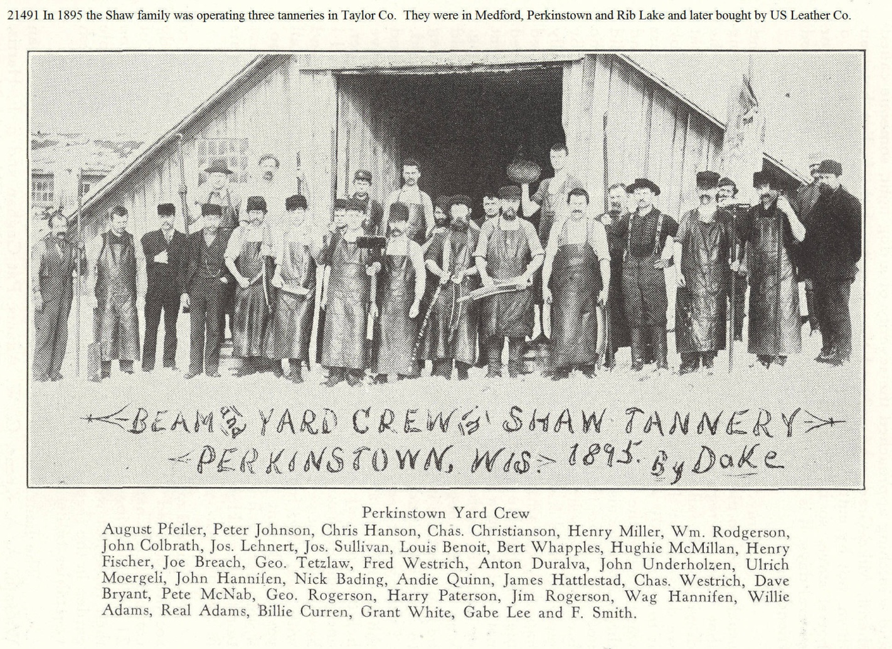 | The Perkinstown tannery was the second tannery in Taylor County built by the Shaw family. While surrounded by a massive amount of standing hemlock which could be conveniently transported to the Perkinstown tannery site, the transportation of hides to and from the Medford, Wis, trail head made the Perkinstown operation relatively short-lived.  The tannery was on the east shore of Kathryn Lake in “Downtown” Perkinstown. In 2018 Robert Rusch was unable to find any extant evidence of the tannery there.
5/25/1895 | TC STAR & NEWS | HEMLOCK – WINCHESTER HOTEL – As a demonstration that HEMLOCK TIMBER IS BETTER THAN PINE for frames of buildings, the recent cyclone at Medford is very apt. A new hotel is being built there, and three stories of the frame had been put up. The building was, therefore, just in a condition to furnish an excellent mark for a high wind but, in spite of the fact that other buildings in the town [Medford] were unroofed and trees were blown down, THE FRAME OF THE NEW HOTEL STOOD THE TEST, and all damage can be repaired and the frame straightened.  E. H. Winchester, one of the stock holders in the hotel company, has commenced TO SING THE PRAISES OF HEMLOCK in letters to friends. Wausau Record (emphasis added)  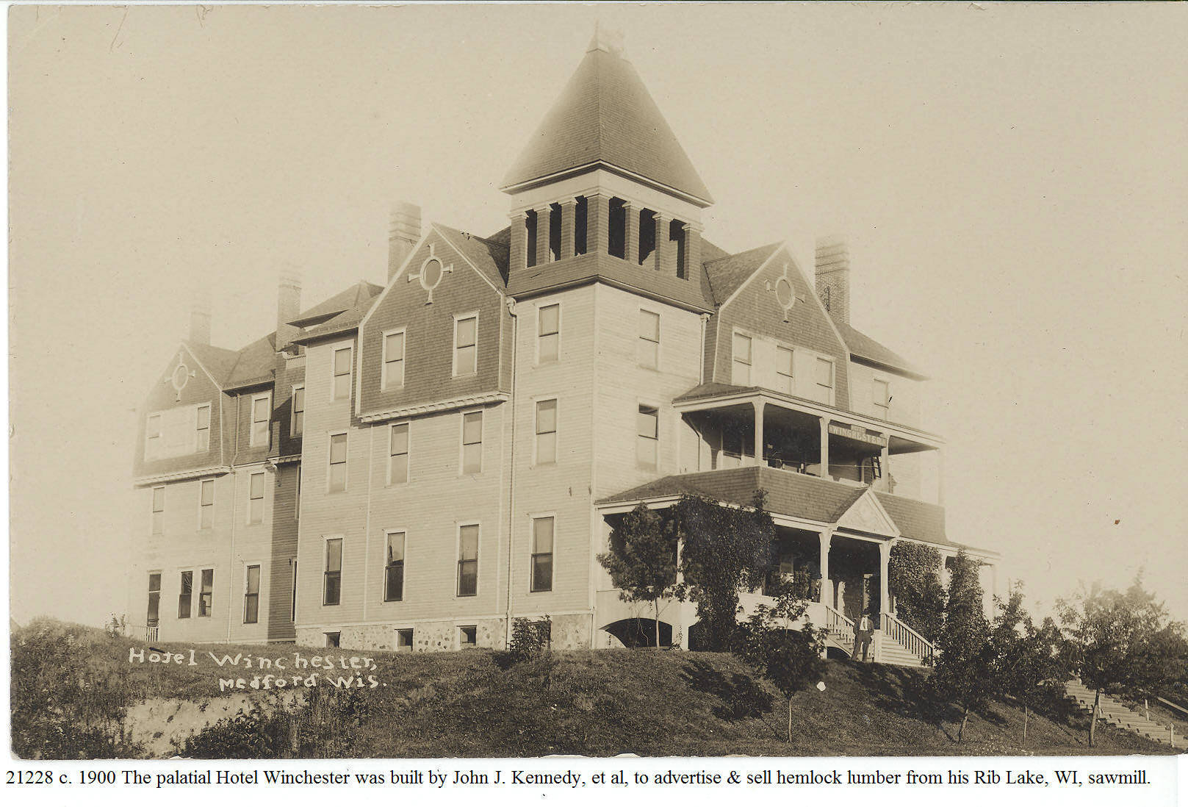 | High winds, which the editor described as a “cyclone”, destroyed and damaged many buildings in Medford. The three story Winchester hotel-under construction-came through in tact; elsewhere the STAR & NEWS reported: “The serious twist given the new hotel Winchester by the recent cyclone has been remedied to the satisfaction of all interested. The twist was attributed to a fault in then plans, the first floor being insufficiently braced to withstand a hard wind. This has now been adjusted and the building will be stronger than ever.”  Note that E. H. Winchester, a local businessman very successful in selling insurance to saw mills, gave his name to the hotel. Another stock holder was John J. Kennedy, whose Rib Lake saw mill provided the hemlock lumber from which the hotel was built. The hotel was owned by John J. Kennedy and other investors doing business as the Medford Hotel Association.  The primary purpose in constructing the Winchester Hotel was TO SELL HEMLOCK by graphically demonstrating that hemlock lumber could be successfully used for substantial structures. The cyclone was a God-send of publicity!
8/17/1895 | TC STAR & NEWS | HEMLOCK – Accident at Shaw Tannery AT RIB Lake – A young man named Herman Mielke, employed at the Shaw tannery at Rib Lake, met a very distressing accident while at work last Sunday evening. He fell into a vat of hot water and when rescued was in terrible condition. The scalding he received was so severe as to loosen the skin on both legs and lower part of his body to the point a good deal dropped off. Dr. Williams, of Chelsea, attended the unfortunate man and he was taken to St. Joseph Hospital at Chippewa Falls. | This is the second such accident reported in the Star & News.
1/4/1896 | TC STAR & NEWS | HEMLOCK – Winchester Hotel – The Hotel Winchester continues to be the center of attraction and is visited daily by a large number of people. The writer had the pleasure of a visit to the great building, now nearing completion and soon to be open to the public. Nearly all the rooms were nicely carpeted and a large part of the furniture is in place. The latter is mostly of antique oak finish and presents a very handsome and durable appearance. The chamber floors are covered with ingrain carpets of good quality. The parlor and reception rooms have been treated more expensively, the floors being covered with Royal Velvet Wilson carpets and furniture to correspond, presenting a decidedly luxurious appearance. In fact, everything on the first floor is rich and handsome, from office to kitchen, and that in other parts is good enough for anybody. (emphasis added) | The framing material for this “great building” was lowly hemlock from Kennedy’s Rib Lake sawmill. Its owners had the not-so-hidden agenda to promote hemlock lumber. It turned out to be a great advertising success.
2/1/1896 | Postcard owned by Rib Lake Historical Society, LLC |  | The Winchester Hotel stood on a high hill south of Medford’s downtown. It was southwest of the junction of Second and Division Street.  In the 1800’s the sawmill owners in Taylor County initially cut and sold exclusively pine. While hemlock trees were abundant, it was initially unsaleable because of its unwanted lumber characteristics. John J. Kennedy, who had founded Rib Lake and constructed the first sawmill there in the fall of 1881, realized that to sell hemlock lumber, the prejudices against it had to be overcome. In partnership with other area mill owners, he had the Winchester Hotel built exclusively of hemlock lumber and on a high hill in the city of Medford, making it visible to anyone in the county seat. As a advertisement for hemlock, the Hotel Wellington proved a stunning success.  The hotel was named for E.H. Winchester, successful insurance salesman of Medford and close friend of John J. Kennedy. Winchester was president of the State Bank of Medford in January, 1895.  The Winchester Hotel opened 2/1/1896 featuring 38 guest rooms, and an in-house barber, café and “sample rooms,” i.e. bar, see 1/22/1896.  When the hotel was razed, all of its hemlock lumber was used to build other structures, including the Medford Methodist Church, which used its hemlock church until 1975.
2/1/1896 | TC STAR & NEWS | HEMLOCK-Hotel Winchester Opens – [ADVERTISEMENT] – The Hotel Winchester Barber Shop by Chas. B. Windus, Excellent Service, Courteous Treatment, First Class: Bath & Room. Metropolitan in all respects. | It appears that the Hotel has a full time barber. It must anticipate a substantial number of male quests.  The Star & News reported that Fayette Delos Shaw had a banquet served in the Hotel’s dining room.
3/14/1896 | TC STAR & NEWS | RIB LAKE-KENNEDY-HEMLOCK-OVERVIEW–Last week the writer had the pleasure of a buggy ride to the thriving little burg of Rib Lake. Hundreds of men are constantly at work in that place in the large saw and planing mills of J.J. Kennedy and the immense tannery of Fayette Shaw and we believe MORE MONEY IS IN CIRCULATIONTHERE PER CAPITA THAN IN ANY OTHER PLACE IN [Taylor] COUNTY.  The place is constantly building up, and many improvements were noticed since our last visit. They have a model school building, and their schools are conducted by competent teachers, fine church edifices, and more in contemplation. Money has recently been subscribed for the erection of a Catholic church, work on which will be commenced this spring.  Through the courtesy of Mr. J.J. Kennedy, we were shown through his large and elaborate office rooms, which are models of convenience and ELEGANCE. The business end of an enterprise like his is an important feature, and he is well provided with efficient assistants and room to attend to it.  A visit was also made to the tannery where E.C. Getchel presides as general manager. Elliot has a responsible position on his hands, and it is necessary for him to think and work continuously. His thinker is well developed, however, and his physical condition is first rate, so that he does not seem to suffer from overwork. The CAPACITY OF THE TANNERY HAS BEEN INCREASED FROM A START OF 150 HIDES PER DAY UNTIL NOW THEY PUT IN 525 HIDES DAILY and ship five [railroad] carloads of finished SOLE LEATHER every week.  The site of the tannery seems to have been made to order, and is doubtless the most convenient of any of the large tanneries owned by the Shaws. Their system of water works is one that would do credit to this city [Medford], and would be ample for our needs, if we possessed one similar to it. It would not be a bad plan if our city authorities would appoint a committee to examine these works before making contracts for the construction of water works.  Shawtown is now likened to a tree, because it is covered with bark. IMMENSE PILES of this commodity [tanbark] can be seen in all directions and it is estimated that about 13,000 CORDS [OF TANBARK] ARE PILED THERE. (emphasis added)  Our time was limited while there, and we regret that we are unable to give the entire place a creditable write-up. | The writer was probably Mr. Danielson, the new editor/owner of the Taylor County Star & News.  Rib Lake was in the midst of boom times. The Shaw tannery, built in Rib Lake in 1891, was flourishing. There was full employment. These conditions induced by grandfather, Herman Emanuel Rusch to leave his Fairchild, Wisconsin, farm and move to work as a blue collar employee at the Rib Lake tannery in 1896.  The part of Rib Lake north of Fayette Avenue was dubbed Shaw Town or Shawtown. While Fayette Delos Shaw’s name alone was on the deed to the Rib Lake tannery, his father, Fayette M. Shaw, and other family members were active in the business. At this time they were operating tanneries in Medford, Perkinstown, and Phillips, and constructing another in Mellon.  The immense bark pile was on the east side of West Street south of High Street. It is the geographical high point of the village and its piles of bark were over 25 feet high. Railroad spurs ran between the long piles which had a carefully constructed “roof” of bark to shed water and allow long term storage.  On August 21, 1897, the biggest single advancement in Rib Lake retail, commercial history happened: A.C. McComb platted “McComb’s Racing Park Addition to Rib Lake.” It created McComb and Landaal (now spelled Landall) Avenue as well as Forest and Pearl Streets with 122 lots of land ready for development! The lots along McComb Avenue quickly became the shopping and retail center of the Village.  Consult image #15296 to see McComb’s land plat and map. It, along with historic photos, e.g., J.J. Kennedy helping A.C. McComb measuring for the plat, image #10,771, may be seen and down loaded free-of-charge at www.riblakehistory.com.
3/22/1896 | TC STAR & NEWS | HEMLOCK-Hotel Winchester – The writer took dinner, at the invitation of mine host, Fred Ward, at the Hotel Winchester, at Medford. After partaking of an elegant repast we were shown the house from the water tank in the attic to the domain of Prof. Williams in the basement. The house is built upon the brow of a hill and is elevated from the front [Main] street some several feet while the back [South Second] street is on a level with the house. The style of architecture is modern and in some instances original and striking.  But we will have more to do with the inside. The main entrance is through wide doors, opening outward, from one of the finest lobbies that can be found in any hotel in the state—wide and roomy. To the left of the entrance is a handsome, large and well lighted writing and reading room, while to the right is a spacious and handsomely furnished parlor, immediately back of which is the ladies’ reception room.  Further back and to the left is the toilet room and coat room. Through the lobby and directly opposite the entrance is the dining room, large, square and well lighted, and back of this the kitchen and china closet. The upper floors are laid off into parlors and sleeping rooms—every room furnished the same. There are thirty-eight guest rooms and every one of them outside rooms well lighted.  In the basement is a well apportioned café, presided over by Prof. Williams, and sample rooms, a barber shop, cellars and furnace room. The house is finished throughout in natural woods with a very harmonizing effect, but we haven’t the space to describe as we should like. Fred Ward, the prince of hotel men, presides over the house, and no hotel man in northern Wisconsin has more friends than the genial Fred. – Colby Phonograph | All the framing lumber was hemlock from J.J. Kennedy’s Rib Lake sawmill. The Winchester was clearly the largest and most luxurious hotel Medford ever had to offer.
4/4/1896 | Wisconsin Central Railroad Land Handbook republished in Taylor County Star & News | “The astonishing thing about Taylor County (and this may be said of the other counties we have written about) is that it is only within the last few years that the strength of the hemlock lands and the general fertility of the timber lands have come to be appreciated….”  “TAYLOR COUNTY IS KNOWN AS THE GREAT HEMLOCK COUNTY OF THE STATE. No where else in the state can so much hemlock of so fine a quality be found; and every acre of these hemlock lands in the county is fertile and capable of producing fine crops of all the small grains, as well as the very best of the root crops…”  “Every farmer in Taylor County secures ready cash market for every log of hemlock lumber and every cord of bark, as well as for all the hemlock ties he can furnish…” (emphasis added) | A professional forester told me that Taylor County is unique in the State of Wisconsin for the quality and quantity of hemlock reproduction; he believed the well drained, loam soils explained our current good, natural reproduction of hemlock.  Deer browsing of hemlock has devastated hemlock regeneration in Wisconsin. To demonstrate this fact, RPR has constructed and maintains, on his home property, SE NE 13-33-2E, a deer exclosure. The exclosure was built to protect one-half of a small patch of native Canadian Yew. As of 10/31/2015, the yew protected by the exclosure thrives and has reached 3 feet in height, while the unprotected yew remains at ground level – deer routinely browse it to this level.
5/30/1896 | TC STAR & NEWS | HEMLOCK-Shaw Continues Bark Purchases – I wish to deny the report that has been printed in some of our county papers to the effect that I would not buy bark this coming season. On the contrary, I am buying and shall continue to buy all the hemlock bark that is brought to me. I wish to say to all farmers in this locality that they can peel all the bark they wish to, with perfect assurance that they can sell the same for cash at the tannery at Rib Lake, Wis.  /s/ Fayette [Delos] Shaw | This responds to a comment made by George Knower in the “Greenwood Leaves” column the week earlier that the tannery might stop buying bark and rely on its own bark camps.  Just about every farmer owned some forest land with hemlock in it. Farmers routinely used their large families to help make tan bark which the farmer hauled with his own sleigh for cash at the tannery.  While Shaw’s announcement did not say what Shaw would pay, in the past he paid $2.50 per cord. A cord was originally a pile of bark 4 feet by 4 feet by 4 feet, although the tannery now weighed the bark and calculated a cord at 2,240 pounds.  While $2.50 a cord for tan bark delivered to the tannery was considered by many as too little, farmers were a substantial source of tan bark going to the Rib Lake tannery; it was badly needed cash and the farmers’ family worked “free” cutting trees they already owned.  In the very next edition of the Star & News, George Knower wrote of the Interwald area: “everyone who has land with green [uncut] hemlock on it is busy peeling tan bark.”  On 6/6/1896 the Shaw firm announced; “after Sept. 1st, we will buy bark as usual paying $3.50 per cord cash.”
9/4/1897 | TC STAR & NEWS | “A [railroad] car load of water mains for the Perkinstown water works arrived Thursday and are now being hauled to that HEMLOCK METROPOLIS in the wilderness. The work of digging the trench is about completed, and now that the piping has arrived, the system will be completed in short time, and Perkinstown will be the FIRST VILLAGE IN THE COUNTY TO HAVE A COMPLETE SYSTEM OF WATER WORKS.”  “Power will be supplied by the tannery, and the running expenses of the plant will be scarcely nothing. Thus, the taxpayers of that village will be benefitted in more ways than one. They will henceforth be able to get their property insured at reasonable rates, besides the many conveniences the works afford.” (emphasis added) | Perkinstown was never legally a village de jure. A de facto village existed briefly there to provide homes for tannery workers.  These water mains (pipes) were probably three trunks with their centers bored out.
10/9/1897 | TC STAR & NEWS | THE FIRST HEMLOCK PULPWOOD FROM TAYLOR COUNTY  “J. B. Ramsey and M. V. Falconer have contracted with the Pulp Wood Supply Co., of the Fox River valley, to supply that concern with 10,000 cords of hemlock pulp wood. THIS…IS THE FIRST INSTANCE IN WHICH HEMLOCK HAS BEEN BOUGHT FOR THIS PURPOSE IN TAYLOR COUNTY and will afford our farmers an opportunity of disposing of their small hemlock at a fair profit, instead of burning it up.”  “The 10,000 cords are all to be delivered this coming winter. All the hemlock to be used for this purpose must be peeled, sound and reasonably free from knots, and ranging in size from 5 to 16 inches in diameter.”  “This will certainly prove a golden opportunity to our farmers.” (emphasis added) | The cities along the Fox River between Lake Winnebago and Green Bay were industry-based on numerous paper mills. Here is the first Medford report of purchase of Taylor County pulpwood for the Fox River Valley.  Note the reference to happy farmers. Farmers routinely cleared their lands to make fields or pasture. Now that a hemlock pulpwood market came, farmers had a more lucrative market to sell tanbark, logs and, now, pulpwood.  As late as 1947, Clifford Fischer of Medford was hauling and selling hemlock pulpwood in 4-cord truckloads.
1/1/1898 | TC STAR & NEWS | HEMLOCK LOG DRIVE ON SILVER CREEK  “W. H. Taylor of Westboro has a contract with the Valley Lumber Company of Eau Claire to put into Silver Creek about 2,000,000 feet of hemlock. The contract price is very favorable to the logger and should prove a profitable venture.” | Here is Taylor County hemlock river driven to the City of Eau Claire for sawing.  I assume the bark went to Shaw’s Rib Lake tannery or John Duncan’s Westboro tannery, then under construction.
1/22/1898 | TC STAR & NEWS | CAPITAL LUMBER CO. BUYS CHELSEA SAWMILL  “Capital Lumber Co.’s sawmill [at Chelsea] is now running full blast. IT IS DOUBTFUL IF THERE IS A BETTER EQUIPPED MILL IN THE STATE FOR SAWING OF HEMLOCK LOGS.”  “Among the arrivals [in Chelsea] this week were: A. E. Proudfit, F. W. Shepherd and L. [Louis] A. Rousseau, capitalists from Madison [Wisconsin]. The two former are interested in the Capital Lumber Company and came to inspect the [Chelsea] plant. They were much surprised at the many improvements made at the mill, including a dry kiln capable of preparing green lumber for market in 3 days.”  “A little snow would be of great value in the hauling of logs by settlers. Still, logs are coming in quite lively, and if all indications do not go astray, we will see a stock of 8 to 10 million feet of HEMLOCK logs by spring.” (emphasis added) | Capital Lumber had bought the sawmill one quarter south of “downtown” Chelsea on the east side of Wisconsin Central’s railroad tracks. It had long been operated by Abram Taylor.
2/2/1898 | TC STAR & NEWS | REMAINING TIMBER TYPES IN TAYLOR COUNTY  “The Milwaukee Sentinel published a report of the State Forestry Commission showing the approximate amount of standing timber in the several counties of Northern Wisconsin.”  “It credited Taylor County with having 200.000.000 feet of pine, 950,000,000 feet of HEMLOCK, and 950,000,000 feet of hardwood timber, which shows that there are still several trees to be cut in this county.” (emphasis added)
2/2/1894 | TC STAR & NEWS | [Advertisement]WANTED  “3,999 cords of tan bark at Stetsonville [Wisconsin] this coming winter, and 2240 lbs. is a cord. Good weight guaranteed,  /s/ H. G. Amberson  Stetsonville, Wis.” | There was no tannery in Stetsonville and the closest was 5 miles away in Medford. This tan bark would be shipped out via the Wisconsin Central Railroad.  This ad was aimed at farmers who had hemlock on their land.  A cord of hemlock tanbark could be determined by size or weight; a pile 4x4x4’ or 2240 pounds.  Traditionally, a tanbark cord was a pile of hemlock bark cut 48 inches long and piled 4 feet high and 4 feet wide. Note that this buyer had switched to a definition of a cord by weight, i.e., a cord equals 2,240 pounds.
2/19/1898 | TC STAR & NEWS | RECORD HEMLOCK LOG SLEIGHS  “A record was doubtless created at Charles Squires’ Camp on Thursday last, in the line of hemlock log hauling.”  “Eight [sleigh] loads were hauled to the [Black] river, a distance of about 7 miles, the aggregate scale of which were 52,000 feet, or an average of 6,500 feet per load. THIS IS A REMARKABLE FEAT IN HEMLOCK and the loads contained about 125 logs each.” (emphasis added)
2/19/1898 | TC STAR & News | Rib Lake Ripples- HEMLOCK – Hemlock pulpwood is being brought in by the carloads the past week.  Rib Lake can also boast of a few “Klondikers” as H. Harding and Jake Miller leave here in the near future to explore Alaska [for gold].  A week ago Thursday night at the regular meeting of the Modern Woodmen [of America Lodge] at their Hall, and after all business was discussed and they were ready to leave, in walked the Royal Neighbors loaded down with baskets of good things and invited the Woodmen to a royal feast with which they did justice. A hasty program was arranged as follows: Song by Woodmen, Reading by Mrs. C. Egelerson, Song by Paul Long, Song by Deputy Fillpot [Deputy Head Counsel for the Modern Woodmen of America of Loyal, Wisconsin], Song by Woodmen.  The get-together finished with an address by Deputy Filipot, which closed a good time which will go down as part of the history of both Royal Neighbors and Woodmen.  /s/ “Nibs” | Having a market to sell pulpwood is a real boon for landowners; pulpwood can be made from the small parts of a tree and other parts not big enough or sound enough or straight enough to make saw timber.  Since hemlock was the single biggest component in Rib Lake forests at that time, the ability to sell hemlock pulpwood was a God send. The landowner could sell the hemlock bark to the tannery, and the hemlock saw logs to J.J. Kennedy’s mill, and hemlock pulpwood to some far away paper plant. This meant complete utilization of the ubiquitous tree.  Fortuitously, the Wisconsin Central Railroad, which served Rib Lake, had its mainline running directly to Neenah, Wisconsin, and other paper plants in the Fox River Valley. This convenient railroad route helped keep freight rates low.
1899 | 102 Wisconsin Reports 275 | NELSON VERSUS [FAYETTE DELOS] SHAW. An 1899 decision of the Wisconsin Supreme Court that was tried in the Taylor County Circuit Court in Medford, Wisconsin. | Nelson was a teamster employed by Fayette Delos Shaw to haul tanbark to the plaintiff’s VRL tannery. Nelson’s route was approx. 8 miles long beginning near Mud Lake in the TRL and ending in the Village of Rib Lake. Nelson was seriously injured when his loaded sleigh went down a hill and the sleigh hit a ditch and gully, the force of which threw Nelson off the load, causing him to be injured.  The evening before the accident Nelson had complained to the defendant’s foreman about the ditch and gully at the bottom of the hill saying it was dangerous and he would quit work if the defendant did not fix the road; the foreman promised Nelson that he would have the ice road fixed before the plaintiff came out with another sleigh load of tanbark the next morning.  The case was tried before a jury and Shaw claimed, among other things, that Nelson’s lawsuit was without merit because Nelson “assumed the risk” of injury. The jury decided in favor of Nelson and the tannery owner, Shaw, appealed to the Supreme Court.  The Wisconsin Supreme Court upheld the jury’s decision awarding damages to Nelson and wrote: “The most serious question in the case is whether the plaintiff [Nelson] was not guilty of contributory negligence, as a matter of law, in driving down the hill while sitting on the [sleigh] load with the soles of his boots even with the front end of the load, and hence with nothing for his feet to brace against, but upon the whole evidence we are constrained to hold that the question of contributory negligence was for the jury.” “The judgment of the circuit court [over turning the jury’s decision] is reversed, and the cause is remanded for a new trial.”
8/12/1899 | TC STAR & NEWS | WOOL STORERS’ DISEASE  “An Ashland, [Wisconsin], special to the Milwaukee Sentinel says: “An Italian laborer at the Shaw tannery at Mellen was brought here today, suffering from an unusual malady, from which doctors say there is no hope of recovery.”  “His disease is a common one in Asiatic countries, but rarely occurs here. At the Shaw tannery, hides imported direct from China are being used, and the disease was contracted in handling them.”  “In Europe and Asia it is called “wool storers’ disease”, and is prevalent among men handling cattle. It is a microscopic germ that enters the skin and continues through the whole system.”  “The poison itself is called “anthrox” (sic) and is confined in the earlier stages of development to the cuticle. It is of a burning nature. This is the sixth case that has been brought here, the disease being contracted in each instance from handling these foreign hides.” | The disease was anthrax.  Earlier reports showed hides were imported from South America and Australia. This is the first mention that Shaw imported hides from China as well.  Later a number of Medford area residents came down with anthrax and successfully sued the owners of the Shaw Tannery in Medford.
9/6/1899 |  | HEMLOCK LOGGING CONTRACT  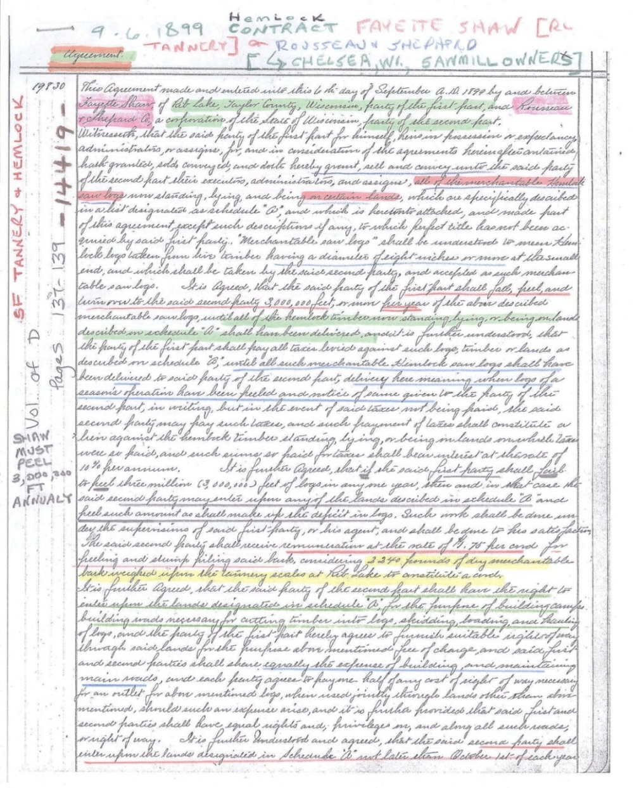  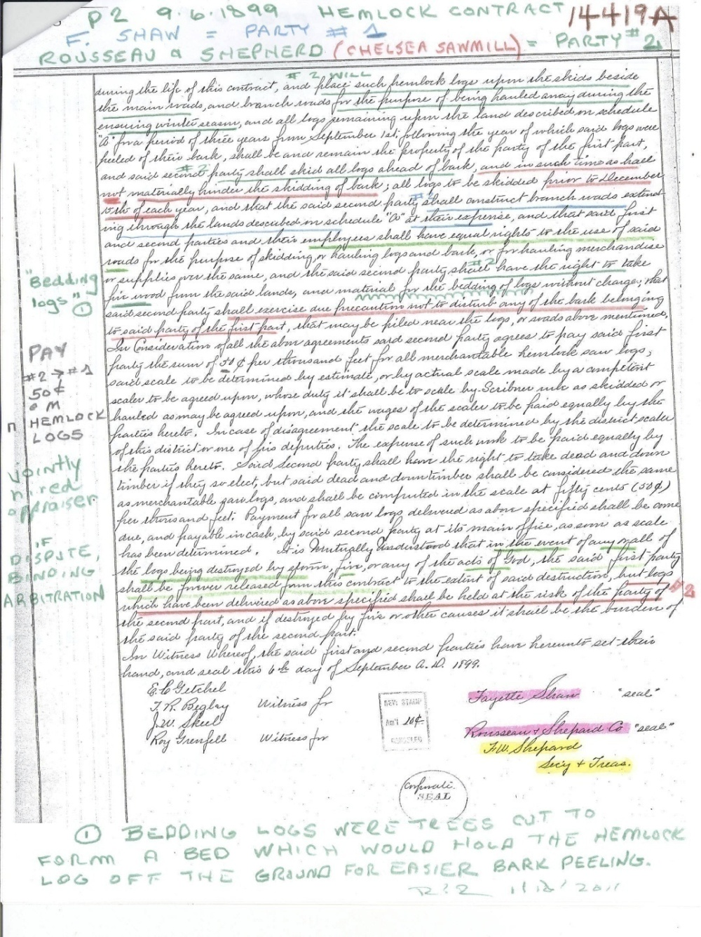  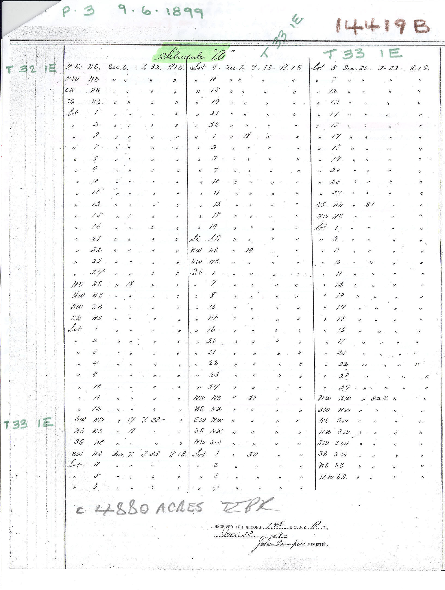  A MODIFIED VERSION OF THE HEMLOCK CONTRACT DATED 9/6/1899 FOLLOWS. THE MODIFICATIONS CONSIST IN DIVIDING THE CONTRACT INTO 25 NUMBERED PARAGRAPHS, EACH WITH A DESCRIPTIVE HEADING DRAFTED BY ROBERT P. RUSCH. | This detailed hemlock contract was signed September 6, 1899 between Fayette Delos Shaw, operator of the Rib Lake Tannery, and F.W. Shepard, on behalf of the Rousseau and Shepard Lumber Co of Chelsea.  The tannery wanted a steady flow of tanbark to extract naturally occurring tannic acid for its huge Rib Lake facility constructed in 1891. It also wanted to make money on selling the hemlock logs to the Chelsea based lumber company.  This complex contract attempted to deal with the host of possibilities that could arise when tanbark was being cut, piled, and dried on a parcel of land near the same time that the logs from which the tanbark had been peeled were cut to size, skidded, decked and removed.  See image #14480, Document & Photo Collection of the Rib Lake Historical Society for a summary of this contract.
10/7/1899 | TC STAR &NEWS | HEMLOCK RAILROAD TIES  “A. Gearhart is now in the employ of the Wisconsin Central Railway Company as tie inspector and general all-around-hustler for business. Mr. Gearhart is a first class man, and his well-known integrity will act as a guarantee to the people of this section of Wisconsin that they receive a fair estimate for their ties. By the way, prices are considerably better than usual, being as follows:  “White oak No. 1…..50 cents  White oak No 2…..30 cents  Hemlock, tamarack or cedar…..23 cents  No. 2 Hemlock, tamarack or cedar….10cents  Rock elm……….25 cents”  “At these prices an experienced tie maker can make more money than a distinguished country newspaper man.” | Albert A. Gearhart was a son of C. H. Gearhart, who came to Chelsea in 1874 and was the first supervisor of the Town of Chelsea.  While railroad ties can be and were sawn at sawmills, many were hewn by hand, by skillful use of a broad axe; this meant that a farmer or settler could, himself, make railroad ties and get in on these good prices.  Before making a tie, the hewer could strip the hemlock for tan bark. The Shaw Co. was at the time offering $3.50 per cord for tanbark delivered to its Medford tannery.
11/1/1899 | TC STAR & NEWS | WANTED  “Anyone wishing to sell Pine or Hemlock logs delivered in the Black River for the coming winter will do well by seeing or writing A. S. Armstrong, Hemlock, Wis., before selling them elsewhere.” | Hemlock was a tiny town adjacent to Hemlock Dam, a site about 5 miles north of Neillsville on the Black River. Driving hemlock logs down the Black River was still frequent; the Medford Manufacturing Co. was in the process of a mammoth increase in power and capacity at its Medford mill and gearing up to exclusively cut hemlock and hardwood. The same company rebuilt the Whittlesey dam on the Black River in 1899 to facilitate hemlock log drives.
11/18/1899 | TC STAR &NEWS | MEDFORD SAWMILL GREATLY IMPROVED  “Had anyone ventured to predict 20 years ago that such improvements as are now being made by the Medford Manufacturing Co. in itssawmill property would be done at this late day, their mental equilibrium would have been questioned. Pine, which was then the only timber worth cutting, has about all disappeared, and perhaps a hundred million feet of hemlock and many millions of hardwood logs have also been either run down the Black River or sawed into lumber. And to think that now we were about to have the best sawmill in the history of Medford, with more than double the power and capacity of the old McCartney mill, would indeed have seemed incredible 20 years ago.”  “But such is the case. A large force of masons and assistants have been at work for some time building an engine and boiler room of stone and mortar, the dimensions of which are 54 by 56 feet, and the stone walls are to be 14 feet high. This will house the largest and most powerful [steam] engine ever brought to Taylor County, being rated at 250 horse power, and a battery of four mammoth boilers. The old 50-horse power outfit, if placed beside the new, would resemble a play thing in comparison. The interior of the entire sawmill will be remodeled and improved with the addition of better and larger machinery to harmonize with the increased power.”  “The annual output of lumber will be increased by millions of feet annually for several years to come, consisting of hemlock and hardwood, and an era of prosperity in this industry is before us, greater than ever before.”  “The new dam at Whittlesey has been completed and it is a model of its kind in every respect. The old dam at the sawmill in this city was removed entirely, and a new one, constructed according to the latest approved models, has taken its place.”  “The new mill manager, Mr. L. [Lee] W. Gibson, means to do business, and evidently does not believe in doing it in a “one horse” way.” (underlining added) | The improved Medford mill cut its last log in 1926; it closed when its timber was exhausted.  The reconstruction of the Whittlesey dam on the Black River allowed the Medford mill to continue log drives to its mill.  But the major improvement in log transport to the Medford mill took place later; it was the construction of logging railroad owned and operated by the Medford sawmill. That railroad track ran northward from the mill, parallel with the Wisconsin Central. Just north of Allman Street, the logging line turned westward and eventually ran within 3 miles of Perkinstown.  The reconstruction of the Medford dam on the Black River permitted the mill to create a flowage that was used as its mill pond. Logs brought by rail to the mill were dumped into the pond and stored there until needed. Logs were pulled one-at-a-time from the mill pond by the “bull chain” into the sawmill.  In 2012 the Medford municipal dam stands on the site of the mill dam.
11/23/1899 | Vol. Misc. D, pg. 572, Taylor County Register of Deeds | [A deed conveying all hemlock and its bark on 40 acres in Taylor County.] | Alvin Pierce for $30 sold all the hemlock on the NE NE, 19-33-2E, Town of Rib Lake.
1900 | Rib Lake Historical  Society | 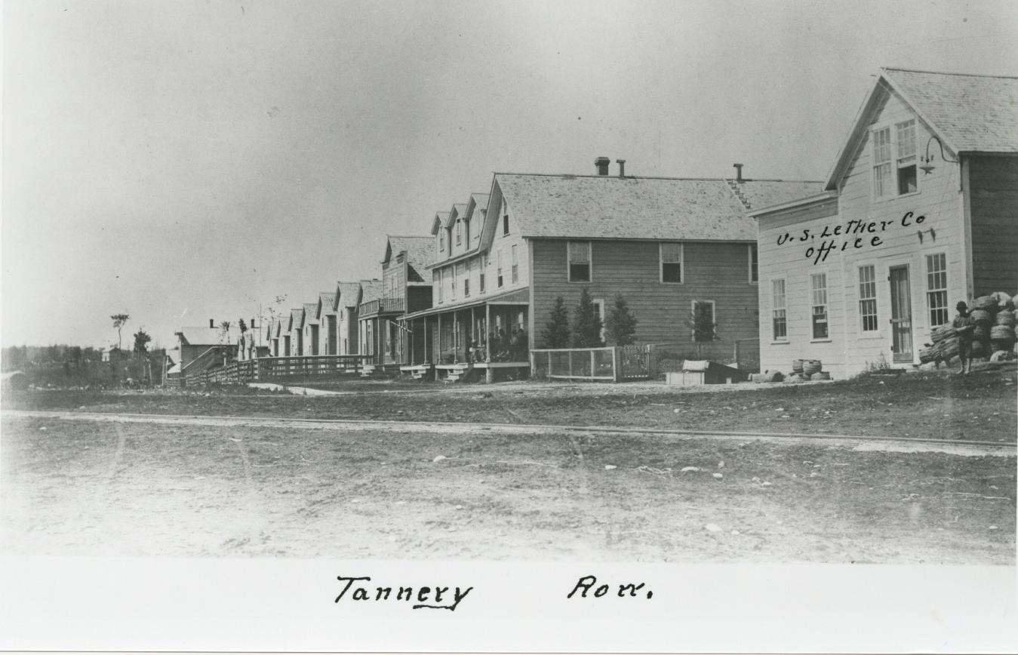  #10788 | Photo looks west over Fayette Avenue at its junction with McComb Avenue in the Village of Rib Lake about 1900. A railroad track spur of the Wisconsin Central Railroad is shown in the foreground leading to the Fayette Delos Shawn tannery, later acquired by the United States Leather Co.  The building at the far right is the tannery office. Identical 1 ½ story wood-frame buildings in the center of the photograph are “company houses,” residences built and owned by the tannery and rented to employees. In 2017 at least four of them continue to serve as private residences at their original locations.
c. 1900 | Rib Lake Historical Society | 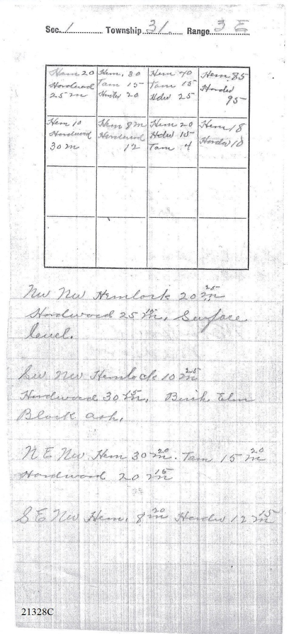 | About 1900 W.E. Hibbard of Medford, WI, was hired to cruise a half section of land in Taylor Co, WI, and estimate the type and volume of its standing timber; image 21328C shown at left, is in two parts:  A. The grid map shows 8 quarter quarters constituting the north ½ of Section 1, Township 31 North, Range 3 East in the Town of Goodrich, Taylor County, WI. Each box represents one quarter quarter section and within the box Hibbard has summarized his findings. The Arabic numerals report his estimated board feet, abbreviated to thousands; for example, 20 means 20,000 board feet.  He abbreviated hemlock to “Hem,” tamarack to “Tam,” and hardwoods to “Hdw.”  B. The lower half of entry 21328C are Hibbard’s handwritten notes. His description for the NW ¼ NW 1/4, Section 1, 31-3 East reads “surface level;” Inexplicably, he wrote both 20 and 25 “m.” I take it that the m was the roman numeral used to indicate 1000.  For the SW ¼ NW ¼ he inexplicably wrote “10” and “25” m of hemlock as well as hardwood, both “30” and “15” m; the hardwood consisted of “birch (probably yellow birch, a predominant shade tolerant species in the virgin forests of the area), elm and black ash.”  Note that no mention is made of pine. By 1900 all of the pine, in the Goodrich area white pine (pinus strobus), had been cut off. In all probability, the stated estimates of the hemlock and hardwood represent the volumes contained in the virgin forest.
3/3/1900 | TC STAR & NEWS | “L. [Lee] W. Gibson and W. N. Killen, of the Medford Manufacturing Company, attended the meeting of the Northwestern Hemlock Timber Manufacturers’ Association held at Milwaukee this week.” | The Northern Hardwood & Hemlock Manufacturers’ Association lasted until c. 1982. Darrell Dammof Stetsonville was its last president. Robert P. Rusch of Rib Lake was its last attorney.
10/20/1900 | TC STAR & NEWS | EFFECTIVE DATE FOR UNITED STATES LEATHER CO. TO TAKE POSSESSION OF RIB LAKE, MEDFORD, PERKINSTOWN,PRENTICE,PHILLIPS AND MELLEN TANNERIES FROM F. M., T. & F.D. SHAW CO. | The grantee, USLC, was a large corporation headquartered in New York, New York.  TC Star & News articles make no mention whether this purchase included John Duncan’s Westboro tannery.  Nota bene; the Rib Lake Historical Society possesses portions of the “Bark Ledger – U. S. L. Co.” A company bookkeeper made detailed notes of bark purchases from 1900-03 from villages along the Wisconsin Central mainline, givingthename of the teamster delivering bark, the amount, the rate of pay [it varied from $4.00 per cord paid to August Neumann of Whittlesey to $5.25 paid to J. W. Gray at Westboro], the number of railroad car into which the bark was loaded, the amount and date of payment.  Representative pages will be scanned into the Photo &Document Collection as image 15985.  There is no mention of Rib Lake, or likely Rib Lake teamsters, within the “Bark Ledger” but for two purchases of less than two cords of bark from “Lou [Louis] Kennedy.” The 1880 Census shows Louis residing in Spencer, Wis., which was the then home of J.J. and Angus Kennedy. Louis’ residence and work place in 1900 is unknown as of 7/5/2012.
2/23/1901 | TC STAR & NEWS | “TAYLOR COUNTY THE GEM, Its Climate, Soil, Products and Industries.”  “TANNERIES The second largest industry [in Taylor County, next to lumbering] is that of leather making. Three large establishments, one each at Medford, Rib Lake and Westboro, are in constant operation and afford employment to a large number of men the year around.”  “Tanneries also furnish a ready market for a vast quantity of hemlock bark. Formerly known as the Shaw tanneries, they are now operated by the United States Leather Company.” | The Star & News article reporting the purchase of the Shaw tanneries by the United States Leather Company also reported that the buyer would close the Shaw tannery at Perkinstown.  While vast stands of hemlock surrounded Perkinstown, it was inaccessible; not only did untanned hides have to be hauled to Perkinstown, but all leather made there had to be hauled out. This required long and arduous sleigh or wagon horse pulls through hilly glacial topography. USLC promptly closed the Perkinstown tannery, but operated its Rib Lake facility until 1922.
3/11/1901 | Taylor County Register of Deeds, Vol D of Misc, p. 323 | 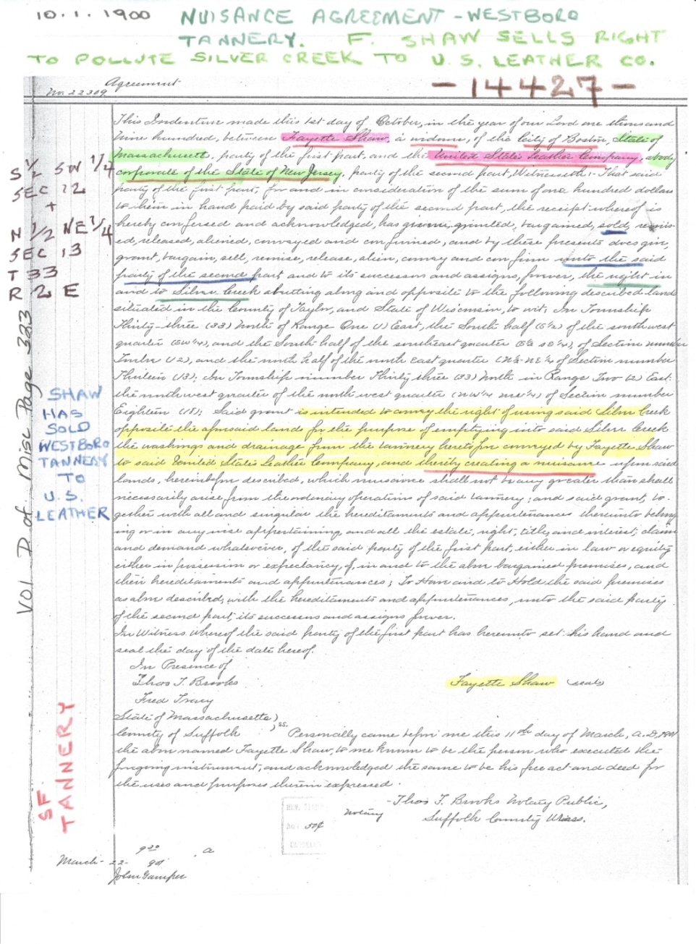 | This agreement is between Fayette Shaw and the USLC of New York, New York. John Duncan had founded a small tannery on the banks of the Silver Creek in Westboro which utilized hemlock tanbark. Duncan sold out to Shaw, whose family already owned tanneries in Medford, Perkinstown and Rib Lake. About 1900 Shaw sold his Westboro tannery to the USLC.  When Shaw sold its Westboro tannery to USLC, it appears an important element had been overlooked. The Westboro tannery dumped its spent hemlock liquor and large quantities of hair and fleshings stripped from the hides directly into Silver Creek.  This agreement purports to transfer the right somehow owned by Shaw to dump these noxious pollutants into Silver Creek to the USLC.  As of March 13, 2016, the Rib Lake Historical Society has been unable to locate an act of the Wisconsin state legislature or other authority empowering Shaw to pollute Silver Creek.
4/13/1901 | TC STAR &NEWS | “We learn that the U. S. Leather Co. will peel about 35,000 cords of bark for its tanneries in north Wisconsin, and will take 25,000 cords from private parties.” | In September, 1900, the United States Leather Company bought the tanneries at Medford, Perkinstown, Rib Lake, Westboro, Prentice, Phillips and Mellen, Wisconsin. It immediately closed the one at Perkinstown.  In keeping with the practice of its predecessor, Shaw Company, it intended to operate “bark camps” to fell hemlock trees and peel tan bark; this article projects that such company crews would generate 10,000 cords.  Another 25,000 cords would be bought from “private parties,” falling into the following categories:  a.Jobbers. Jobbers were independent companies or persons contracting to cut hemlock which the United States Leather Co. owned or had stumpage rights to, for a predetermined payment.  b. Other Companies. This category included companies like W. A. Osburn, l/k/a Rib Lake Lumber Co. or Heidrick& Matson at Westboro or John S. Davis at Phillips.  c. Farmers and settlers. Usually cutting on their own land.  d. Other, private entrepreneurs; often a one man operation.  e. Hybrid. Shaw or USLC sometimes sold its timberlands or timber (stumpage) reserving the right onto itself or its assignee to cut and peel the tanbark.
4/13/1901 | TC STAR &NEWS | CITY OF MEDFORD BONUS BOND  “At a meeting of the City of Medford city council, Attorney Thaxter called up the matter of the bonus bond running to the Shaw tannery company. The Shaws having sold to the U. S. Leather company, the bond is technically non-enforceable.”  “[Councilman] Wehman thought that all right to collect on the bond was lost. Wesle thought that the City was under a moral obligation to pay. He moved that if the Shaws gave a suitable guarantee bond that the U. S. Leather Co. would carry out the contract for the four remaining years, the City pay the remainder of the bonus.”  “The vote was a tie, Smith, Wesle and Boeckler voting yes, The mayor gave the casting vote (sic) in favor of the motion.” | As an inducement to get the F. M., T. &F.D. Shaw Co. to build a tannery in the City of Medford, the City had entered into an agreement to pay Shaw a sum of money if the tannery was built and Shaw operated the tannery in Medford until, at least, 1905.
4/27/1901 | TC STAR & NEWS | THE ENTIRE WESTBORO TANNERY COMPLEX, BUT FOR THE BARK PILES, BURNS ON APRIL 23. | This is a suspicious fire. On 10-20-1900 the Taylor County Star & News reported that the U.S. Leather Co had just purchased every tannery in Taylor County, except for Westboro. U.S. Leather presumably felt the Westboro Tannery would not be profitable. The tanbark next to the Westboro tannery was saved from the fire while the structures were a total loss.  I smell a rat here. The tannery owner may have torched the tannery to collect insurance. It was a common practice dubbed “selling the building to its insurance company.”
7/6/1901 | TC STAR & NEWS | WEDDING BELLS  “Wednesday was, barring the heat, an ideal day and enabled Mr. and Mrs. Thaxter Shaw to carry out their plans for the entertainment of the friends, whom they had invited to be present at the marriage of their daughter, Miss Letitia Weiler Shaw, to Mr. Theodore Owen Withee of La Crosse…” | This article provides proof supporting my conclusion that the close, successful symbiotic business relationship between J. J. Kennedy and the Shaw tanneries included personal friendship.  The invited guests attending the wedding reception included Mr. & Mrs. John J. and Flora Kennedy, their son Donald and an unidentified daughter, “Miss Kennedy.” Donald Kennedy was listed among the “attendant ushers.”
8/10/1901 | TC STAR & NEWS | ASSOCIATION FIXES PRICE OF HEMLOCK LUMBER  “The Northwestern Hemlock Manufacturers Association, of which F. W. Shephard of Chelsea, Wisconsin, is secretary, met in Milwaukee Monday, and advanced the price of hemlock lumber 50 cents per thousand.” | F.W. Shephard, with L. A. Rousseau, owned and operated the Chelsea sawmill. It had long ago switched to sawing the abundant hemlock of Taylor County.  By modern standards the price increase approved by the association was blatant price fixing. President McKinley was in power and Teddy Roosevelt was vice-president.
10/5/1901 | TC STAR & NEWS | “Fred M. Shaw, now traveling salesman for the United States Leather Company, with headquarters in Chicago, shook hands with his many Medford friends this week…” | F M Shaw and other Shaw family members had built the Medford tannery southeast of Perkins and Whelock Streets in the City of Medford. In 2015, a portion of the Hurd Millwork Corporation occupies the site.  Fred Shaw had a palatial house built on “Aristocracy Hill,” on South Second Street, south of Perkins Street in the City of Medford.
10/19/1901 | TC STAR & NEWS | LAST OF SHAW LEATHER  “The last of the Shaw leather was tanned at the Medford tannery last week, and that institution is now in full control of the U. S. Leather Co. The change caused a layoff of about 4 days for a portion of the men, those in the finishing department, owing to the fact that the same length of time elapsed between the last batches of Shaw hides and the first of the new company’s.”  “The last shipment of Shaw leather was made about one week ago, which terminated the interests of T., F. M. & F. D. Shaw & Co. [Thaxter, Fred M. and Fayette Delos Shaw] in this city as a corporation.”  “The only member of the old firm who will remain here is Mr. Thaxter Shaw, who has been retained by the trust as superintendent of this tannery. Mr. F. D. Shaw is closing out his interests here as rapidly as possible and expects to depart with Mrs. Shaw and their little daughter for Boston in a week or so.” | Note the description of the United States Leather Co. as a “trust.” That is a story unto itself. In short, the U.S. Leather Co. was a giant holding company, owning and operating many tanneries and other companies. For example, in 1906 it bought the Rib Lake Lumber Co. and ran it until 1936.
10/26/1901 | TC STAR & NEWS | RIB LAKE TANNERY AT CAPACITY  “William Hess and his men have to hustle to supply the demand for ground bark, and this means the tannery is running almost to its full capacity.” | The first step in extracting tannic acid from tanbark at the tannery was to grind it.  William Hess was in charge of hauling bark to the Rib Lake tannery.
11/2/1901 | TC STAR & NEWS | FAYETTE DELOS SHAW LEAVES MEDFORD  “Mr. and Mrs. F. Delos Shaw departed Wednesday last for Boston, their future home. In their departure Medford sustained a loss in the ranks of its citizens that will be felt for a long time. During their long residence here they had become a part of then social and business life of the city, and their presence will be sincerely missed by a large number of warm, personal friends, who will join with us in wishing them long years of health, happiness and success in their new home.” | Delos was active in the Medford baseball team; by all accounts he was a good pitcher.  Title to the real estate, and, therefore the tannery later built upon it, was conveyed to Fayette Delos Shaw by J. J. Kennedy on 6/25/1891 for the Rib Lake tannery site. The same deed required the grantee to construct and operate a tannery. You can see the deed in the Document & Photo Collection at www.riblakehistory.com. The deed is image #15231.  At the time of his death, about 1940, Delos was residing in Phillips, Wisconsin, with a married daughter.
11/15/1901 | TC STAR &NEWS | “Medford and Taylor County. Most Prosperous and Promising City on Wisconsin Central Railroad. Best Inducement in the State for Farmers and Manufacturers.”  “G. E. Vandercook, staff correspondent of the Milwaukee/Sentinel, visited Medford lately and made the subjoined portraiture of present conditions…”  TANNERIES  “Owing to the scarcity of hemlock in the East about twelve years ago, the attention of T., F. M. & F. D. Shaw & Company, one of the largest tannery concerns in Maine, was turned to this section of Wisconsin, and, as a result, Medford secured the location of one of the largest sole leather tanneries in the world. Other tanneries were subsequently established, but the original commencement of the industry was here [Medford].”  “A transfer of the property was made to the United States Leather Co., and at present, large tanneries are located here [Medford], Perkinstown, Rib Lake, Prentice, Phillips, Mellen, Stanley and Wausau.”  “The importance of this industry to Northern Wisconsin can be seen when it is stated that the consumption of hemlock bark amounts to 80,000 cords annually, requiring an expenditure of between $400,000 and $500,000 for this item alone.”  “The combined capacity of the tanneries at present is about 4,000 sides per day. Between 700 and 800 men are employed in the tanneries, not including the large number required in other lines of work in and about the tanneries. The supply of bark is said to be adequate for many years to come, and the company is making many purchases of land to secure bark for future years.”  “The location of the tanneries caused the up building of the lumber industry, and the mills of this county are at present profitably employed in sawing hemlock. Among the principal manufacturing enterprises of this nature are the Medford Manufacturing Co., Joseph Gibson Co. at Perkinstown, Heidrick-Matson Co. at Westboro, Ellingson Bros, Albert La Berge at Stetsonville, and F.N. Norton at Olson.”  “At Chelsea…is located the plant of the Rosseau-Shepard Co., ONE OF THE PRINCIPAL HEMLOCK MANUFACTURING CONCERNS OF THE STATE. Probably no better illustrations of the value of the industry can be given than to state that the pine around Chelsea has been cut for many years, and this firm has been able to build up one of the largest trades in hemlock in the state, in a field that had been abandoned by other lumbermen. Their mills and factories not only turn out lumber in the rough but make inside finishing material from hemlock.” (emphasis added)  PRINCIPAL TOWNS,  “The principal town in Taylor County, excepting Medford, is Rib Lake on a branch of the Wisconsin Central running out of Chelsea. The town originally was located by J.J. Kennedy, one of the pioneer lumbermen in this part of Wisconsin. Some months ago he disposed of his interests to the Osborn (sic; should read Osburn) Lumber Co., but still retains management of the business. Without exception, the Rib Lake plant has been one of the largest influences in the development of the county…” (emphasis added) | At the time of U. S. Leather Co. purchase of the Shaw tanneries, it announced that it would immediately close the tannery at Perkinstown. Since then, nothing in the Star & News indicates that it continues to operate. I believe the claim that the tannery at Perkinstown is still operating to be inaccurate. RPR  G. E. Vandercook totally failed to note the pioneering role of J. J. Kennedy in using and promoting the use of hemlock lumber.  The same edition of the Star & News reported: “W. G. Hinman of Marshfield, representing the Standard Lumber Company of Dubuque, Iowa, is looking after three [logging] camps of his company on the east fork of the Little Black River. They will put out about 7,000,000 feet of hemlock” [for a river drive to Dubuque.]  TIMELINE RE SALE OF J.J. KENNEDY LUMBER AND CREATION OF  “RIB LAKE LUMBER COMPANY”:  1) On 9/14/1900 J.J. Kennedy, as president of the “J.J. Kennedy Lumber Co.,” a Wisconsin Corporation, signed a sale agreement to sell the company for $525,000 to W.A. Osburn and three other men of the state of Pennsylvania, see image #14426.  2) On 10/27/1900 the Articles of Incorporation of the W.A. Osburn Lumber Co., headquartered in Rib Lake, were created, see image #10995.  3) On 2/14/1901 W.A. Osburn, et al, contracted to sell the Rib Lake sawmill to W.A. Osburn Lumber Co., incorporated, see image #14849.  4) On 11/13/1901 J.J. Kennedy Lumber Co. deeds the Rib Lake sawmill and other lands to W.A. Osburn Lumber Co., see image #14501 and #13412.  5) On 5/6/1902 the W.A. Osburn Lumber Co. renames itself the “Rib Lake Lumber Company,” see image #10999.
12/13/1901 | TC STAR &NEWS | PINE AND HEMLOCK – Rising Price for One and Threatened Corner of the Other  “The price list committee of the Mississippi Valley Lumbermen’s Association at Minneapolis, the other day, agreed to advance the price of lumber from 50 cents to $3 a thousand [board feet], according to grade. The committee says the immense demand is responsible for this action.”  “Altoona, Penn., correspondents say that interests closely identified with those of John A. Dubois, the Pennsylvania lumber king, are backing of a project having for its aim the cornering of the hemlock market. Twenty million dollars are said to be at the disposal of the combination.”  “Mr. Dubois has sent representatives to half a dozen states and their work has been done so quietly that its nature and intent were not revealed until the “corner” had been practically affected. Hemlock is $14 to $15 [per 1,000 board feet], but it is thought the scramble for it that will now ensue will bring the price up to $19 or $20. The latter figure is the one fixed by the combination for letting go of their vast accumulations.”  “A Milwaukee lumberman interested in hemlock, says the [Milwaukee] Sentinel, scoffs the report that a corner had been formed in that lumber. He says: “if Pennsylvania men have really tried to perfect such a corner, they have [not] reckoned with their host. Wisconsin has a practically unlimited amount of hemlock, which is in so many hands that to combine the producers would be impracticable.”  “The Pennsylvania hemlock supply is annually less, and it is only a question of time when Wisconsin and other Northwestern states will be called upon to furnish a large part of the Easterners’ supply. At present, much [hemlock] cut in Wisconsin is going East, and Wisconsin can break the corner, if such a plan is really being considered.” (emphasis added) | The State of Pennsylvania had large hemlock forests; in fact, its official state tree is the hemlock.  The existence of a “price list committee” reminds me of the days the Wisconsin State Bar had its “Uniform Fee Schedule.” When I was admitted to the Wisconsin Bar in 1972, the admittees were furnished a copy of the Schedule; it prescribed the “recommended” minimum charge for common tasks a general practitioner would likely encounter.
1902 |  | RIB LAKE TANNERY TAX VALUE EXCEEDS THAT OF RIB LAKE LUMBER COMPANY  A document by Robert P. Rusch entitled “Local Tax Valuations of RLLC & US Leather Co. operations in the Village of Rib Lake in 1902 based on tax valuations,” is Image 17445 in the Photo & Document Collection of the Rib Lake Historical Society. | Rusch’s conclusion was that the assessed value of the US Leather Co. tannery operation in Rib Lake exceeded the value of the RLLC operation as shown by local tax valuations.
c. 1902 | Rib Lake Historical Society | 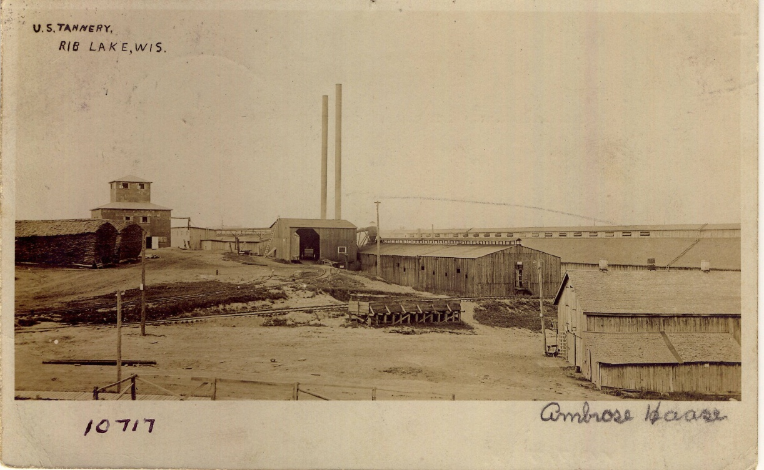 | The photo shows the tannery in the Village of Rib Lake about 1900. The tannery was constructed in 1891 on land purchased solely in the Fayette Delos Shaw in order to avoid creditors with claims against his father and other family members.  Fayette Delos Shaw bought the land from J.J. Kennedy and entered into a complex contract with Kennedy that, among other things, set a deadline for the tannery construction and operation and required cooperation with Kennedy’s sawmill in acquiring hemlock logs.  The view looks northward across Fayette Avenue. The objects from left (west) to right (east) are as follows:  1. Two piles of hemlock bark over 20 feet tall and sporting a gable cap made from bark in order to divert rain and allow long-term bark storage.  2. The multi-storied “Pan house,” portions of which have been extensively remodeled and are occupied as a private residence in 2016.  3. The twin chimneys served the power plant, which is not pictured. Fuel for the boilers was routinely waste wood shipped to the site by railroad from the RLLC mill one-half mile to the south.  4. The barn receiving house has a large door open to the camera and a wagon or railroad car inside. Hemlock bark was unloaded there and ground into small pieces to be mixed with water, sugar and other substances to release naturally occurring tannic acid from the bark. The concoction was colloquially referred to as “liquor.”  5. The long building on the horizon at the right is over 300 feet long and was the vat house. The building housed over a hundred wooden vats in which the “liquor” was mixed with the hides. Tannery Creek ran beneath the vat house and was freely used to dispose of spent liquor, fleshings, hair and other debris which was washed ¼ mile downstream via the creek into Rib Lake.  6. The building in the right foreground was for storage, including dozens of well-built sleighs used in winter to convey bark.  7. Not pictured but to the extreme right was the “beam house” where the hides were taken from the vat house for finishing. Finishing included rolling under pressurized rollers which resulted in gleaming brass surfaces on the rollers.  8. Note railroad track spurs throughout the tannery site. Standard gauge tracks of the St. Paul, Minneapolis, and Sault Ste. Marie railroad, the “Soo,” ran throughout the tannery site. The trackage provided convenient movement of tanbark by railroad to the tannery as well as shipment of finished hides throughout the country. The tannery owned its own “dinkey,” a small gas-powered locomotive used for switching.
1902 | Anna May Kennedy collection via Joe Heisler | 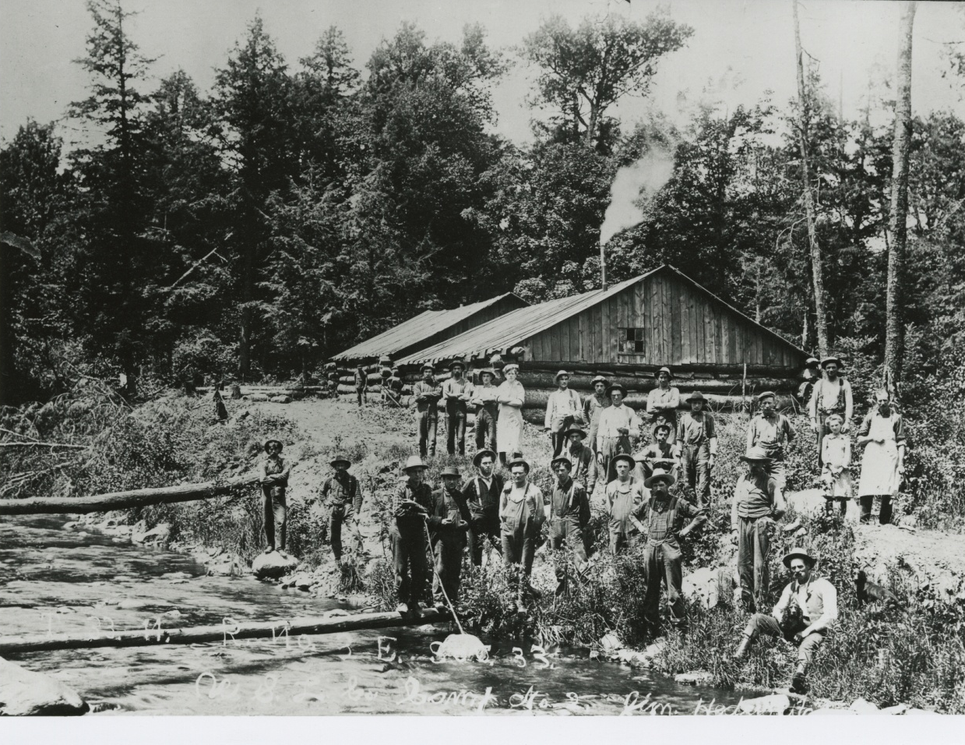  #10792 | Text accompanying photo reads: “United States Leather Co. Camp 2 in Section 33, Town 33 North, Range 3 East, James Hedrington, foreman.”  This was a bark camp in 1902 where its 26-man crew exclusively peeled hemlock bark to produce tannic acid at the Rib Lake tannery.  The man wearing the white apron is the head “bull,” cook, who stands along Wood Creek and his cook shanty, which emits white smoke from his cook stove. To the rear is another log cabin, the bunk cabin, where the camp crew – other than the cook and his crew – slept.  The United States Leather Co. of New York, New York, routinely operated one or more of its own bark camps every season, normally the months of May through July, when the sap was flowing in the hemlock trees, allowing its bark to be easily stripped. In addition to its own camps, the United States Leather Co. bought bark from sawmill owners like J.J. Kennedy, private “jobbers,” as well as farmers and others willing to do the arduous work.
2/14/1902 | TC STAR & NEWS | ADVANCE IN Hemlock – Important Meeting OF NORTHWESTERN HEMLOCK Manufacturers’ AssociatioN -- The prices of hemlock lumber were advanced by the Northwestern Hemlock Manufacturers’ Association at its meeting in Milwaukee last week. The advance is from 50 cents to $1 a thousand feet, according to the grade.  The following officers of the Association were elected: President, J. T. Barber, Eau Claire; Vice-president, W. A. Holt, Oconto; treasurer, A. K. Week, Stevens Point; secretary, F. W. Shepard, Chelsea, (Taylor County).  A Milwaukee paper says that members of the Association say that the advance in the price is not due to the greater cost of manufacture, but to the fact that hemlock is becoming scarcer and the fact that the prices of pine lumber have advanced and the hemlock stuff (sic) always follows. An incomplete roll call developed that the members had on hand 70,000,000 feet and that they will make in the neighborhood of 145,000,000 feet the coming season  Mr. F. W. Shepard was also appointed chairman of the committee on the grading of the product, and Donald Kennedy [a son of J.J. Kennedy] of Rib Lake was appointed a member of the same committee. B. W. Davis of Phillips was appointed a member of the committee on prices. | Donald Angus Kennedy, born October 30, 1876 in Spencer, Wisconsin, was the oldest of J.J. Kennedy’s children; as soon as he came of age, he worked at his father’s lumber company office and served as an executive secretary when his father sold out to W. A. Osburn in September, 1900.  The W. A. Osburn Lumber Co., which stationery advertised “Hemlock & Hardwood Lumber,” promptly hired Donald A. Kennedy to continue at the office as both a corresponding and executive secretary; e.g. on 4/27/1902 Donald drafted correspondence and signed on behalf of W. A. Osburn Lumber Company; image #10667. Donald signs the paperwork changing the corporate name to Rib Lake Lumber Company on 5/6/1902.
4/4/1902 | TC STAR & NEWS | TANNERY SUITS ARE SETTLED – CASES STARTED TWO YEARS AGO – Damage suits aggregating $72,000 brought against Thaxter Shaw, et. Al., by farmers in Taylor County were settled out of court this week for $1,500 a piece, each of the parties to the actions pay their own costs.  The plaintiffs in these actions, which are usually called the “tannery cases,” were John Berngruber, Nick Schafer, Simon Erickson, Carl Herman, Michael Zenner, Joseph Kranig, Carl Zimmerman, Conrad Blumenstein and Maury Erickson, all of whom owned farms along the Little Black River south [of Medford]. The defendants in the cases were the owners of the local tannery before its sale to the United States Leather Company. About 3 years ago an epidemic of anthrax killed a number of the cattle and horses owned by these farms and it was claimed that the germs of the disease came from the tannery, polluting the water in the river.  By the river water overflowing the land belonging to the plaintiffs it was alleged that the disease germs were planted on their farms and it was sought to recover both for the actual loss of stock and for damage to the property.  The suits were commenced March 12, 1900, by Bouck & Hilton of Oshkosh, and after various delays, were set for trial at Stevens Point…. A settlement was made before the trial was begun, and the actions dismissed. Schweppe & Urquhart of [Medford] represented the defendants. | The defendants were Thaxter Shaw and his brother Fayette M. Shaw and his son, Fayette Delos Shaw.
1/6/1903 | Journal #2 of the Ogema Lumber Co. at Ogema, WI. | 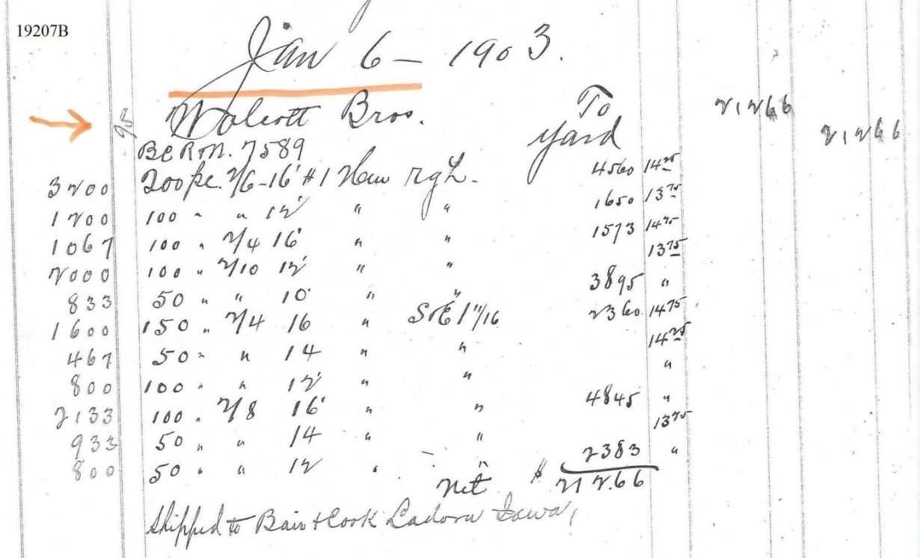 | This 1903 record details the sale of “hemlock rough [unplanned]” by the Ogema Lumber Co. to Bair & Cook Lumber Co. of Ladora, Iowa, for $212.66.  Journal #2 of the Ogema Lumber Co. is truly a treasure trove of information regarding hemlock lumber and wood products. In meticulous detail, a chronological record was kept of hemlock sales by the Ogema Lumber Co. throughout 1903.  At that time, hemlock lumber made up over 90% of its lumber sales. Image 19207B is shown on the left.  1. The date of the transaction was Jan. 6, 1903.  2. The “Wolcott Bros.” was a lumber brokerage through which most of the Ogema Lumber Co. out of state sales took place.  3. “BCRM 7589” is the number of a railroad boxcar and the initials of the railroad that owned it.  4. At the very bottom of this entry: “shipped to Bair & Cook [lumber company] Ladora, Iowa.”  5. The column of numbers at the far left indicate board feet, “3200.”  6. The next column reads “200 pc” indicating 200 pieces, i.e. boards in the transaction.  7. The next column reads “2/6” which stood for a board 2” high and 6” wide.  8. The next column “16’” indicates a length of 16 feet.  9. The next column reads “#1” indicating grade #1, knot-free, defect-free clear wood.  10. The next column reads “Hem rgh” standing for rough, i.e. unplaned hemlock.  11. The next column reads “45.60.” That figure was obtained by multiplying the figure in the next column, “$14.25,” per board foot times the 3200 number in column 1. In other words, the 200 pieces of 2x6x16 of hemlock cost $45.60.  12. The meaning of the phrase “to yard” is currently not certain. It is probably some form of an accounting mechanism.  13. The final, rightmost, column reads “212.66,” i.e. grand total of items sold in this transaction was $212.66.  At the time this entry was scanned, the journal belonged to Alfred Unick of Rib Lake. He indicated that it was his intention to donate the journal to the German Settlement Historical Society located in the Town of Spirit, Wisconsin. As of 8/16/2015, the Rib Lake Historical Society Document & Photo Collection contains copies of approximately 100 transactions of the Ogema Lumber Co.
4/25/1903 | Ogema Lumber Co. Ledger; scanned as #19207 | The Ogema Lumber Company of Ogema, Wis., sold “hemlock flooring #1” to C.A. Anderson of the Town of Brannan; the cost was $14.00 per 1000 board feet. | Today, 10/31/2015, hemlock is considered a soft wood and inappropriate for use as flooring. This sale demonstrates that the ubiquity and low cost of hemlock resulted in sawmills getting rid of their vast quantities of hemlock in uses which, to the modern eye, would appear inappropriate. This sale is a good example.  While the ledger does not say so, the hemlock flooring sold to Mr. Anderson was already probably planed.  This ledger contains hundreds of hemlock transactions. A representative number have been scanned into the Rib Lake Historical Society Document & Photo Collection.
11/28/1903 | The Sentinel, l/k/a The Milwaukee Sentinel, “Heard in the Hotels.” |  | As of January 17, 2016, R.P. Rusch has not been able to confirm the claim that the RLLC, in 1903, was the world’s largest hemlock sawmill. When the RLLC of Delaware, in 1936, was sold, the Milwaukee Journal reported that its sawmill was the largest sawmill in Wisconsin “in capacity.”
1/8/1904 | Rib Lake Herald | “LARGEST IN THE WORLD! “The RLLC is the Largest Hemlock Manufacturer in the World. 25 million feet to be cut this season. The lumber cut throughout the country will generally be less than last year.”  “Milwaukee Sentinel, Nov. 28 “The Board of Directors of the RLLC held a meeting in this city [Milwaukee], which was attended by a number of the businessmen of the southern Wisconsin towns. Among them were H. Sanborn of Ashland, Wisconsin, L.R. Rousseau and H.C. Miller of Rib Lake “The company is the largest hemlock lumber producing concern in the world.”Said Mr. Miller, at the Republican [hotel], “and her cut will be as large this season as last. My opinion is, however, that the lumber cut will be generally considerably less. We expect to put in about 25,000,000 feet of hemlock.” (emphasis added)  “J.J. Kennedy, the former owner of the Rib Lake plant, has engaged in the lumber business in Idaho, and in company with his sons and brother, is building a large mill for the manufacture of pine lumber. A number of his former employees have gone out there and as a result northern Wisconsin will have a considerable addition to the lumbermen operating in Idaho pine.” | As of 11/10/2013 R.P. Rusch has no verification that the RLLC was, in 1904, the world’s largest manufacturer of hemlock lumber. The claim is plausible for a variety of reasons, including:  A) Wisconsin, between 1895-1905, was the leading producer of lumber in the United States;  B) Rib Lake lay in the center of a massive stand of hemlock;  C) J.J. Kennedy, by the mid-1880’s, had enthusiastically switched his attention from pine to hemlock;  D) Kennedy’s new mill, constructed in 1897 in Rib Lake, was a state-of-the-art operation. R.P. Rusch
c. 1905 | Rib Lake Historical Society | 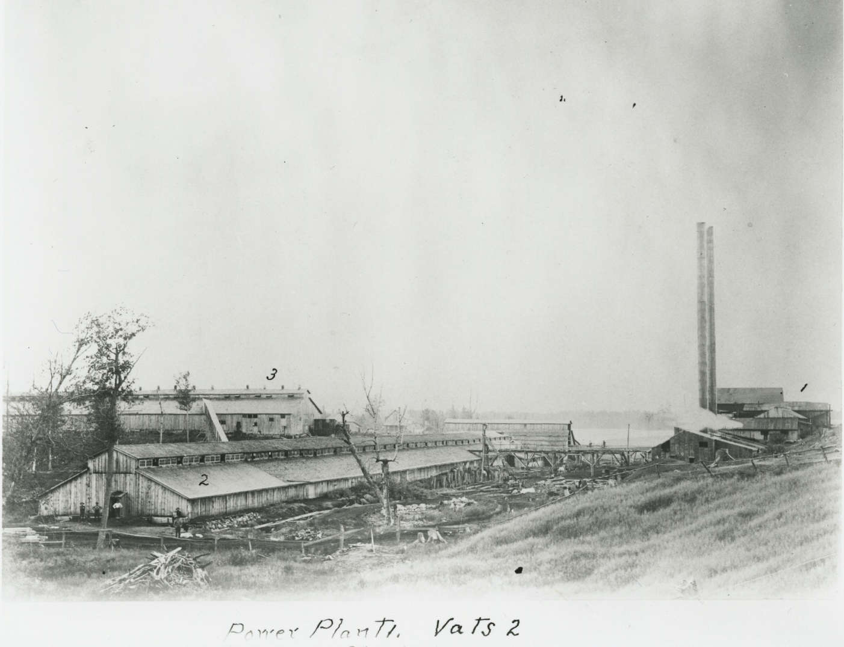  #10789 | Photograph looks south over the Rib Lake tannery complex owned by the United States Leather Co. of New York, New York.  The twin towers at the right stand next to the boiler room.  The building marked “2” in the center is the vat house, extending over 300 feet long and built on concrete pilings over Tannery Creek, and housing hundreds of wooden vats in which a concoction called “liquor” soaked cow hides to be turned into sole leather; the major ingredient in liquor was ground hemlock, called “tan bark.”  The building at the hill at left marked “3” is the beam house, where the soaked hides were hung from the ceiling to dry. Later the hides were pressed and stretched by power rollers, creating shoe leather.  Tanning operations at Rib Lake permanently closed in 1922; some say that the closure was due to the discovery of synthetic tannic acid by a German chemist, making the use of tan bark from the environs of Rib Lake too costly and uneconomical.
c. 1905 | Rib Lake Historical Society | 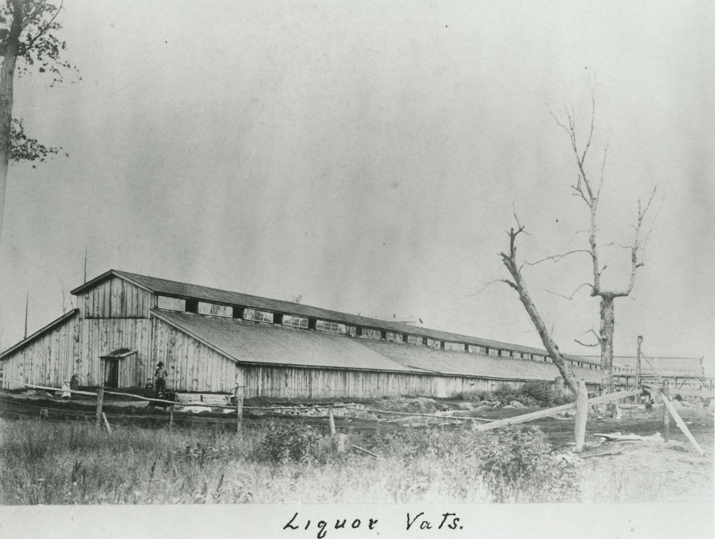  #10790 | View looking south at the Vat House of the United States Leather Co. tannery at Rib Lake. The building housed hundreds of wooden vats in which cow hides, many imported from the American west, as well as Argentina, Australia and China, were soaked in a concoction called “liquor,” the major ingredient in which was tannic acid obtained from hemlock bark.  The Vat House was built on concrete pilings erected on either side of Tannery Creek, which emptied into Rib Lake ¼ mile to the south. Unbothered by any environmental rules or regulations, the company routinely emptied the spent liquor, including hair and fleshings, into the creek. In summer, this polluted water created a stench pervading the Village of Rib Lake.  The tannery site was purchased by Fayette Delos Shaw in 1889, who called its location and amenities the best tannery site he had ever seen. The liquor house was over 300 feet long; note the change in the roof suggesting the liquor house had been enlarged. In 2017, the 5 foot high sloping concrete pylons that formerly supported the liquor house are the only extant remnants of this once mammoth building.
c. 1905 | Image #21015 Rib Lake Historical Society | 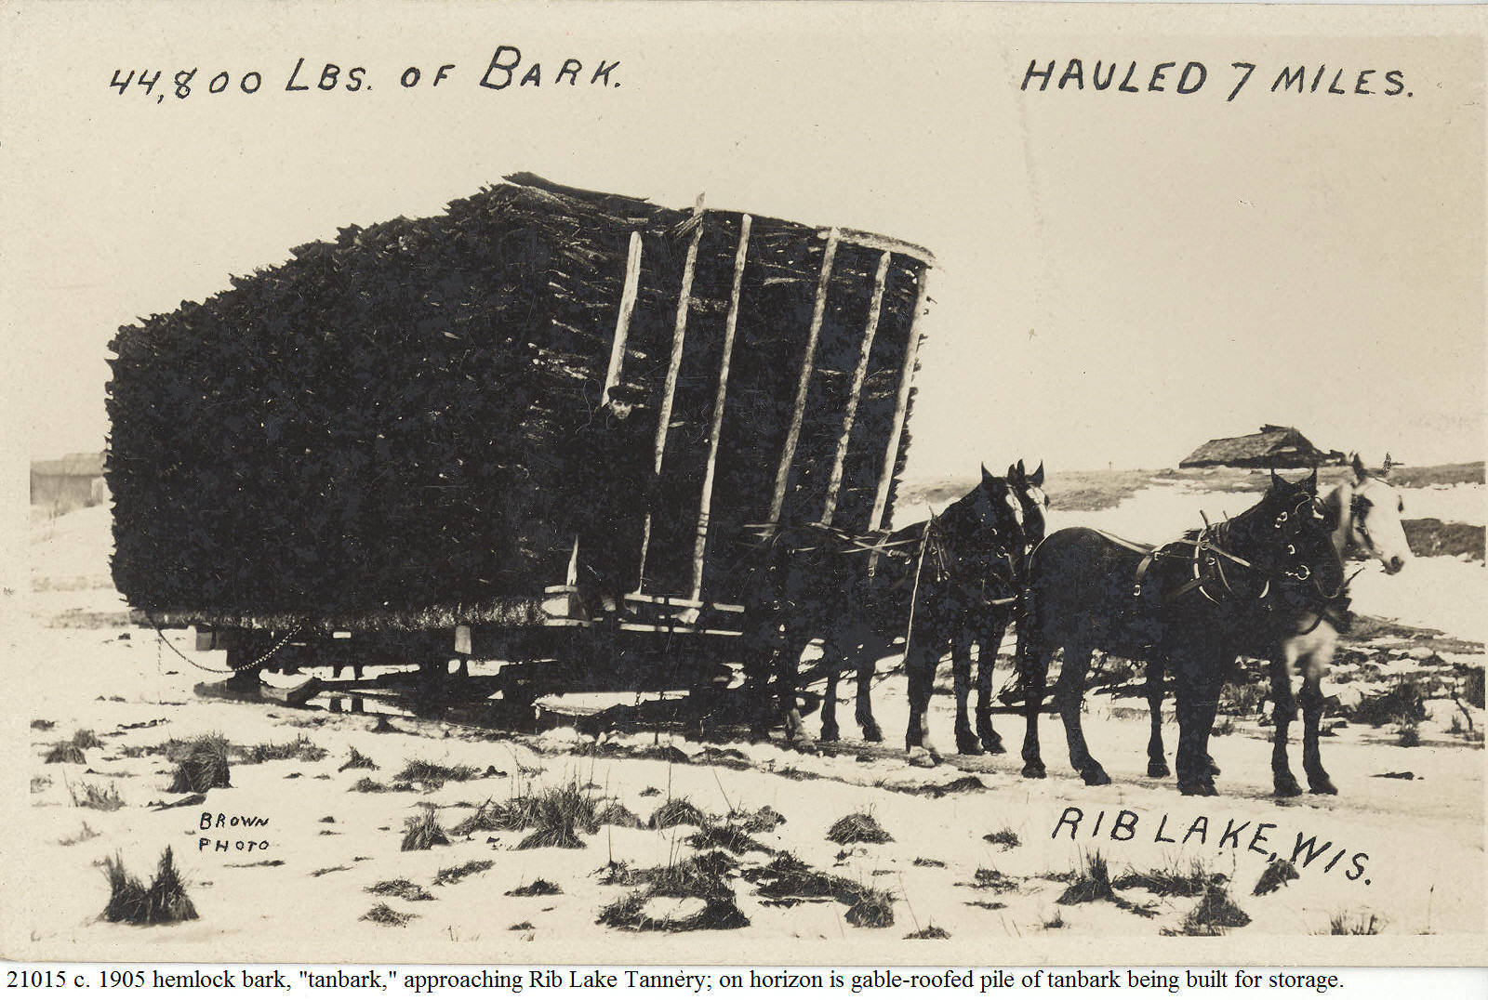  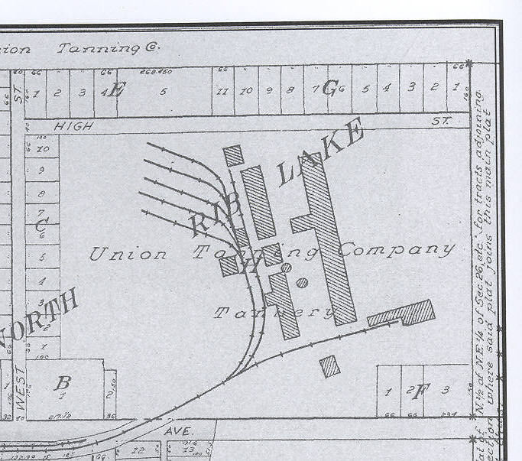 | When tannery founder Fayette Delos Shaw purchased the real estate for the Rib Lake Tannery in 1891, the grantor, John J. Kennedy, inserted a provision in the deed prohibiting the grantee from blocking an important sleigh road on which logs were hauled to the Rib Lake sawmill.  The same sleigh road was extensively used to haul tanbark, which was routinely stored in monstrous 20 foot high piles of bark, capped with a waterproof gable top in 300 foot piles to the west of the tannery. This photo on its horizon shows such a tanbark pile being built. Building the pile was done by a crew of men handling each piece of the bark in “bucket brigade” fashion. The last person would carefully place the bark to form a peaked pile from which rain would run off.  The tanbark piles at the Rib Lake Tannery were in parallel lines between which ran standard gauge railroad track. These tracks junctioned with the Wis. Central Railroad and allowed railroad transport of tanbark.  For map, see illustration at left taken from 1913 Standard Atlas of Taylor County. It shows the size of the Rib Lake Tannery buildings north of Fayette Avenue in the Village of Rib Lake as well as the standard gauge railroad lines connecting to the Wisconsin Central Railroad.
1907 | Wisconsin 1934 Regional Plan Report | TOTAL WISCONSIN HEMLOCK CUT EXCEEDS THAT OF PINE  “In 1907, the hemlock cut [in Wisconsin], 785,522,000 board feet, exceeded the white pine cut for the first time and hemlock since that year has declined much less rapidly than white pine.” | Major portions of this book have been scanned as #18128. The page in question is #18128P.
1907 | Dennis Kuehling collection | 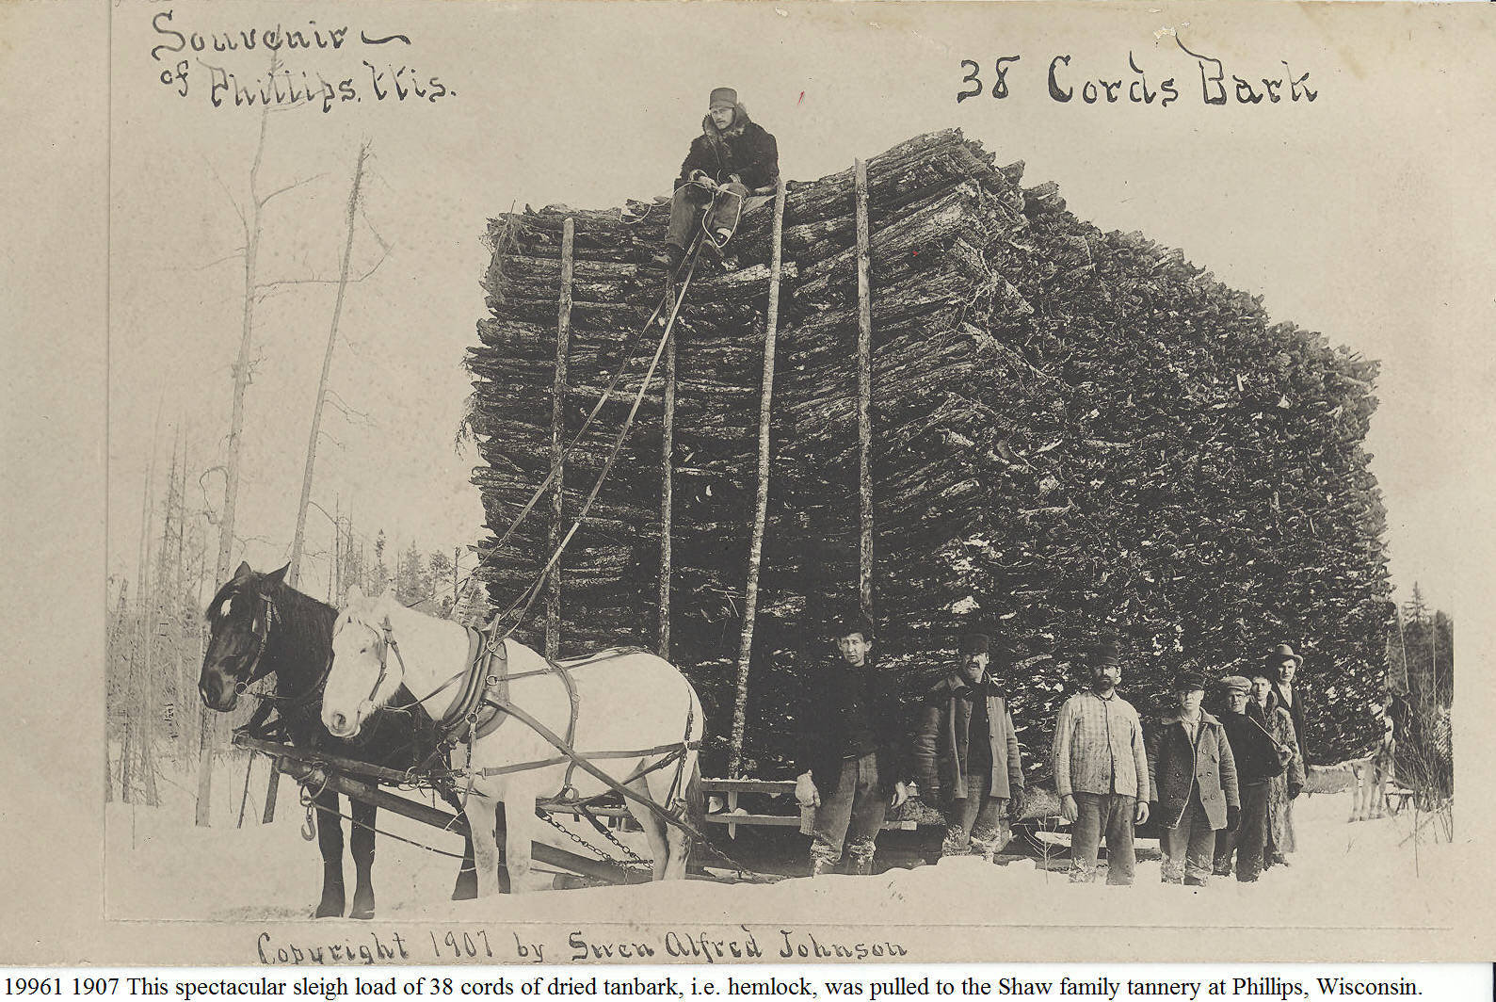 | In addition to their tanneries at Medford, Perkinstown and Rib Lake in Taylor County, the Shaw family bought out the Westboro tannery and built others in Prentice & Phillips, Wisconsin.  While dried tanbark is bulky, it is relatively light. This load is 12 feet wide, consisting of 3 piles of 4 foot long tanbark. The teamster sits on the center pile.  This was obviously a carefully posed photo. A tanbark cord was originally 4x4x4 feet; later a cord was defined by weight.
1910 | Ben Kauer collection | 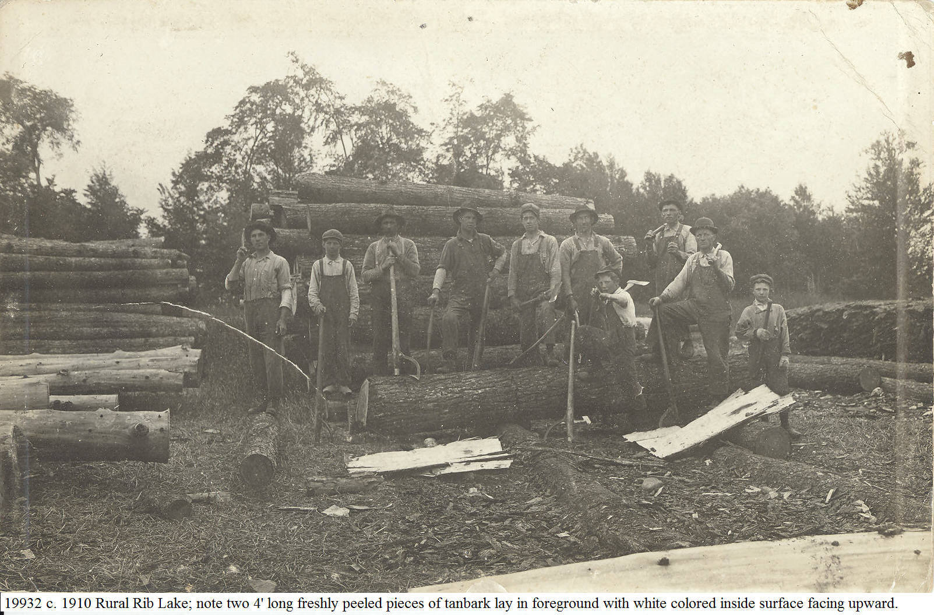 | While the men on the left are holding cant hooks and have paused from decking the hardwood in the center of the picture, this photo contains important views regarding hemlock. On the far right is a long pile of hemlock bark, “tanbark.” The bark had been previously peeled and air dried in the woods, this picture was taken in the fall when the tanbark had been transported to this site and piled in a long pile awaiting transportation to the tannery.  The man wearing a hat on the far right holds a bark peeling spud over his right shoulder. A hatchet lays on the ground beneath the large horizontal log. The hatchet was used to cut the hemlock bark on a freshly felled tree into 4-foot sections.  At the extreme bottom side of this photo can be seen a part of a freshly peeled hemlock log.  At the foreground on the left are peeled hemlock logs that have been rolled to form the first course of a hemlock log pile.
1910 | Stanley Hebda, Village of Rib Lake | 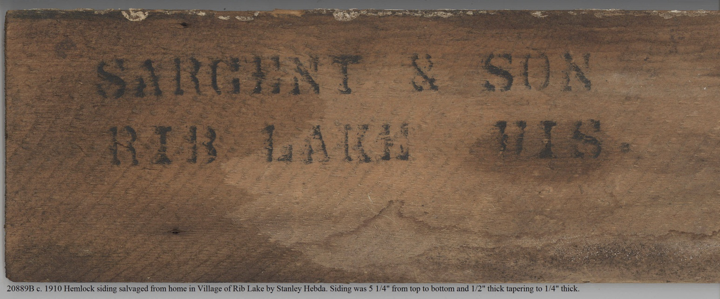  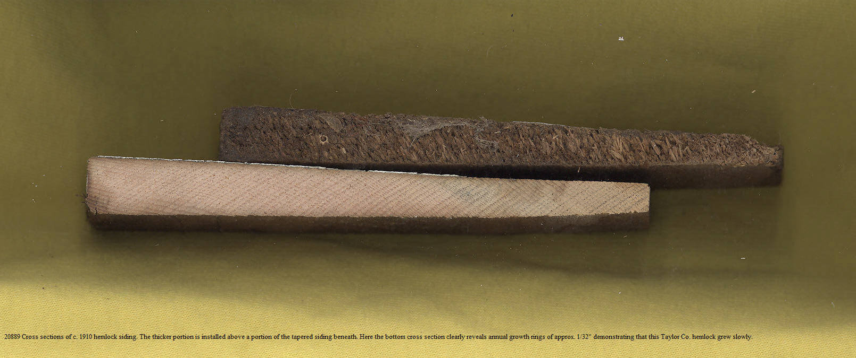 | Hemlock dimensional lumber & siding was manufactured by a variety of north Wisconsin sawmills, especially after pine was exhausted.  Cross sections of hemlock siding. The one at the bottom reveals annual growth rings of approx. 1/32” per year, indicating slow growth in the well-stocked, crowded virgin forests of Taylor County, Wisconsin.
1910 | Chet & Bernie Brahmer photo collection; image 19780 | 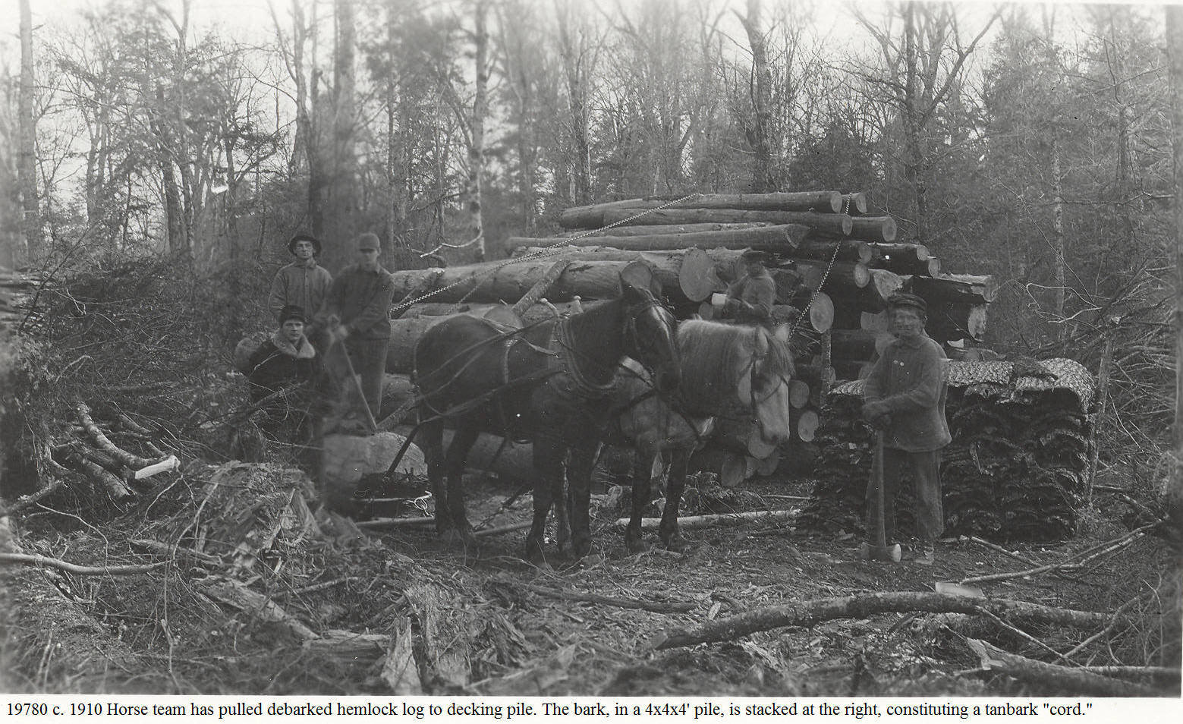 | This rare photo shows a tanbark cord in the woods. Several months previously the hemlock bark had been stripped from the tree. The bark had been loosely piled against stumps, saw logs and whatever else was handy to have it air dried. After drying, the bark was piled, both for storage and to allow a tallyman to determine that it met specifications. In the next winter the bark would be transported to the tannery, in all likelihood by sleigh, steam hauler and/or railroad.  Picture taken by George Knower, store owner and postmaster at Interwald, Wisconsin.
1/10/1910 | Letter of Simon Kortenkamp to relatives in Iowa written from Rib Lake, Wis., part of image #14896B | PORTION OF LETTER OF JAN. 10, 1910, BY SIMON KORTENKAMP, THEN RESIDING IN TOWN OF RIB LAKE, TO RELATIVES IN IOWA:  “The sleighs are different [in Rib Lake] than those used in Iowa. The [Rib Lake] lumber company sleds are seven feet wide with runners eight foot long and four inches wide. Their racks will hold three tiers of [hemlock] bark (which is four feet long) and the length of the rack is 24 feet.  “One man made a bet he could haul 32 cords of bark seven miles to town [the Shaw tannery, then in the Town of Rib Lake] with his two horse team and he won it. You can figure it our yourself how high he had to pile his load. A cord of bark weighs 2,240 pounds, which made the load quite heavy.” Simon Kortenkamp | George Corrigan’s article, presented at a meeting of the Wisconsin Forest History Association, and recently cited to me by John Bates, provides confirming details:  A) “The bark was scaled by measurement, but sold by weight of 2,240 or 2,280 pounds for a cord.”  B) “Bark peeling season was a lesson in good planning, management and cooperation. First, before the peeling season started, strips would be run out in the plots of hemlock to be peeled. This was contract labor; so much for a cord, trees cut with bark being cut in 4’ 4” or 4’ 6” lengths…”  Simon Kortenkamp’s reference to a big load of tanbark being hauled 7 miles may refer to the photograph #21015, a copy of which is entered under the date c. 1905 in the “Great Hemlockery.”  I want to give credit and thank Professor Daniel Kortenkamp and author John Bates for their assistance in this entry. RPR
6/7/1912 | Rib Lake Historical Society, LLC; Photo & Doc. Collection, image 18016: invoice #1009 for sale of #3 hemlock lumber to Schaller &McKey Lumber Co., Janesville,, Wis. | 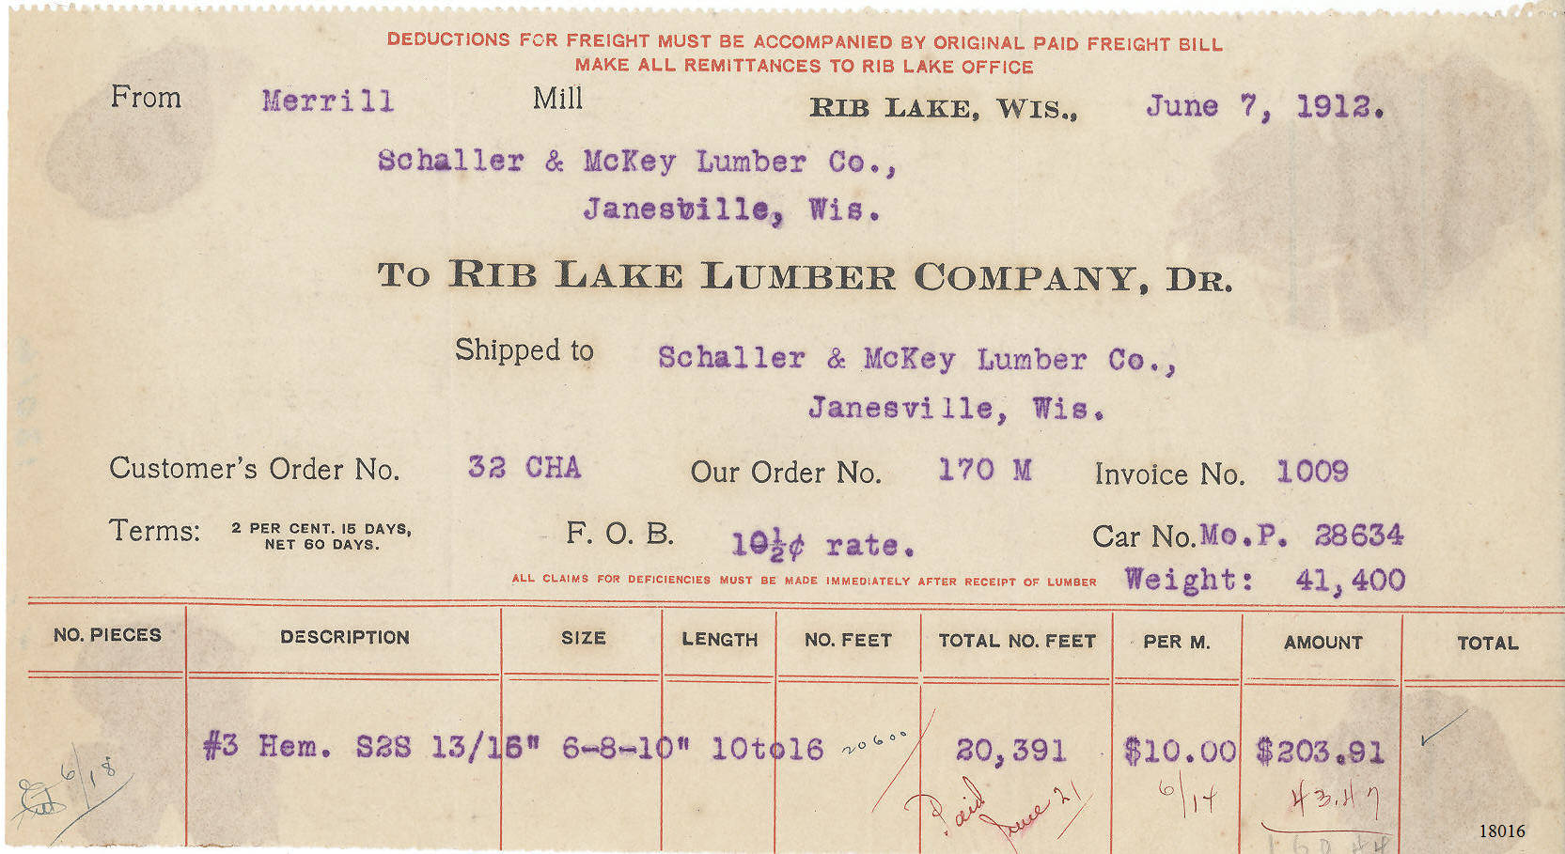 | This invoice covers a #3 grade of hemlock lumber in 6, 8 & 10” widths; #1 grade had no defects or knots.  The transaction was for 170 million board feet at the rate of 10.5 cents per board foot. The RLLC would be paid $203.91 and would load the planed lumber onto Missouri Pacific Railroad Co. box car 28634. Apparently the buyer paid the shipping charges to have the railroad deliver the box car to Janesville, Wis.  The unexplained feature of this invoice is its statement that the transaction was “…from Merrill Mill…” As of 4/13/2014, the Rib Lake Historical Society, LLC, has no evidence that there ever was a mill of the RLLC in the City of Merrill, Lincoln County, Wis.  The RLH Soc. acquired the invoice via eBay March, 2014.
10/8/1912 | 150 Wisconsin Reports 500 | A lawsuit in the Supreme Court of the State of Wisconsin, KRUEGER VERSUS LAKE TRADING COMPANY appealed from a judgment of the Circuit Court for Taylor County. The decision of Taylor County Circuit Court Judge John K. Parrish was affirmed. | This case decided who should bear the loss when a pile of hemlock railroad ties were burned in a forest fire along a logging railroad in the Town of Rib Lake.  “The defendant alleged that the contract was that the railroad ties were to be delivered to it at Rib Lake, loaded on cars, and that in the business of buying and selling hemlock, tanbark, railroad ties and pulpwood at the VRL and vicinity, it was during all the times mentioned in the plaintiff’s complaint the general custom, practice and understanding of all people in said business that such forest products be delivered by the seller by loading the same on railroad cars and having such cars consigned to it at Rib Lake.”  “Under the uncontradicted testimony in this case, the question of place of delivery was provided for in the contract between the parties. It was either on the railroad track, as plaintiff testified, or at Rib Lake on board cars, as defendant claimed. That being so, evidence as to custom was erroneously received and should not have been considered by the jury…”
c. 1913 | Map, 1913 Village of Rib Lake with Rib Lake Lumber Company, tannery and railroad published in 1913 Standard Atlas of Taylor County. | 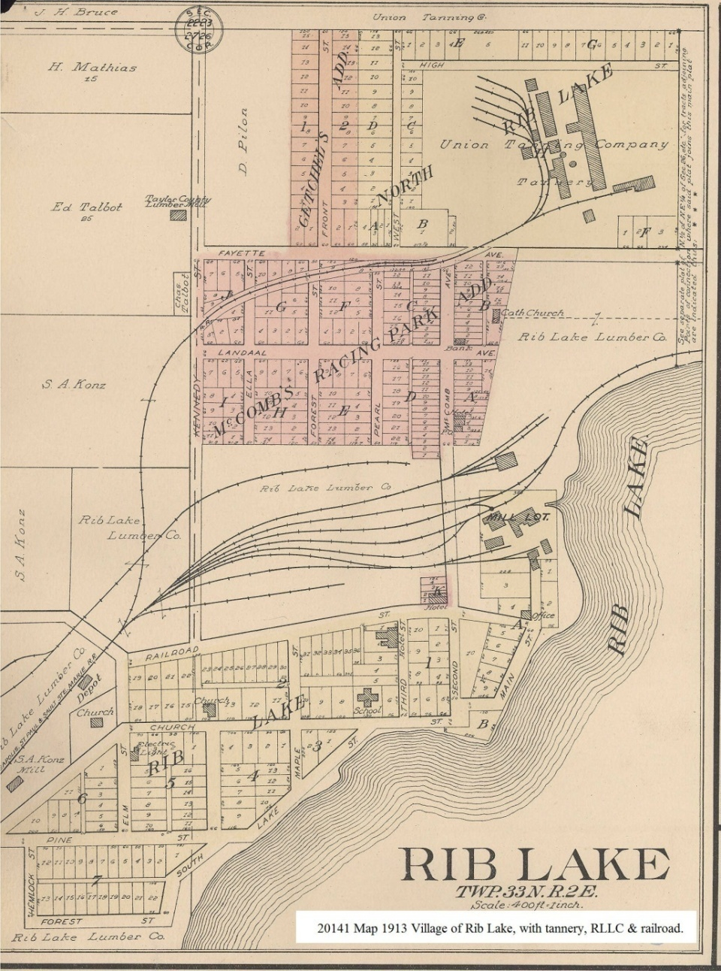 | The map shows Soo Line railroad trackage in the Village of Rib Lake, including the tannery. At the tannery the Soo Line railroad tracks split into five spurs, between which tanbark was piled in storage.
1913 | 1913 Standard Atlas of Taylor County | 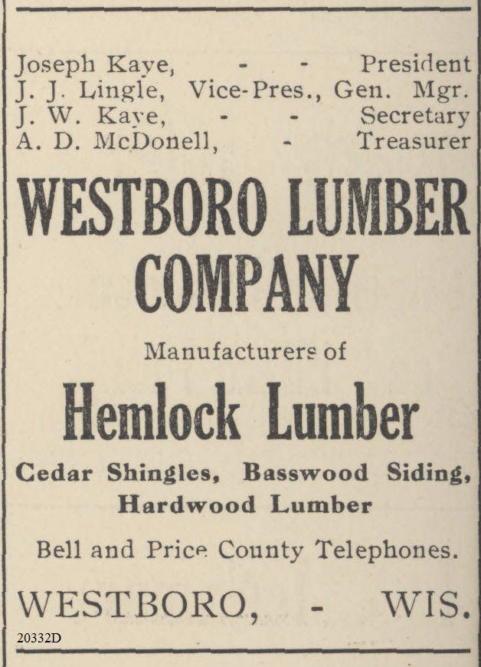 | The logging railroad of the Westboro Lumber Company penetrated the glacial moraines and eskers near the Mondeaux River in Taylor County. In 2017 major portions of that landscape are again covered in Eastern Hemlock as part of the Chequamegon-Nicollet National Forest.
1913 | 1913 Standard Atlas of Taylor County | 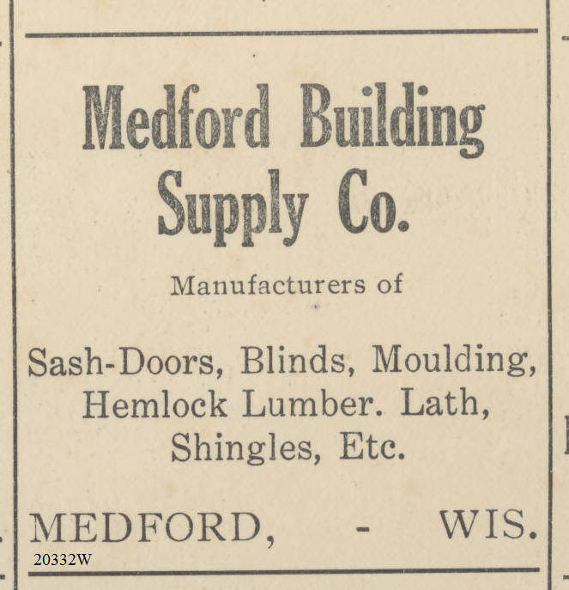 | Located on the Black River, the City of Medford, Taylor County, Wisconsin, once had sizeable pine sawmills. By 1913 the Medford Lumber Company was just 11 years away from closing its doors and the Medford Building Supply Company made no mention of pine being available.  While the qualities of hemlock lumber were clearly inferior to those of white pine, hemlock had one major attraction: it was cheap!
1913 | Standard Atlas of Taylor County | 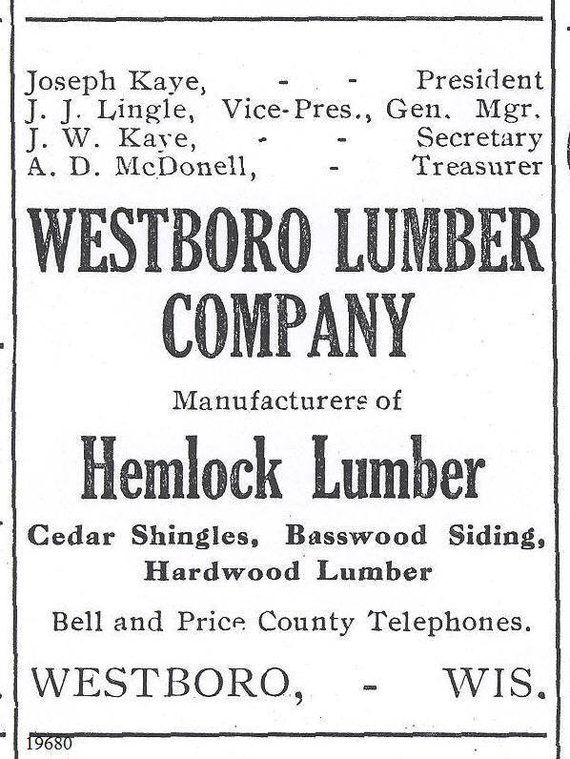 | The Westboro Lumber Co was the successor to the first sawmill built at Westboro; the first mill was constructed in 1873, prior to the creation of Taylor County, by John Duncan, William S. Taylor and James Ritchie.For more than a decade, it would not deign to cut anything other than white pine.  The second Westboro sawmill was built by S.D. Cone, taken over by Levi &Heidrick and morphed into the Westboro Lumber Co.  The pictured advertisement boldly proclaims that the company is “manufacturers of HEMLOCK LUMBER…” Westboro Lumber Co closed in the 1920’s after its railroad had totally logged over the landscape as far west as the Mondeaux River.
6/4/1914 | Clark County Centennial Book: the Book of Years, the Story of Men who made Clark County in Pictures & Type for Clark County Centennial 1853-1953. |  | The flood of June 4, 1914, destroyed the town of Hemlock, Clark County, Wisconsin. N.H. Withee had constructed a dam and grist mill at the site about 7 miles north of Neillsville. The town was named for the vast number of hemlock trees that dominated the virgin forest there and the vast quantities of hemlock logs annually floated to sawmills past the town site.  In 2014, the site looks entirely natural, except for scattered pieces of broken concrete. Dairy farms and hardwood forests have replaced the hemlock trees which once flourished there.  Photo generously loaned by Dennis Kuehling.
1916 | 1916 Taylor County map by C.H. Paetzold, now in the archives of the Rib Lake Historical Society, LLC. | 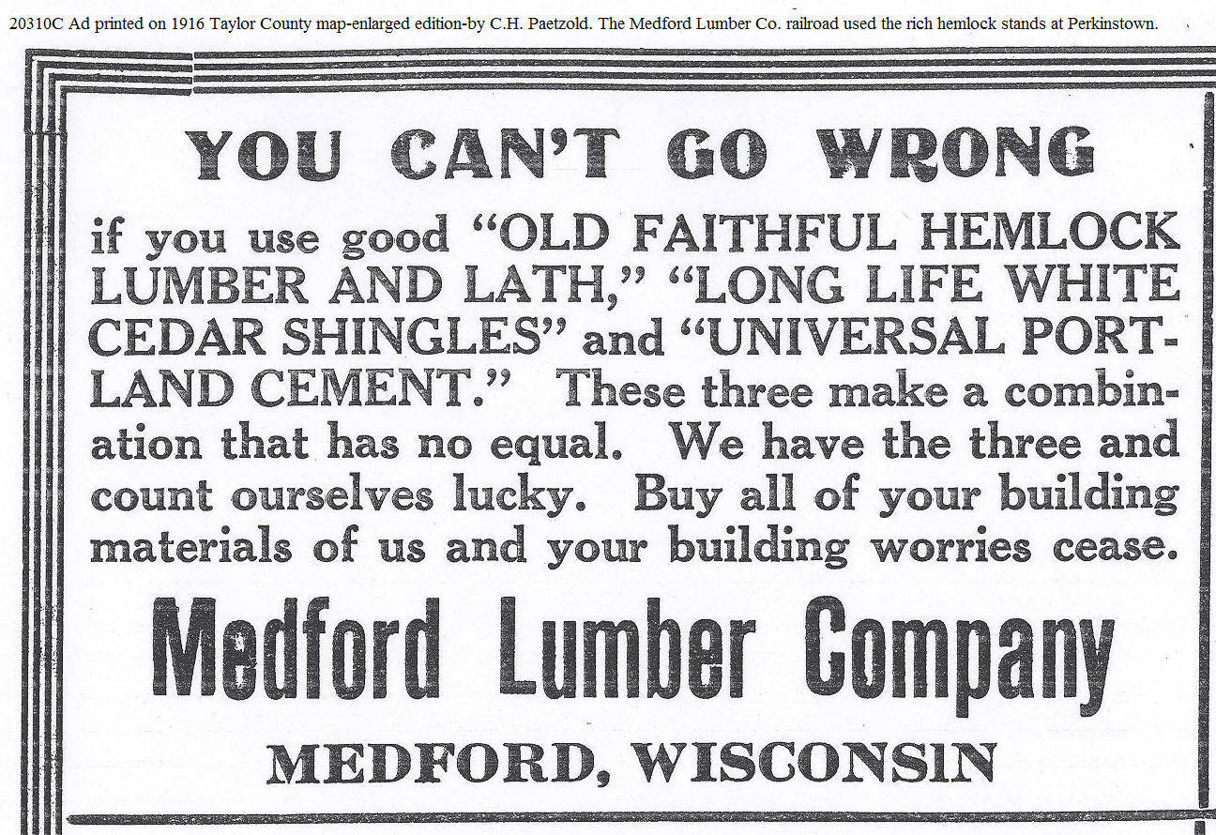 | The ad uses almost religious tones to describe hemlock. The Medford Lumber Company was located on the Black River and initially used river drives.  By 1916 it had extended its logging railroad far to the north and west to exploit magnificent stands of hemlock in the glacial hills near Perkinstown, Taylor County, Wisconsin. Lath was nailed to interior stud walls of homes and commercial structures. Wet plaster was troweled over the lath to form a wall that would be painted or wall-papered.  “Lath & plaster” walls consumed large quantities of hemlock. Eventually sheetrock or wallboard largely took its place.  Since lath was made in 4 foot lengths less than 2” wide and only ¼” thick, it was routinely made from wood that would otherwise be scrap.
1916-1948 | Rib Lake Historical Society, LLC | 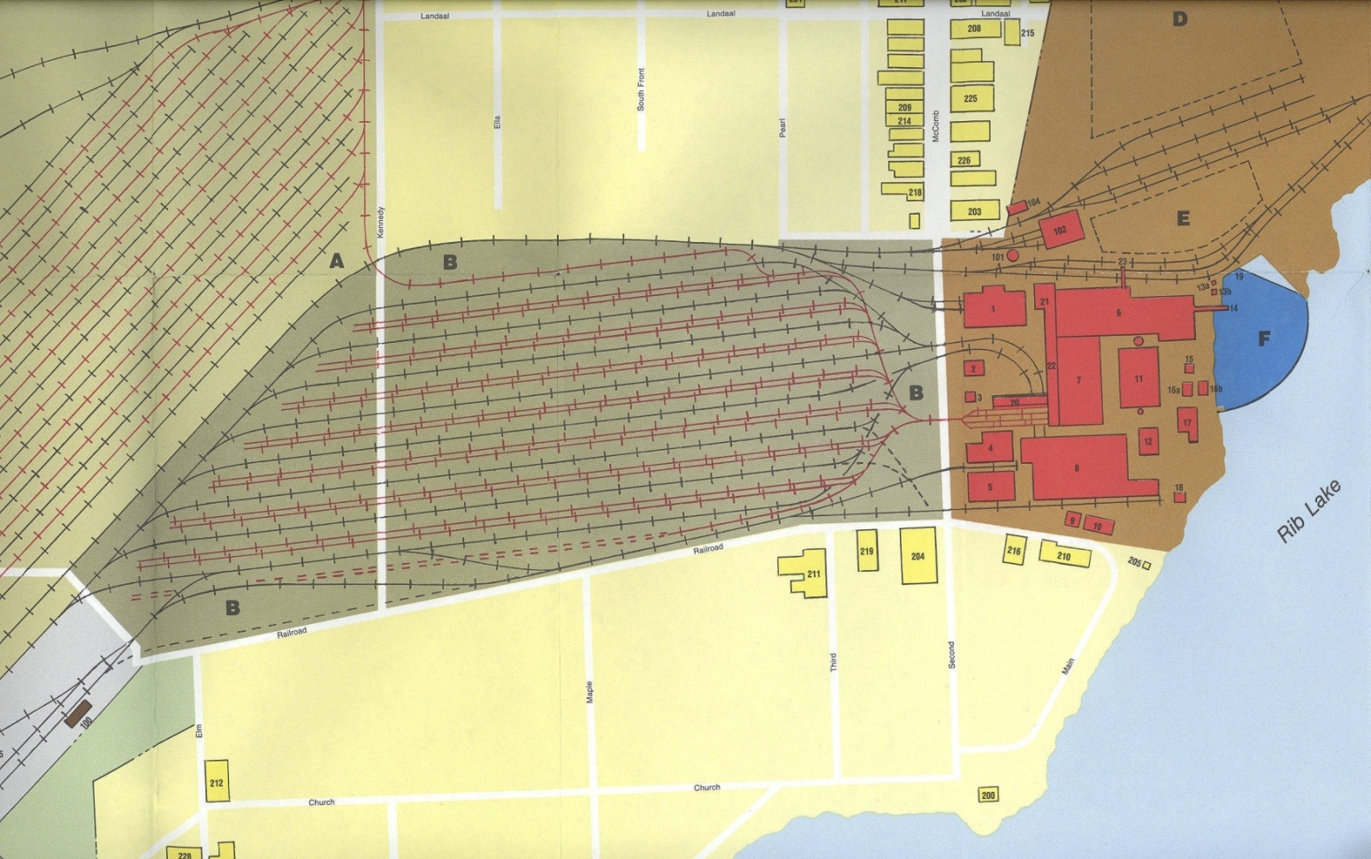 | This is a portion of the “Map of Rib Lake and Environs” by Everett A. Rusch. The red portions are buildings of the mammoth sawmill complex of the Rib Lake Lumber Company built in 1916 and closing in 1948. During this timeframe the Rib Lake Lumber Company sawed principally hemlock.  To the left of the mill complex and marked “B” was the “Hemlock yard” where freshly sawn hemlock lumber was piled to air dry.  The hemlock yard was interspersed by railroad tracks. The tracks shown in red were narrow gauge, on which horse drawn tram carts loaded with freshly sawn hemlock lumber were moved by horse from the sawmill. The lines in black were standard gauge, on which the air dried lumber would be loaded onto flat cars for shipment on the Soo Line.  The two dry yards took up 50 acres. The RLLC sawed its last lumber on June 4, 1948.
c. 3/6/1918 | Merrill Daily Herald | 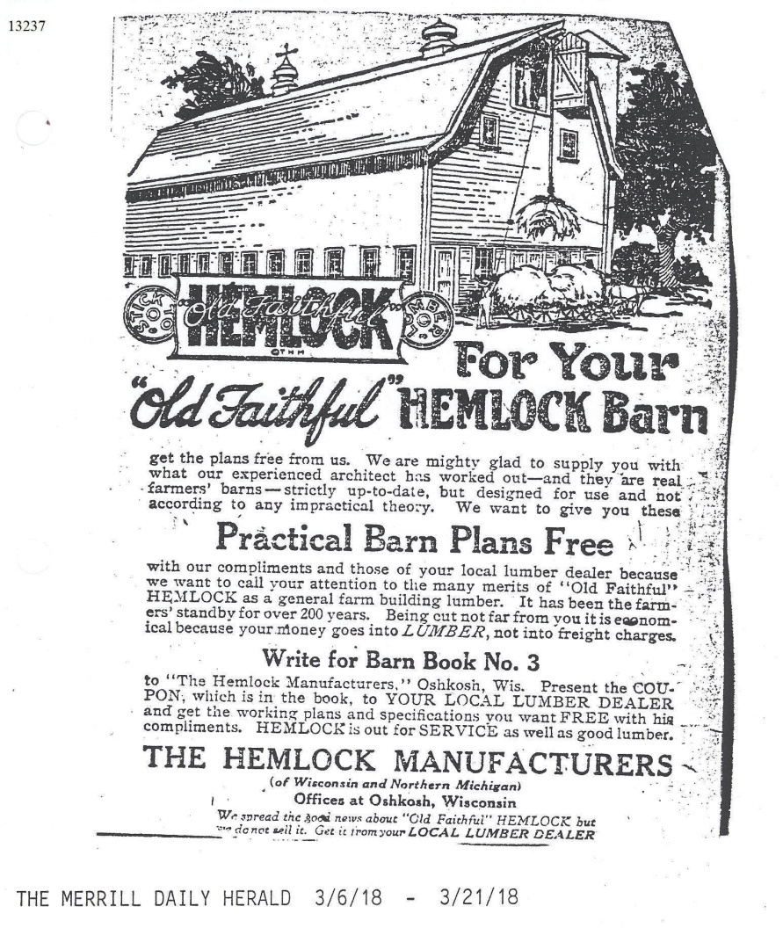 | Note that this advertisement was by “The Hemlock Manufacturers of Wisconsin and Northern Michigan.” Compared to white pine, hemlock lumber was undoubtedly a poor cousin. Hemlock lumber splits easily and rots quickly if exposed to moisture.  Nearly every butt log, “a shaky butt,” of virgin hemlock trees was hollow, making it totally unusable for lumber.  Note that this ad ran in a Merrill, Wisconsin, newspaper. In 2015, the Merrill Historical Society has opened a spectacular exhibit celebrating “The Pinery.” While Lincoln County had spectacular stands of pine where sandy soils predominated, the dominant tree on high lands on the loam soils of Lincoln County was hemlock; see map “Original Vegetation of Wisconsin.”  The City of Merrill had an impressive collection of sawmills, all along the Wisconsin River, which cut pine that had been floated downstream.  This ad was aimed at creating a market for hemlock. By 1918, most of the pine had been cut while much of the hemlock still stood.  Hemlock lumber sold for prices much lower than pine – a fact that the thrifty German American farmers of Lincoln County were sure to note.
3/1/1919 | “The American Lumberman” See #10960 | CAPACITY OF RLLC SAWMILL – 65,000 FEET OF HEMLOCK IN 10 HOUR SHIFT  “The present capacity is 65,000 feet of hemlock, or 50,000 feet of hardwood, in a 10-hour day. It is intended soon to install the other side [the second band saw], which, of course, will increase the capacity 100%.”  “Inventory of lumber at the Rib Lake Lumber Company sawmill on 1/31/1919 was 12,551,834 board feet of lumber, of which 2,562,785 feet was pine.” | Note that hemlock was easier and therefore faster to saw than hardwoods, i.e., leaf trees.  The inventory of lumber basically consisted of the lumber sitting in the dry yards air drying. Note that one-sixth was pine and the rest was hardwood and hemlock.
3/1/1919 | “The American Lumberman” see #10960 | “LARGEST SOLID BLOCK OF TIMBER IN EXISTENCE IN WISCONSIN….” “THE STAND IS PARTICULARLY FINE AND CONTAINS 70 PERCENT HEMLOCK….”  “This tract comprises two complete townships of Lincoln County, lacking only three forties. Adjacent to this vast tract, which is reputed to be the largest solid block of timber in existence in Wisconsin, are several other holdings of large size, so that combined the company controls outright more than 108 square miles of timber, conservatively estimated to contain 620,000,000 board feet and is rather expected to cut out 680,000,000 feet. The stand is particularly fine and contains 70 percent hemlock, 20 percent [yellow] birch and 10 percent mixed hardwoods, with a scattering of pine.” (emphasis added) | In 1919 the RLLC owned the “largest solid block of timber in existence in Wisconsin.” It was readily accessible by the Rib Lake mill via its logging railroad.  From the end of WWII in 1918 until the its sawmill sawed its last log on June 3, 1948, the vast bulk of the timber sawed by the RLLC came from this tract of land in the Town of Corning, Lincoln County, Wisconsin. It was virgin timber, except that the pine, which originally made up approximately 5% of the tract in volume, had for the most part been cut in the 1800’s.  Note that the estimate of “70 percent hemlock” was prepared and published by a reliable silvicultural source, “the American Lumberman.”
1920 | Photo taken 8/1970 by Robert P. Rusch of farm house built c. 1920 by Rib Lake carpenter Philip Bonde for farmer John Schwartz on SE ¼ SE ¼, Section 12-33-2E, Town of Rib Lake. | 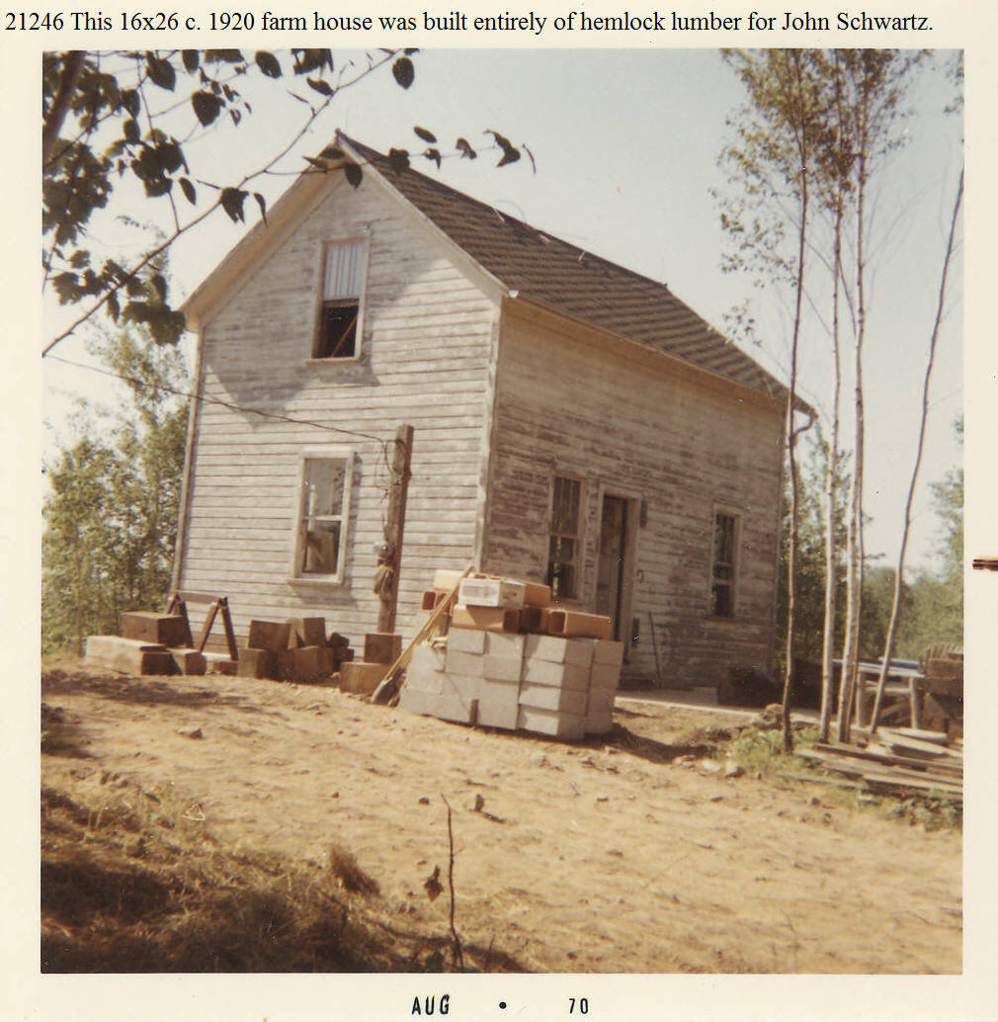 | In 1970 Karen & Bob Rusch were looking for a cabin they could erect on 200 acres of cutover land they had just purchased for $200 in Section 13-33 North, 2 East. Bob’s dad surprised them by telephoning and announcing that he had just “bought them a house.” Herman had been at Zondlo’s tavern and met Marlin Walback, who had purchased 80 acres of land acquired by Taylor County with an old farm house after foreclosing an old-age assistance lien.  Marlin offered the house for sale on the condition that it be moved and asked for $200. Herman immediately replied “that’s too much,” and counter offered $190.The deal was made and Herman then found a local contractor, Robert “Red” Thums, willing to move the structure the ½ mile on County Hwy C for “not more than $200 but not less than $90.”  The photograph shows this sturdily-built, all hemlock structure at its new location; two major additions have been added to it and it makes a cozy home for Kris & Katie Strobach in 2018 at N8643 County Trunk Hwy C.
1920 | Mike Roiger collection | 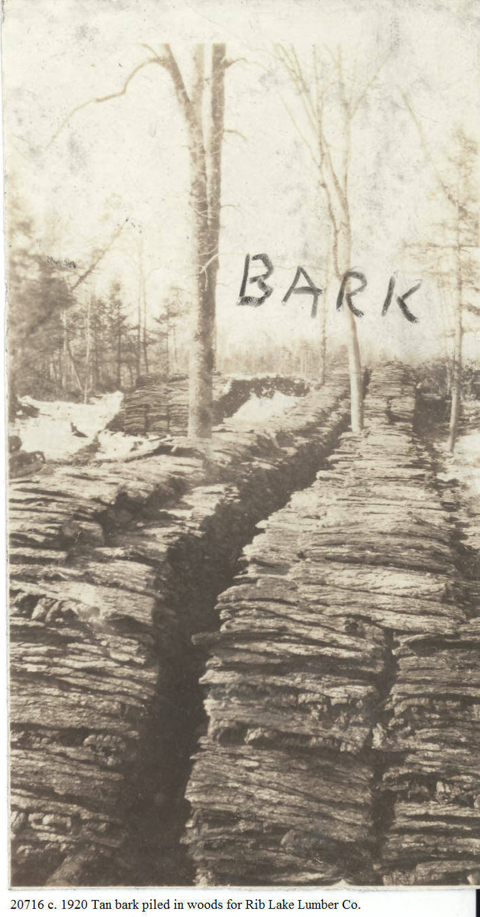 | Making hemlock tanbark required several steps. First the trees were cut in spring when the flowing within them made peeling of the bark possible. The peeled bark was first piled against stumps, rocks or other items to dry.  The next step is shown in this photograph. After the tanbark had dried, it was piled in the woods for temporary storage. Oftentimes these bark piles were inspected in order to determine the number of cords that were ready for the tannery.  All tanbark was cut into 4 foot lengths. Note that the tanbark piled in the foreground of this photo clearly shows the 4 foot length.  The picture was taken in the Town of Corning, Lincoln County, Wisconsin in the 1920’s when Lambert Lamberty was running one of his many jobber camps for the Rib Lake Lumber Company. Conveniently, at that time the United States Leather Co. of New York, New York, owned and operated both the Rib Lake sawmill and the tannery.
11/16/1920 | 173 Wis. 20 | SCHENNING VERSUS DEVERE & SCHLOEGEL LUMBER CO. | This is the 3rd lawsuit originating in Taylor County regarding the hemlock industry to be decided by the Wisconsin Supreme Court. Hemlock lumber had been sawed at either the Hintztown or Stumpville sawmills in the Town of Greenwood and delivered to the logging railroad track east of the Village of Rib Lake, where the hemlock lumber was piled awaiting shipment.  In summary, the plaintiff, Schenning, had the hemlock lumber sawed and contracted to sell it to the defendant. Schenning hauled the lumber and piled it along a logging railroad in the Town of Rib Lake for shipment to the defendant. After the first carload of lumber was shipped on 3/1/1916, the snow melted and the forest and fields dried out, making them prone for forest fires. The plaintiff wrote twice to the defendant alerting them to the extreme fire danger conditions and urging the defendant to have the lumber removed from the Town of Rib Lake: “you know very well that lumber piled close to the railroad, where there is dry grass and leaves, is in immediate danger every time a locomotive moves by,” wrote the plaintiff.  The Supreme Court determined that the defendants had dawdled in waiting too long to both respond to the last letter and to have the lumber removed before it was destroyed by a forest fire.
12/17/1920 | Rib Lake Herald | “A pine tree, said to be the largest in Lincoln County, was cut down by Pollack Brothers on their land at Heller. According to a Merrill paper, the stump was 56” in diameter and 4,713 feet of lumber scaled from the logs, of which 6 were taken from the trunk and 4 from the top.” | While this article describes a white pine tree, it was included to give reliable evidence regarding record-setting trees in the virgin forest.
2/24/1921 | Taylor County Leader |  | In 1921 the Medford Lumber Co. was still operating its logging railroad from Medford westward towards Perkinstown. This line tapped the rich and prolific stands of hemlock which dominated the virgin forests of Taylor County.
6/30/1921 | Taylor County Leader | 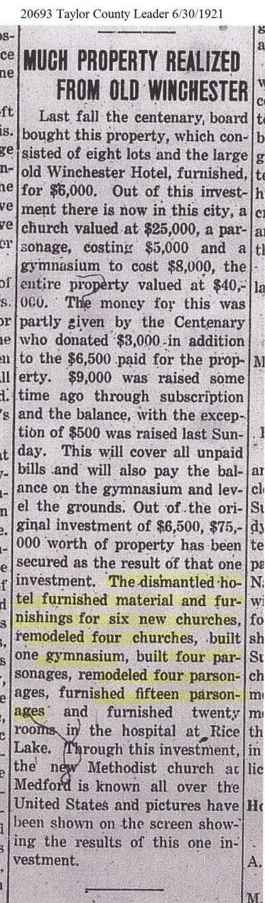 | The construction of the Winchester Hotel in Medford has been extensively covered previously in the “Great Hemlockery.” In summary, the hotel was built by J.J. Kennedy and other lumbermen in an effort to sell hemlock lumber; when lumber mills were first in Taylor County in the 1870’s, hemlock trees were shunned and never used for lumber; compared to white pine, hemlock was a beggar’s stepchild. The butt log of nearly every tree was hollow, the lumber was coarse and split easily and was not decay resistant to moisture.  In the 1880’s the Taylor County lumbermen were running out of white pine and were forced to find other trees to saw or go out of business. There was no shortage of hemlock available in Taylor County since it was the dominant tree in its virgin forests. Rather, the problem in manufacturing hemlock lumber was that at that time there was no market for it. The need for marketing spurred J.J. Kennedy and others to have a palatial 3-story hotel built on the highest hill in the City of Medford – totally constructed from hemlock. The lumbermen aggressively advertised the fact that it was a hemlock structure.  The marketing efforts were successful in the sense that the building withstood all high winds and the elements for over two decades. The hotel Winchester closed not because of its hemlock construction, but its inconvenient location and other social issues.  This article demonstrates that hemlock lumber is in fact superior in durability. All of the lumber from the razing of the Winchester Hotel was recycled and used to build the long list of buildings chronicled in the article. The newly-constructed buildings included the Methodist Church in Medford, which stood until approximately 1980 and was torn down, not because of structural defects but the desire of the congregation to have a more up-to-date architecture.  In short, the construction of the Hotel Winchester and the recycling of all of its materials made an irrefutable argument that hemlock lumber can be a durable construction medium.
2/2/1922 | Taylor County Leader | TANNERY SHUT DOWN  “The Rib Lake tannery was shut down tight last week. The only men left on the payroll are Superintendent McCullough and John Steffeck, the bookkeeper. The tannery has run steadily for nine years. It will start again when the company can dispose of the sole-leather in stock in their various warehouses. How soon that will be nobody knows. At present the demand for sole-leather is poor – Rib Lake Herald.” | The 1922 editions of the Rib Lake Herald are lost. Nearly all copies of the Rib Lake Herald from 1922 through January 4, 1939 are missing. This loss robs us of the ability to track the closure of the Rib Lake tannery. The tannery had periods of closure from time to time; note the report “the tannery has run steadily for nine years.” That implies steady operation of the Rib Lake Tannery from 1912 to February 2, 1922.  It is probable that this article marks the permanent closure of the tannery at Rib Lake.  In 1922 the RLLC and the Rib Lake tannery were both owned by the U.S. Leather Co., which had vast supplies of hemlock available in the Town of Corning, Lincoln County lands.  As of January 2, 2016, the reasons for the closure of the Rib Lake tannery are unknown. According to the late Herman A. Rusch, a German scientist had discovered how to make synthetic tannic acid. This discovery made the laborious collection, transportation and storage of tanbark uneconomical.  As of January 2, 2016, the well-constructed former boiler room/power plant of the former Rib Lake tannery still stands 200 feet north of Fayette Avenue on the west side of Tannery Creek. It is occupied by the Mann family as a private residence.
1922 | Letter by Irwin Maier to George Corrigan published on p. 30 of Some Historic Events in Wisconsin’s Logging Industry, 3rd annual proceedings of the Forest History Assoc. of Wisconsin meeting 9/9/1978. | 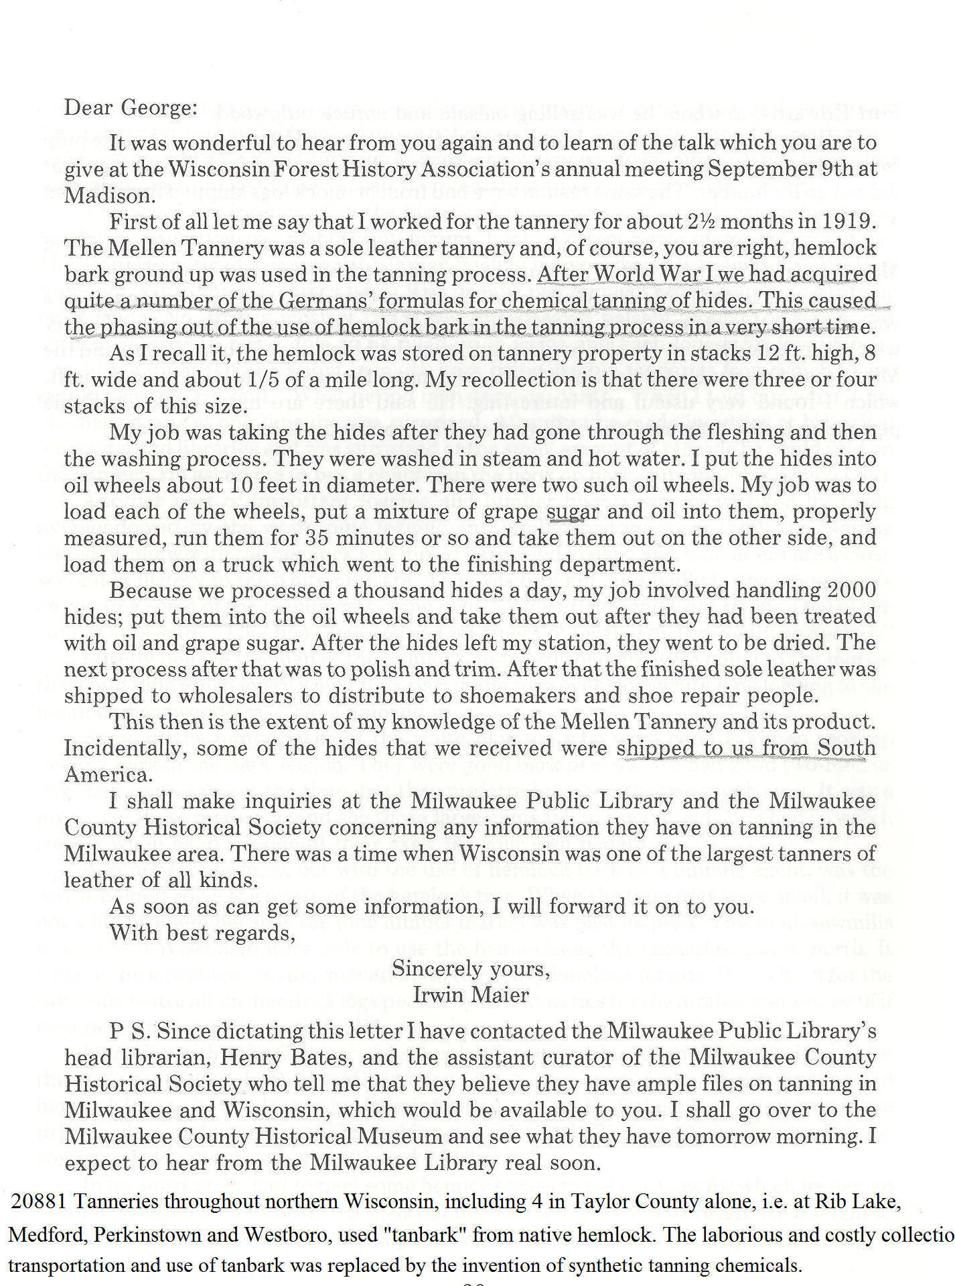 | For centuries, naturally-occurring tannic acid was obtained from trees, including hemlock. This source was the reason for the establishment of tanneries in northern Wisconsin, including the mammoth Shaw tanneries founded at Rib Lake and Mellen, Wisconsin.  Irwin Maier’s letter correctly concludes that the closure of the north Wisconsin tanneries were heavily influenced by the discovery of synthetic chemical tanning agents.  Maier’s letter follows an insightful article authored by George Corrigan entitled Tanneries and the Hemlock Bark Industry in Wisconsin presented at the 9/9/1978 meeting of the Wisconsin Forest History Assoc. The article is reproduced in the Document & Photo Collection of the Rib Lake Historical Society as image #12274 on its website www.riblakehistory.com.
3/16/1923 | Rib Lake Herald | 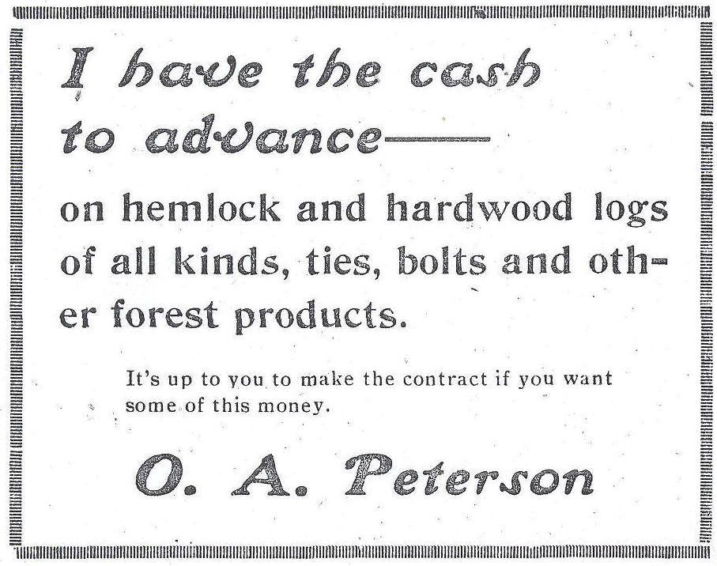 | O.A. Peterson, known to all as “Ole,” was an amazing entrepreneur in early Rib Lake. After the US entered the war against Germany in 1917, he did a huge business of buying and reselling railroad ties to the US government that had taken over the American railroad system.  This ad solicits hemlock logs for Ole’s sawmill on the northwest corner of the Village of Rib Lake. His mill had originally been operated by P.E. Marcus and because of its relatively small size was called the pecker mill, its saws were like those of a wood pecker.
3/16/1923 | Rib Lake Herald | 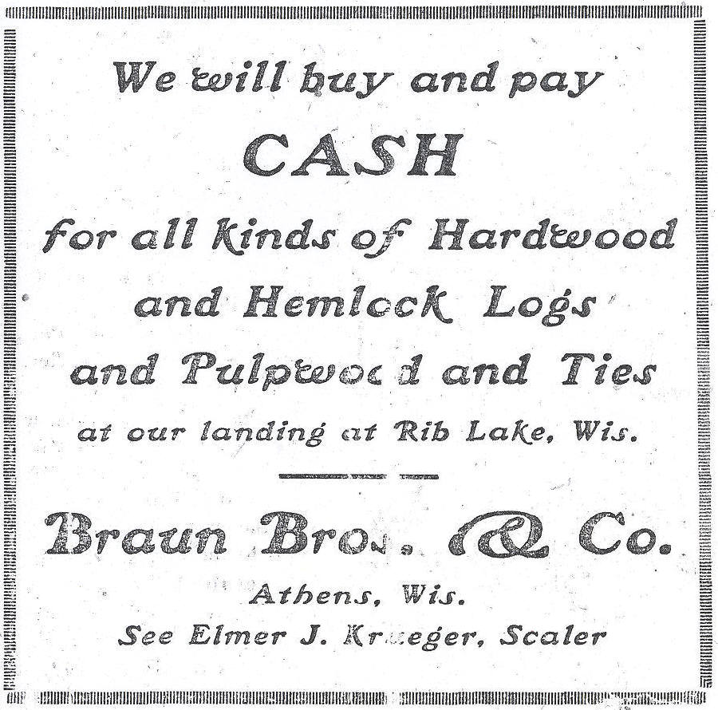 | The Braun Brothers had an operating sawmill at Athens, Wisconsin. Note that this ad for hemlock logs was for delivery “at our landing at Rib Lake, Wis.” The only practical way to get logs from Rib Lake to Athens in 1923 would be by railroad.  Note the preceding ad for hemlock logs run in the same edition of the Rib Lake Herald by Ole A. Peterson.
5/7/1925 | Taylor County Star News | The RLLC is building a new camp, to take about 125 men. It will be known as Camp 20 and will be located about 15 miles southeast of Rib Lake. It is expected that the camp will be used about 4 years, logging a section a year from same. Charles Peterson is foreman and Dan Pilon is cook at the camp.  an outstanding, detailed description of Camp 20 was written by Michael Weckwerth based on his interview of William “Bill” Natzke, long-time jobber for the Rib Lake Lumber Company. Weckwerth’s article is entitled “Rib Lake Lumber Company Camp 20: A Hardwood and Hemlock Camp in Lincoln County, Wisconsin.” The article was dated May 14, 1994 and consists of six pages and has been scanned into the Document & Photo Collection of the Rib Lake Historical Society website as Document #14319.  Reproduced below are pages 4 and 5 of the Michael Weckwerth article.  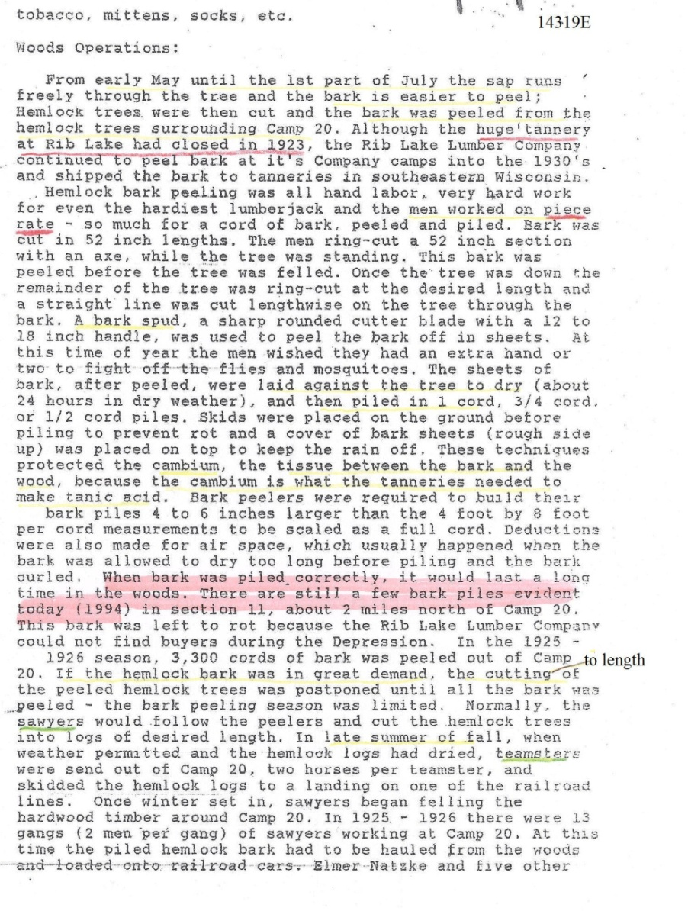  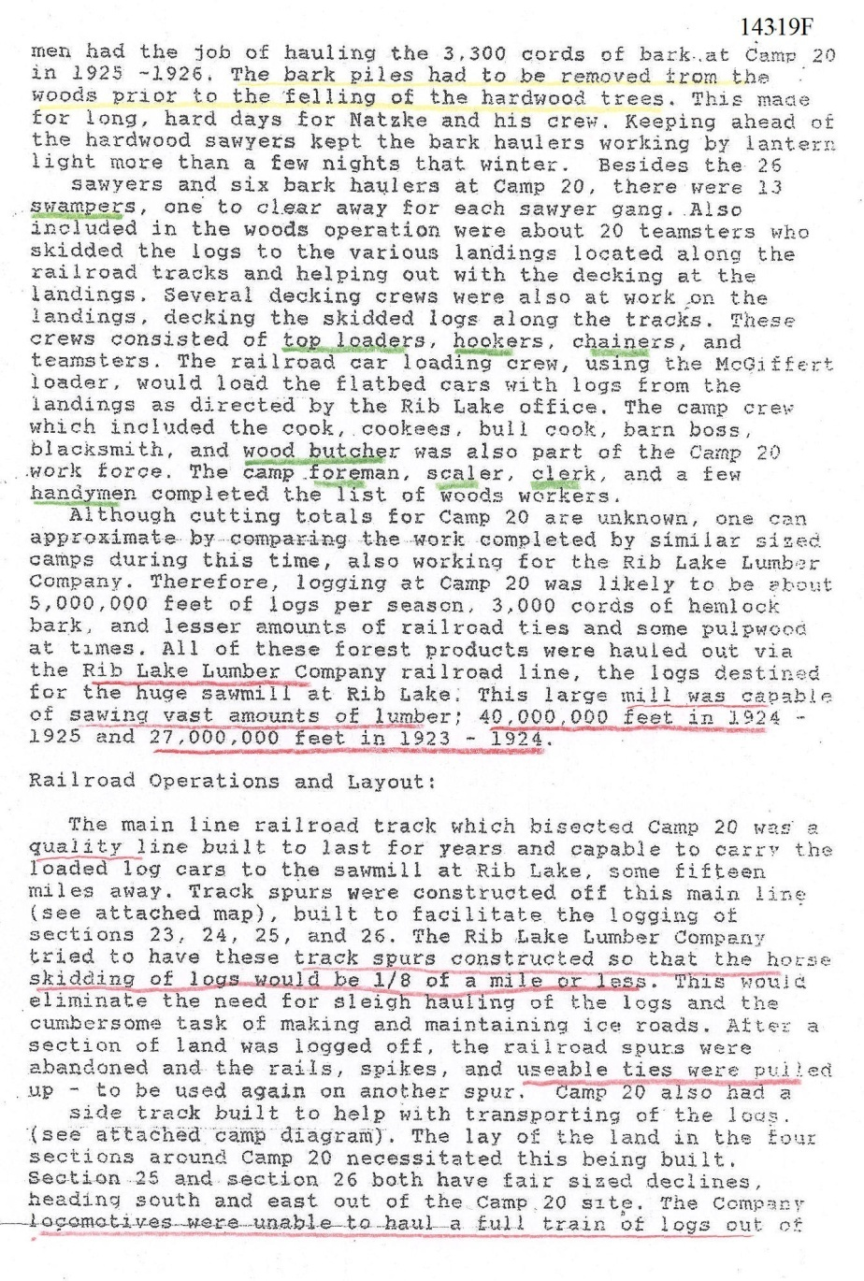 | Note the detailed explanation of making hemlock tanbark.
1927 | The 1927 phone book of the Rib Lake Telephone Company | 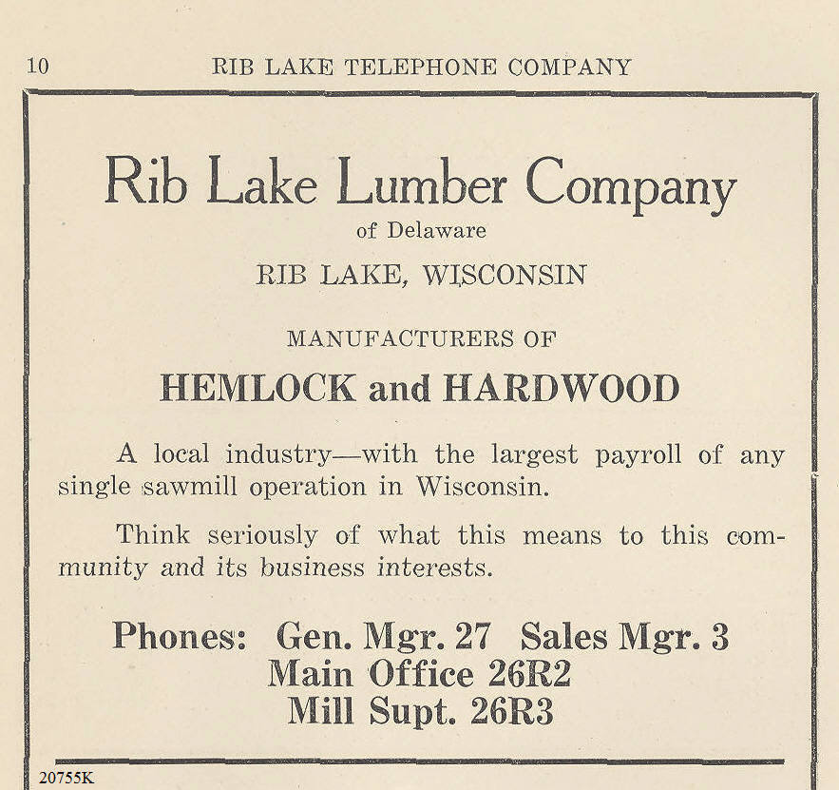 | Until the closure of its sawmill on June 4, 1948, the Rib Lake Lumber Co. was able to continue cutting primarily hemlock lumber from its land holdings in the Town of Corning, Lincoln County, Wisconsin.
1928 | Collection of Lorraine “Dorothy” and Carl Nelson. | 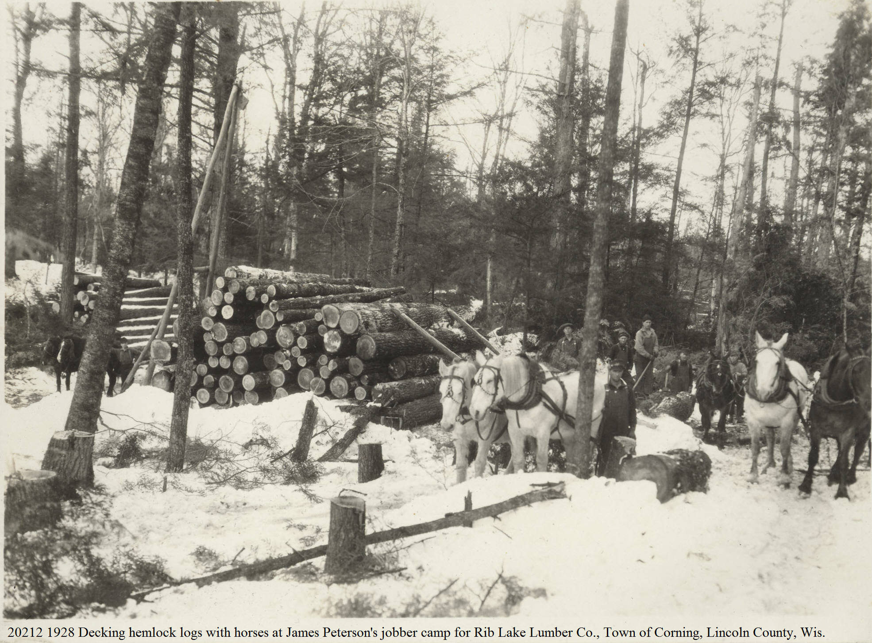 | Note that the hemlock logs had not been peeled for tanbark. The huge Rib Lake Tannery had closed in 1922, as had other area tanneries. A German chemist had discovered how to create synthetic tannic acid; as a result, the market for hemlock tanbark had been greatly diminished.
8/1930 | “Service,” a pamphlet and price list by B. Heinemann Lumber Co., Wausau, WI | 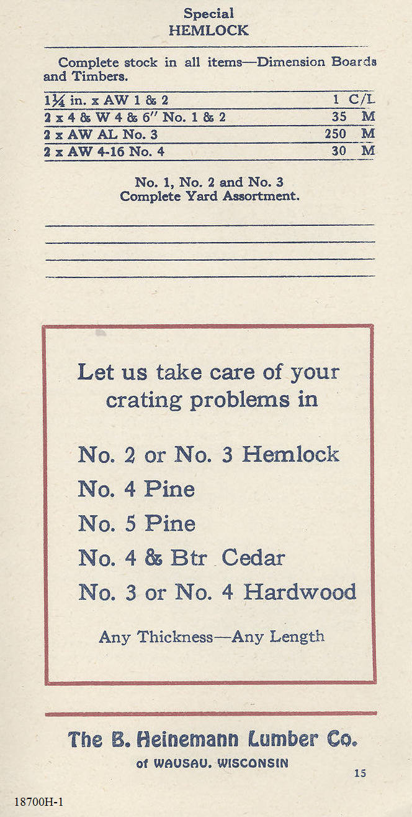 | The “Service” pamphlets were issued at least annually by the B. Heinemann Lumber Co. and intended primarily for use by its salesmen. A number of editions of “Service,” beginning with 11/1926 through 8/1930 have been scanned into the Photo & Document Collection at www.riblakehistory.com as image 18695-18700.  Hemlock is listed in each edition of “Service.” The 8/1930 edition has added to normal information the sentence “Complete stock in all items – Dimension Boards and Timbers.”  The page printed here also includes price information: i.e. $35 per board feet (“35 M”) and $260 per thousand board feet for material that cannot be identified by the Rib Lake Historical Society as of 3/8/2015.  Dave and Helen Marcisgenerously loaned “Service” to the Rib Lake Historical Society, LLC.
1/23/1935 |  | 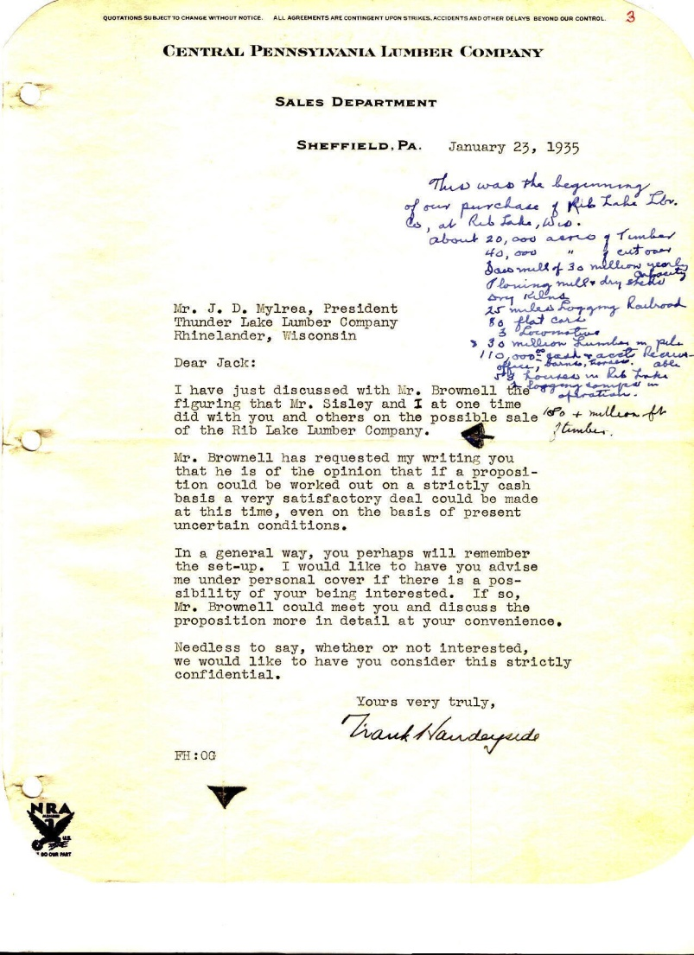 | In 1936, the Rib Lake Lumber Company, owned by the United States Leather Company of New York, New York, was sold. The buyers were John D. Mylrea, Aytch P. Woodson, ___ Brownell and Frank Handeyside. The Milwaukee Journal covered the transaction by announcing that Wisconsin’s largest sawmill in capacity had been sold.  The handwritten notes in blue ink were made by John Mylrea and read: “This was the beginning of our purchase of the Rib Lake Lumber Co. at Rib Lake, Wis. About 20,000 acres of timberand 40,000 acres of cutover [land]. Sawmill of 30 million yearly capacity. Planing mill and dry sheds, dry kilns. 25 miles of logging railroad, 80 flat cars, 3 locomotives. 30 million [board feet] of lumber in piles. $110,000 cash and accounts receivable. Office, 58 houses in Rib Lake. 2 logging camps in operation. 180 million [board] feet of timber.”  The majority of this standing timber was hemlock.
1936 | Darrel Damm scrapbook | 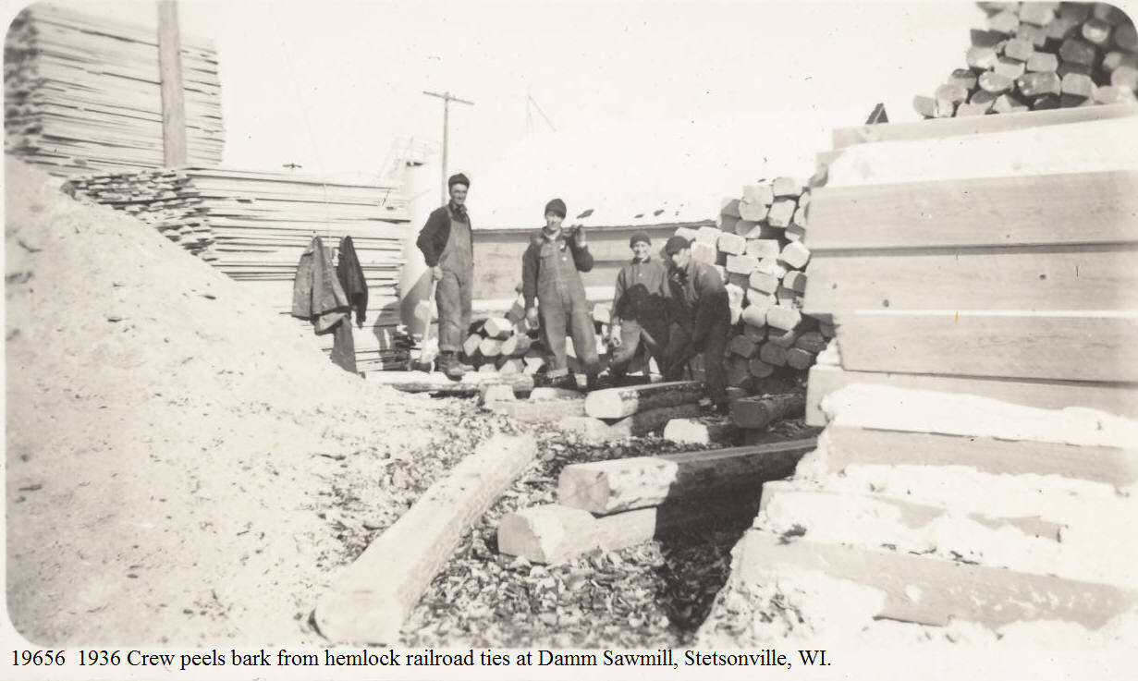 | The relatively small Damm Bros. sawmill at Stetsonville, Taylor Co., Wis. produced thousands of hemlock railroad ties for the Soo Line Railroad in the 1930’s and 40’s. Ties would be sawed to standard thickness and the bark peeled by hand on the two uncut surfaces. Each tie was inspected by a Soo Line employee as the ties were loaded into box cars.  See photos following #19656 to see ReinholdtRamm hoisting a green tie to his shoulder.
1937 | Darrel Damm scrapbook | 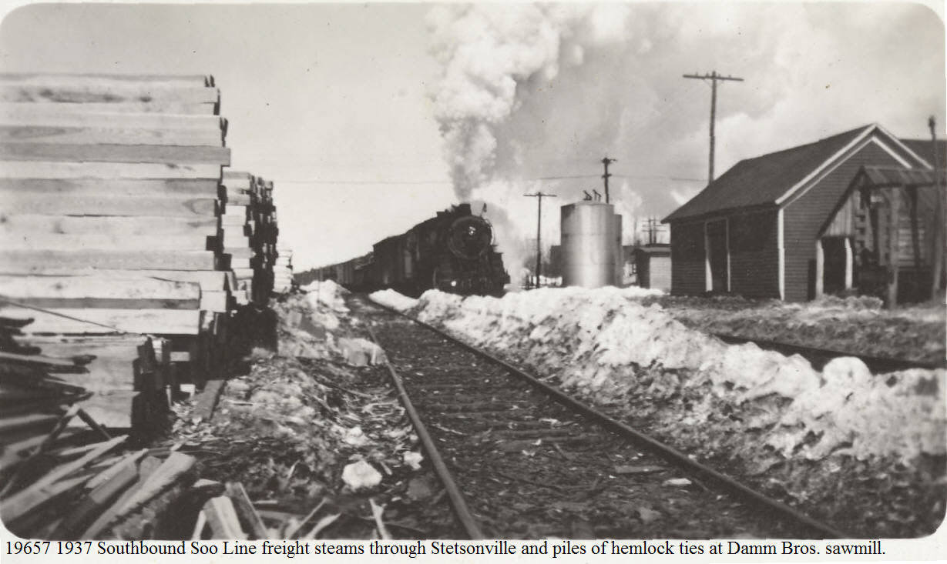 | The locomotive is on the original 1874 right-of-way between Marshfield and Ashland, Wisconsin. In 1874 the railroad was the Wisconsin Central, which received every other section of land from the US Government as a reward for building northward through the great central Wisconsin Hemlockery.
7/1938 | Scrapbooks of John D. Mylrea at Marathon County Historical Society | 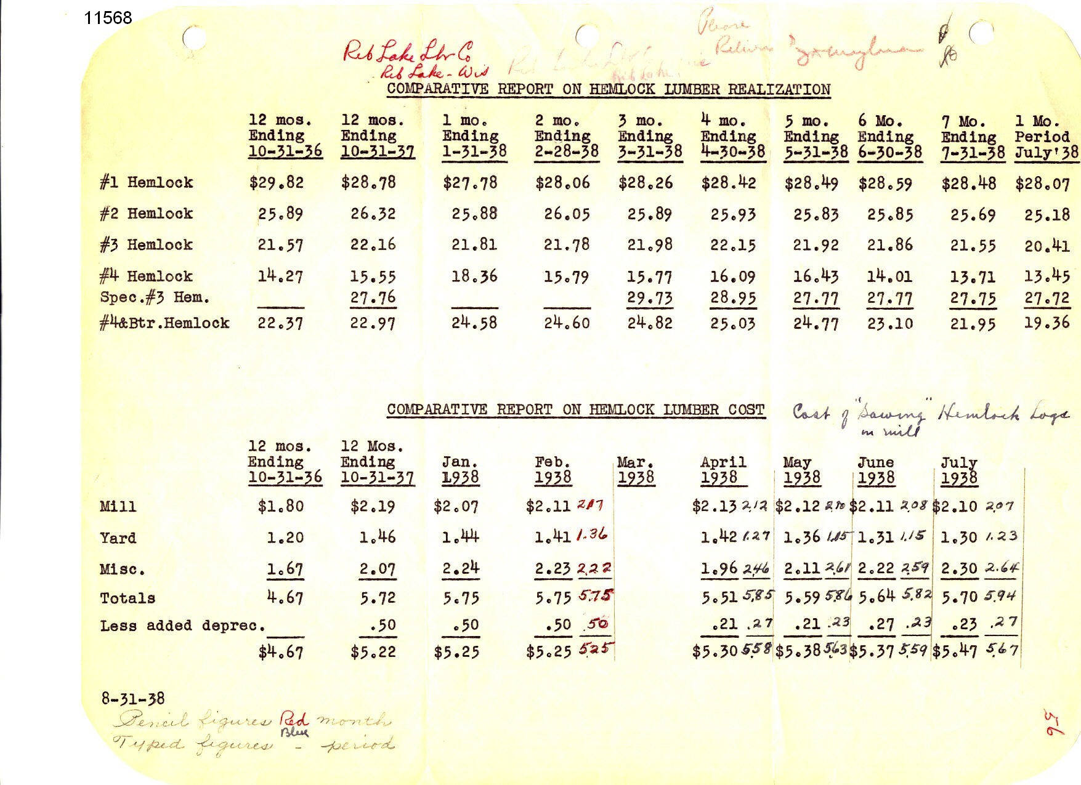 | The handwritten by Jack Mylrea provide: “Cost of “sawing” hemlock logs in mill.”  This document pertains to the RLLC and its mill operations in the Village of Rib Lake. The document has two parts. First the top chart is the “comparative report on hemlock lumber realization.” It reports the amount of money the company realized, i.e. obtained, through sales. The horizontal columns cover six grades of hemlock lumber.  The second portion of the document is the “comparative report on hemlock lumber cost” which Jack Mylrea defines in his handwritten definition as “cost of “sawing” hemlock logs at the Rib Lake mill. The total costs are divided between the expense of cutting the lumber at the mill, secondly the cost of piling the lumber to air dry in the “yard” and, thirdly, miscellaneous. Miscellaneous would include transporting the dried lumber and having it planed and loaded into box cars for shipment.
12/31/1940 | Scrapbooks of John D. Mylrea at the Marathon County Historical Society. | 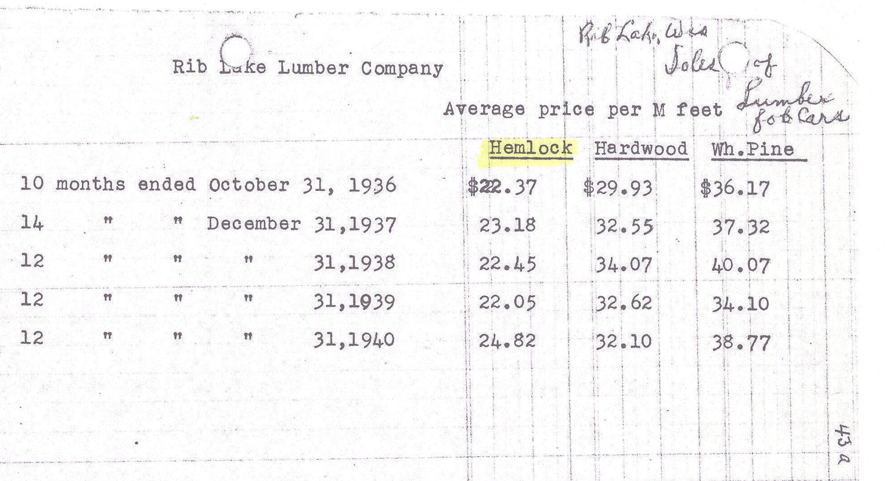  #14257 | This document demonstrates the “average [sale] price per 1000 board feet of hemlock, hardwood or white pine lumber produced by the Rib Lake Lumber Company. The price obtained for hemlock lumber was not that much lower than white pine. It should be noted that Nazi Germany invaded Poland in September of 1939, triggering WWII in Europe. While America did not formally enter the war until after Pearl Harbor on Dec. 7, 1941, the American economy was dramatically stimulated by the outbreak of conflict in Europe.  Jack D. Mylrea, Vice President of the RLLC and its general manager from 1936 through the mill closure in 1948, included this RLLC document in his scrapbooks, now at the Marathon County Historical Society.
11/27/1941 | Scrapbooks of John D. Mylrea at Marathon County Historical Society. | 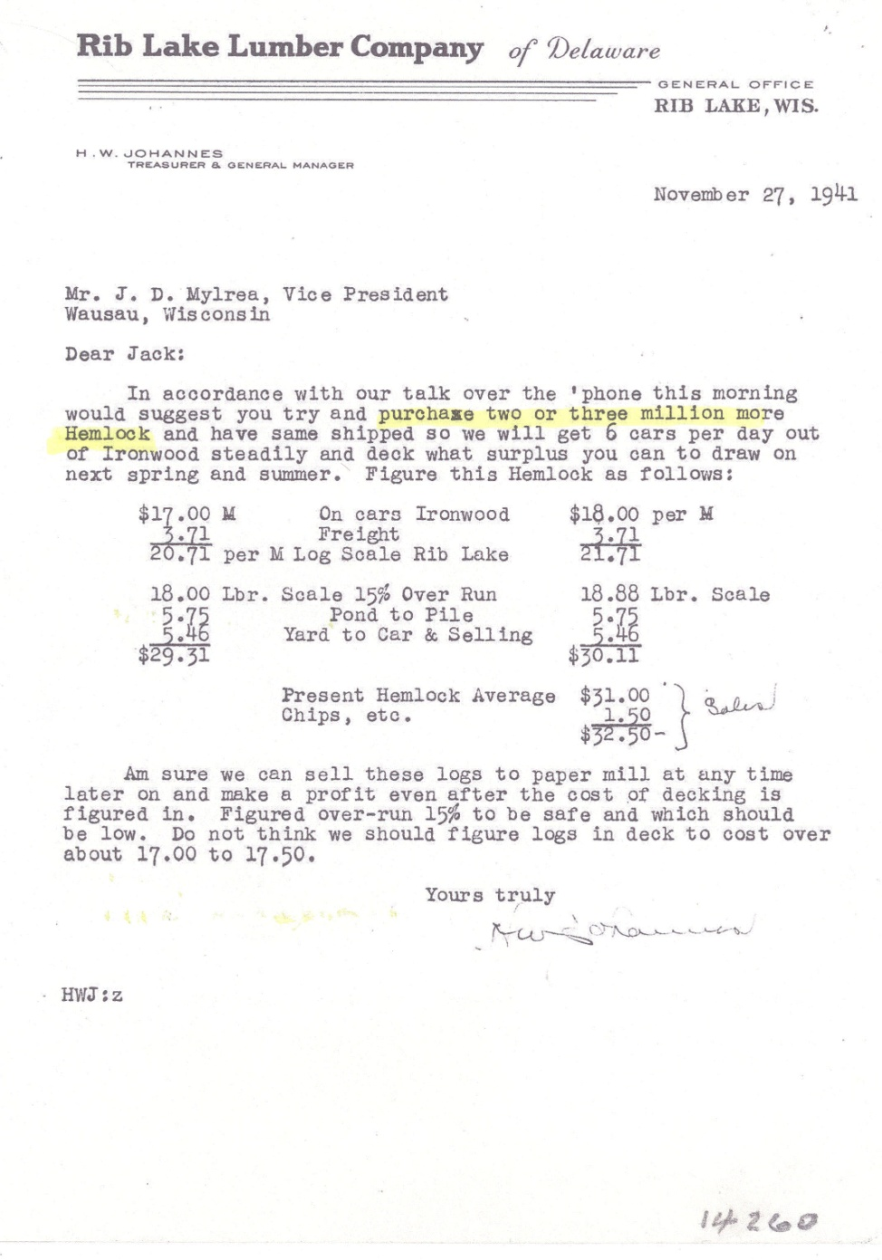 | John D. Mylrea was one of the four buyers of the RLLC in 1936. He was keenly aware that the RLLC plant was one of the most modern and efficient in operation in the State of Wisconsin, having been constructed in 1916; the problem was that it was rapidly running out of saw logs. Mylrea scoured the country sides, including the Upper Peninsula of Michigan and the State of Minnesota buying saw logs to supplement those owned by the RLLC in the Town of Corning, Lincoln County, Wisconsin.  This correspondence by the general manager of the RLLC sawmill at Rib Lake is addressed one of the mill owners, John “Jack” D. Mylrea in Wausau. It details the costs involved in cutting the wood near Ironwood, Michigan and shipping it by railroad to the Rib Lake sawmill. In addition, he shows the costs involved in what he referred to as “pond to pile.” This would refer to extracting the saw logs from the hot pond, sawing them at the sawmill and piling them at the Rib Lake dry yard. In addition, he shows the costs involved in loading the dried lumber on railroad cars and “selling.” Note that the letter concerns the anticipated purchase by the RLLC of “2 or 3 million [board feet] or more of hemlock.”  The reference to “chips” would be to wood chips as opposed to whole boards or timbers. Chips were routinely produced at the sawmill by running scrap lumber through a “hog,” a large piece of equipment where the steel blades of the “hog” shredded the wood scrap into wood chips. Wood chips could be sold to paper companies and were routinely shipped by railroad from Rib Lake to paper mills throughout Wisconsin.
9/10/1942 | Scrapbooks of John D. Mylrea at Marathon County Historical Society. | 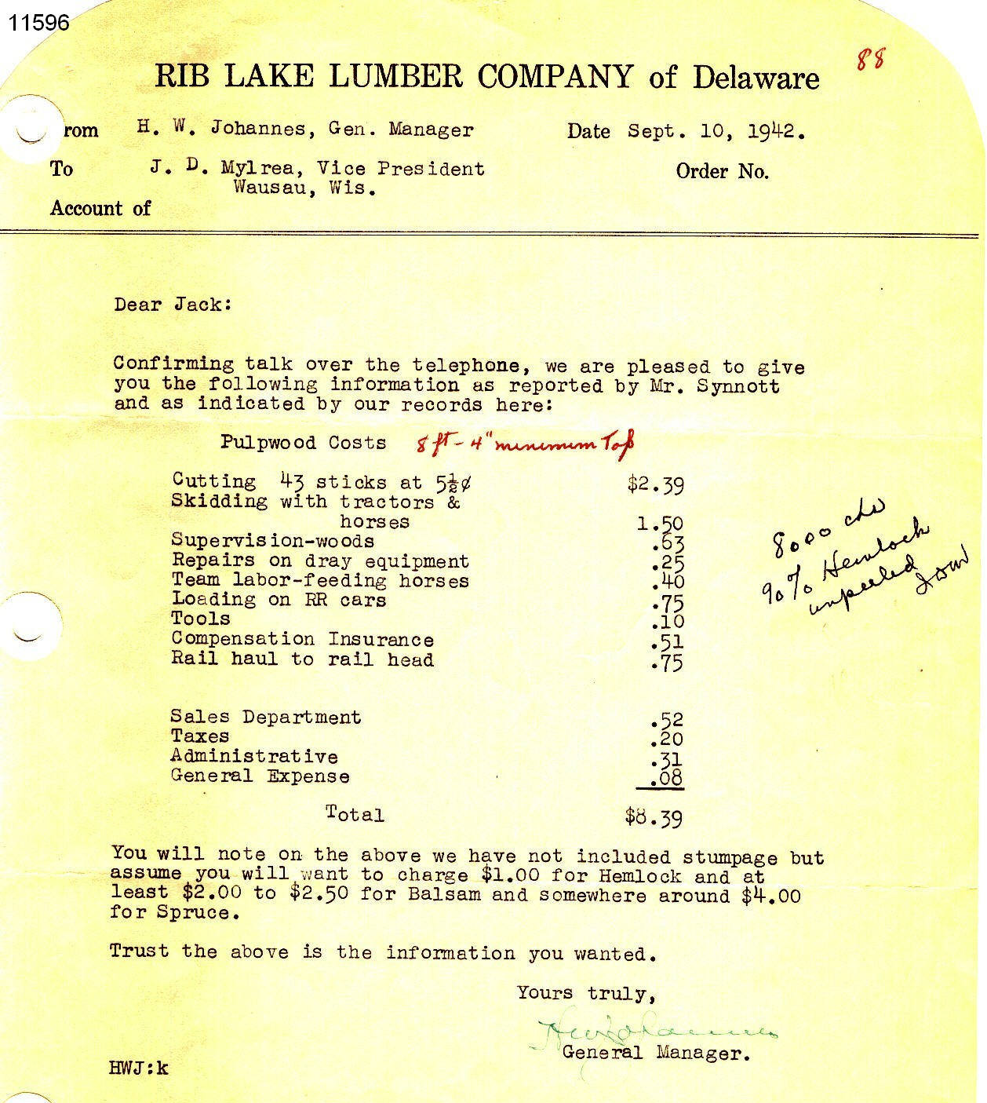 | The general manager of the RLLC, H.W. Johannes, residing in Rib Lake and supervising its sawmill there, wrote this letter to John “Jack” D. Mylrea, vice president of the RLLC residing in Wausau, WI. The letter breaks down the costs experienced by the RLLC in producing a cord of pulpwood. A cord was 8 feet long, 4 feet wide and 4 feet high.  Mylrea’s handwritten notes indicate “8000 cds (cords) (of which) 90% was unpeeled hemlock.  The RLLC sold the pulpwood to paper companies as a raw material for paper manufacture. Note the second to last paragraph indicates the relative expense the RLLC had in different tree species: “You will note on the above we have not included stumpage but assume you will want to charge $1.00 for hemlock and at least $2.00 to $2.50 for balsam and somewhere around $4.00 for Spruce.” It is not clear whether this was regarding stumpage the company bought from others or whether it referred to stumpage cut from the extensive forest lands owned by the RLLC in the Town of Corning, Lincoln County, WI. In any case, hemlock was the cheaper cousin.  The reference to Mr. Synnott referred to the woods boss, commonly referred to as the “walking boss,” who oversaw all the logging camps and tree cutting operations of the RLLC.
7/30/1943 |  | 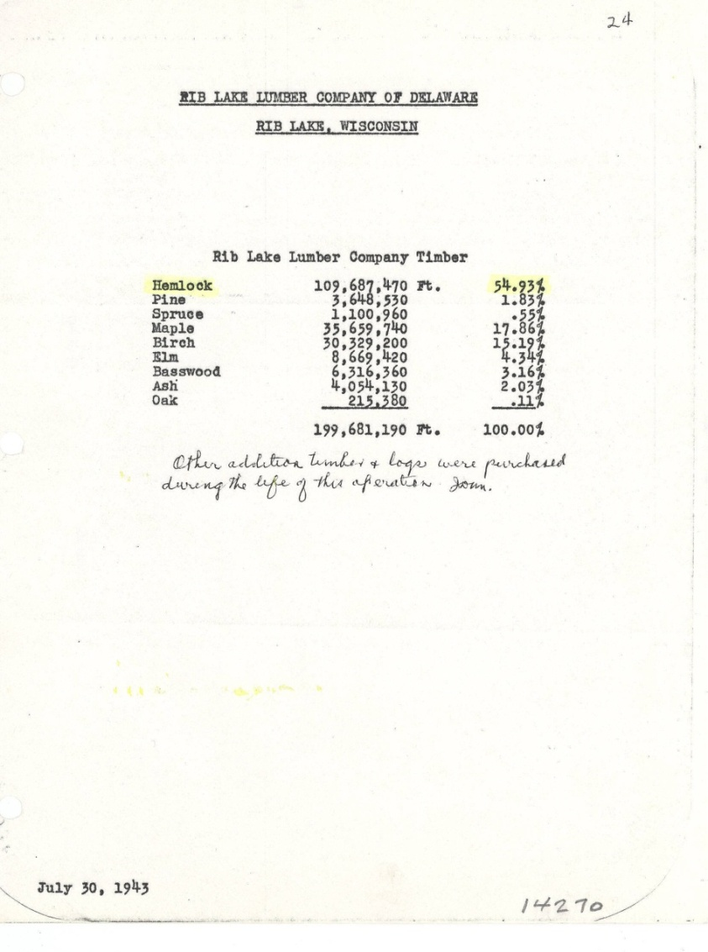 | The typewritten figures show that the RLLC, on 7/30/1943, owned 199,681,190 board feet of timber, of which 109,687,470 feet, constituting 54.93%, was hemlock.  The handwritten note by John D. Mylrea reads: “other additional timber and logs were purchased during the life of the operation.” Those purchases were from various locations in north Wisconsin, as well as the Upper Peninsula of Michigan and from northern Minnesota.
10/1/1944 | “Sawdust,” Published by the Accident Prevention Committee of the Rib Lake Lumber Co. | 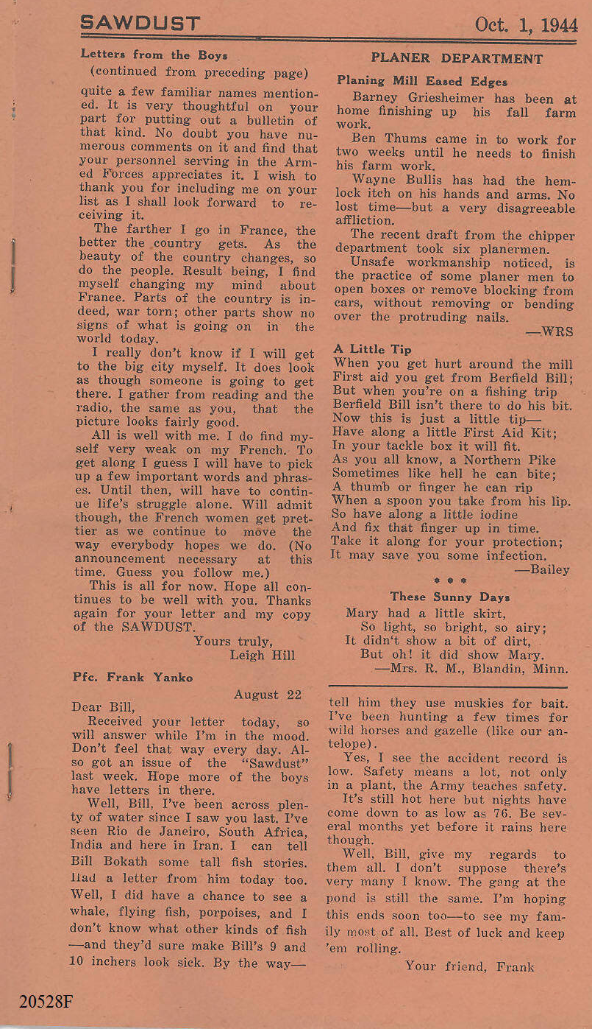 | “Sawdust” was a monthly magazine published by the Accident Prevention Committee of the Rib Lake Lumber Co. Its Oct. 1, 1944 edition reported: “Wayne Bullis has had the hemlock itch on his hands and arms. No lost time – but a very disagreeable affliction.”  No further details were given. Wayne Bullis was an employee working in the planer department where lumber was planed after being air dried. It appears he had an allergic reaction to hemlock.
1/1/1945 | Sawdust Published by the Accident Prevention Committee of the Rib Lake Lumber Co. | The following quote is taken from image #20531F of “Sawdust” dated 1/1/1945. Portions of the original text are lost and indicated here in brackets.  “GREEN YARD  The hemlock is being shipped out before it cooled off from the hot pond. The pilers loadit down on yard [railroad cars] from the tramway.  It really is a big advantage all around. Bill Lemke’s crew doesn’t have to pile it and Bill Daga’s crew doesn’t have [to unload] it. Besides all that, it gives the pilers a chance to be up near [McComb] street and check on everyone going up town and they sure don’t miss a thing.” | The usual procedure at the RLLC was for green lumber to be loaded on tram cars and hauled into the “green yard” where it was piled for air drying, which would take at least several months, depending upon the weather. January, 1945, saw the United States engaged in WWII against Nazi Germany and Japan. The war activity created an insatiable market for lumber. What this article describes is a change in operations for the RLLC. Interestingly, the article refers to hemlock lumber alone and no other species. The hemlock was now taken directly from the transfer chain and loaded onto railroad cars for shipment out of Rib Lake. This lumber would be absolutely green.  Other editions of “Sawdust” reported that there was a huge demand for hemlock lumber to be used as crating. In other words, wooden boxes of hemlock were made to ship supplies.  The demand for lumber caused by WWII also led the RLLC to erect a green planer. Here green lumber was planed and shipped out with no drying of any type.
11/4/1946 |  | 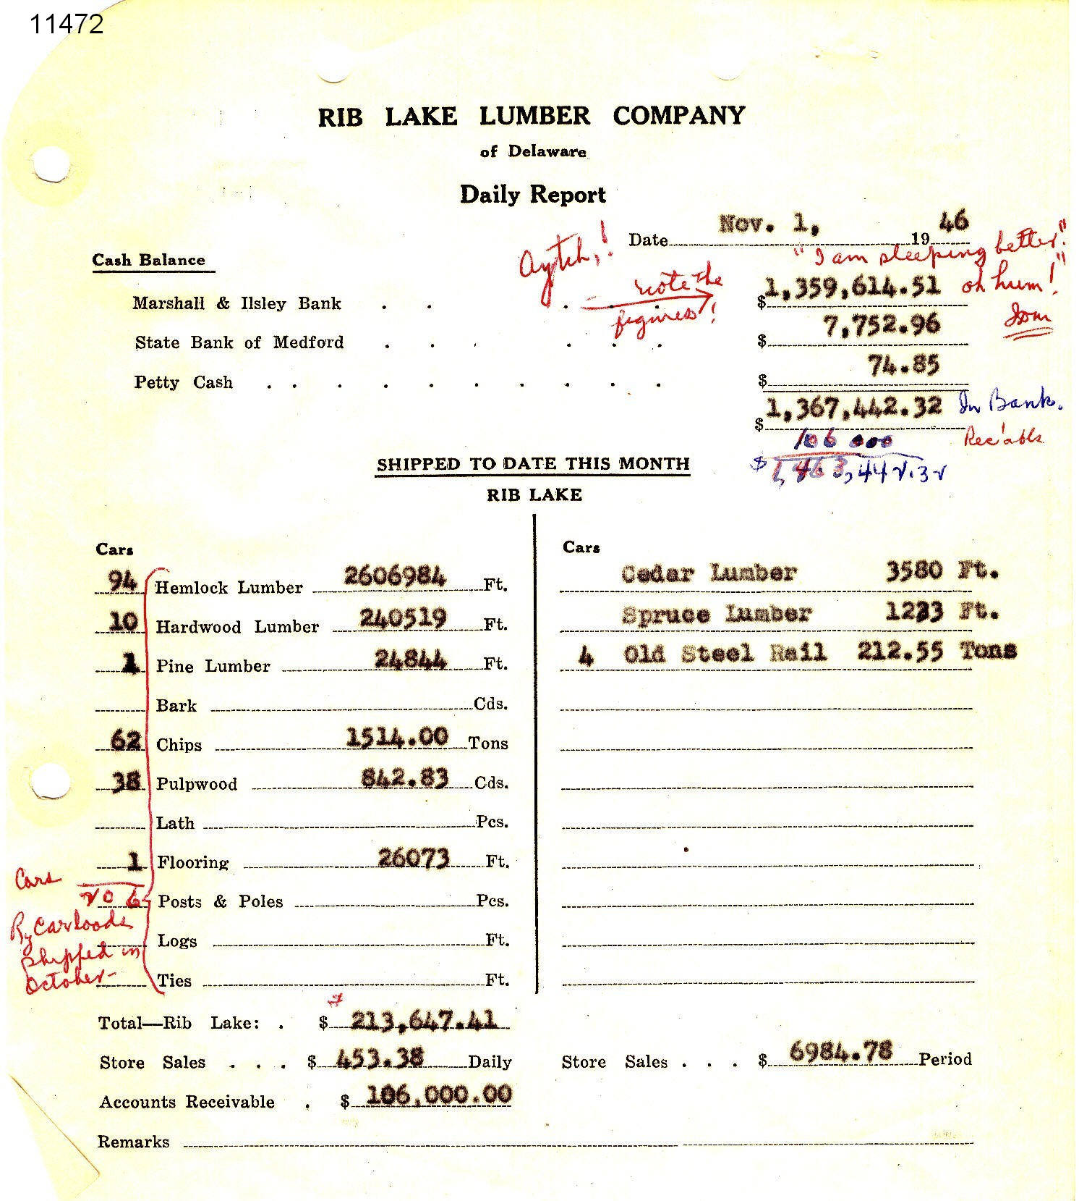 | This document reports that 94 railroad cars of hemlock lumber were shipped from the Rib Lake Lumber Company mill in October, 1946. The 94 cars is in stark contrast to the single car load of pine lumber and 10 car loads of hardwood lumber.  At this time the RLLC’s sole source of timber were its extensive lands in the Town of Corning, Lincoln County, Wisconsin, principally in Township 33 North, Range 4 West. The owners of the RLLC acquired this land in 1936 by purchasing them along with the sawmill from the US Leather Co. In 1946 these lands were “virgin timber” except for white pine, which had been removed in the 1800’s.  According to State Forester Milton Reinke, white pine made up approximately 5% of the virgin forest in the Rib Lake area by volume. This is partially corroborated by this daily report, and others, of the RLLC.
8/30/1947 |  | 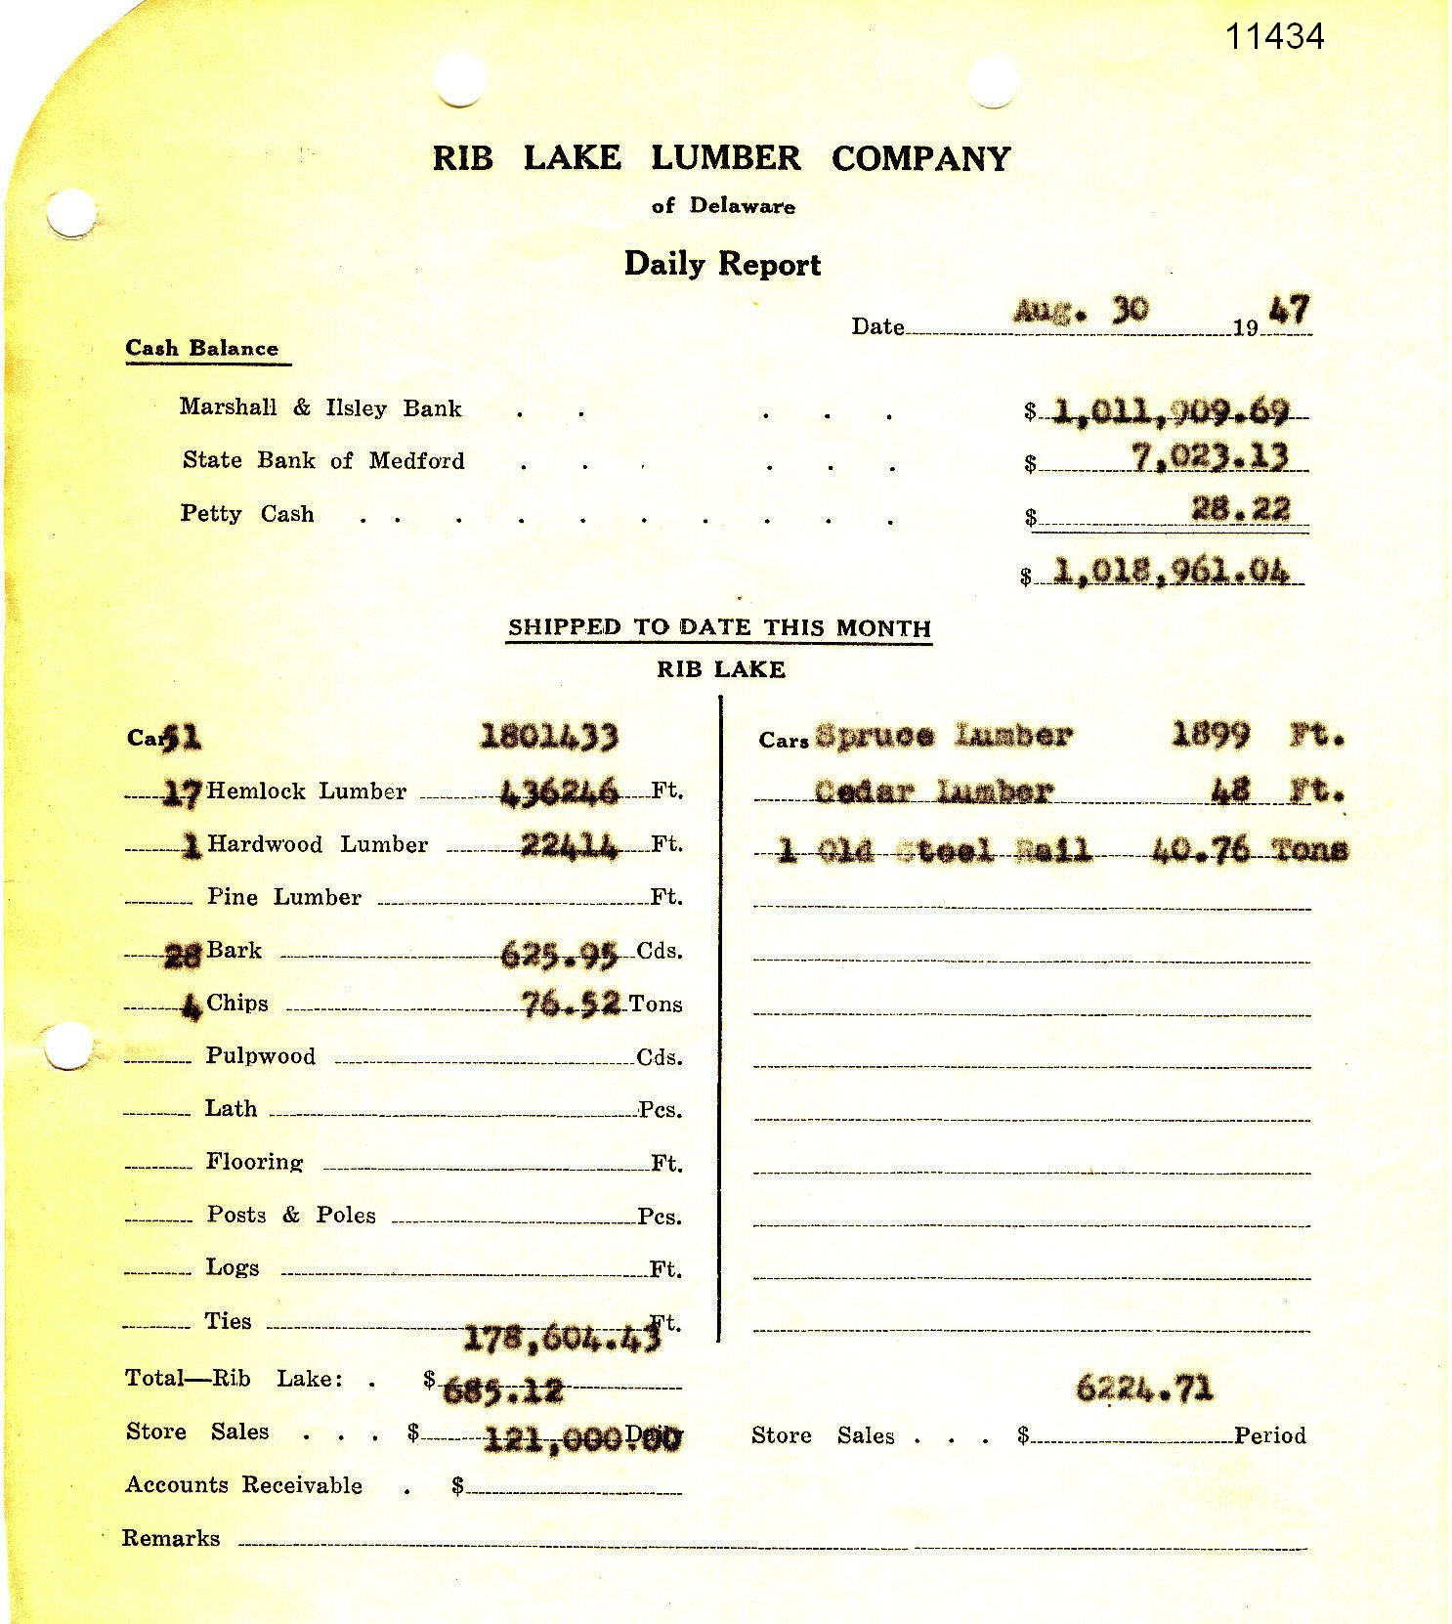 | This report demonstrates that 28 railroad cars of [hemlock] bark, consisting of 625 cords, were shipped from the Rib Lake mill during the month of August, 1947. This hemlock bark had no doubt been harvested in the Town of Corning, Lincoln County, where Camp 28 was still in operation.  Anecdotal reports contend that the bark was shipped to the Trostel Tannery of Milwaukee.
11/28/1947 | Scrapbooks prepared by John D. Mylrea at Marathon County Historical Society | 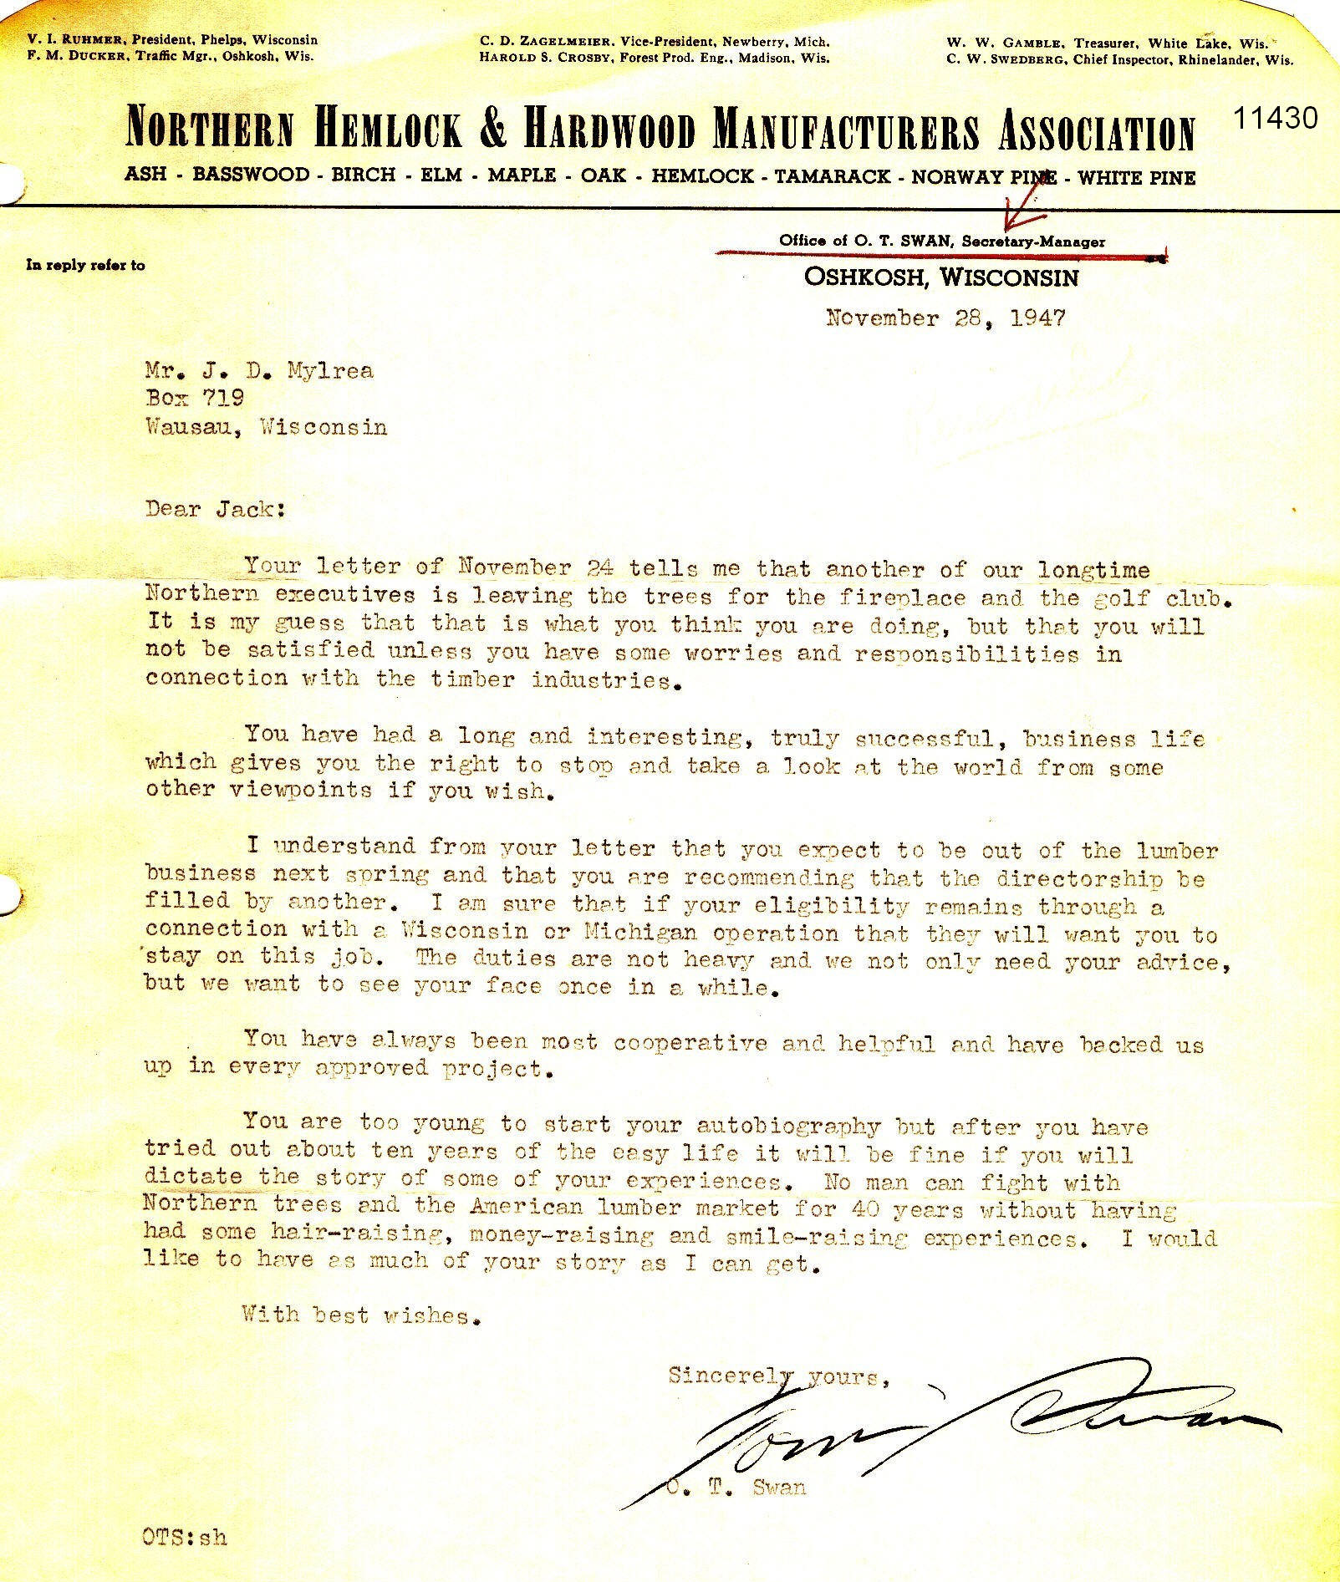 | The Northern Hemlock & Hardwood Manufacturers Association had a long and illustrious history in Wisconsin. It was first created towards the end of the “pine is king” era. It went out of business about 1982.  This letter was addressed to John D. Mylrea, who had long operated the Robbins Lumber Company of Rhinelander before becoming one of the four buyers of the Rib Lake Lumber Company in 1936. The Rib Lake Lumber Company sawed its last log on June 4, 1948.
1994 | Dept. of the Interior, Great Smoky Mountains National Park |  | In 2018 I am told that all of the hemlock trees along the Maine to Georgia Appalachian Trail are either dead or dying. The culprit is a small invasive species called the wooly adeldid.  The culprit has not yet appeared in the hemlock forests of Wisconsin. One state naturalist claims that the insect will not survive in areas having at least 3 consecutive days of weather below 20 degrees Fahrenheit.
1995 | This item is used with permission of the author, John Bates. It is within his book “Trailside Botany; 101 favorite trees, shrubs & wildflowers of the Upper Midwest.” | 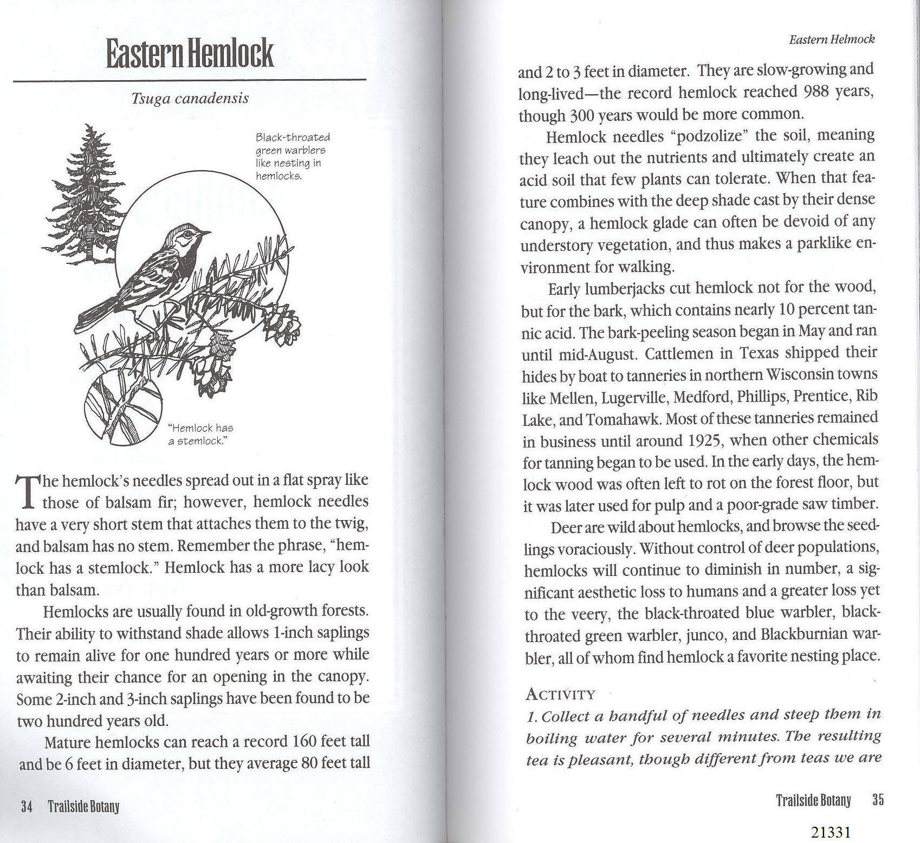 | In 2018, John Bates published a well-researched guide to the remaining old growth forests of Wisconsin entitled “Our Living Ancestors. The history and ecology of old growth forests in Wisconsin and where to find them.” This book contains a photo and text of the Gerstberger Pines, a small, old-growth forest in the Town of Rib Lake.  The term “Gerstberger Pines” was coined by Bob Rusch in his successful effort to sell the idea to the Taylor County Board when Bob was a member of an ad hoc committee lobbying to have the county buy the tract. Fortunately the county board chairman at the time was Herbert Bergman. The tract was saved from cutting by its German immigrant owner, Ernst Gerstberger. Following his death, his heirs asked Herb Bergman to commercially cut the forest. After Herb visited it, he was so impressed by its old growth features that he refused to log it and, instead, urged its preservation.  In 2018 there are less than a dozen huge white pine surviving and forming a super-elevated canopy over the park. The forest is dominated by hemlock, sugar maple and yellow birch, typical of the virgin forest on high ground in Taylor County.
5/1/2013 |  | 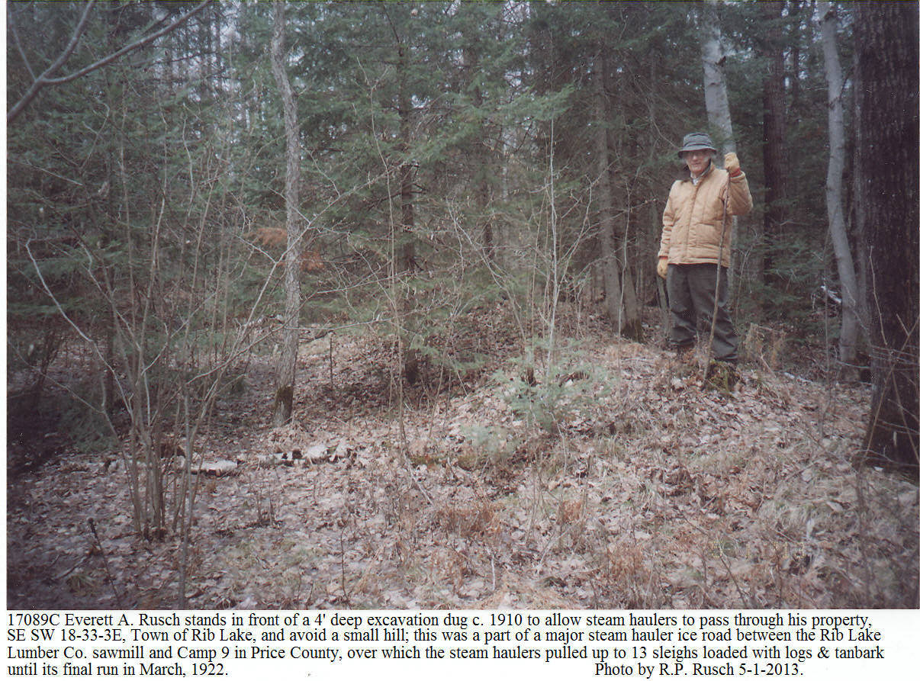 | Vestiges of the great hemlockery survive. This photo shows Everett A. Rusch standing on his property in the Town of Rib Lake where an excavation was dug c. 1910 for an ice road. It ran through Taylor County and into Price County, tapping the hemlock-dominated virgin forest. At late as 1922 the Rib Lake Lumber Co. steam hauler pulled up to 13 sleighs loaded with hemlock logs; untold numbers of sleigh loads of tanbark went over this ice road to the Fayette Delos Shaw tannery, later owned by the United States Leather Co., in the Village of Rib Lake.
1/2014 |  | 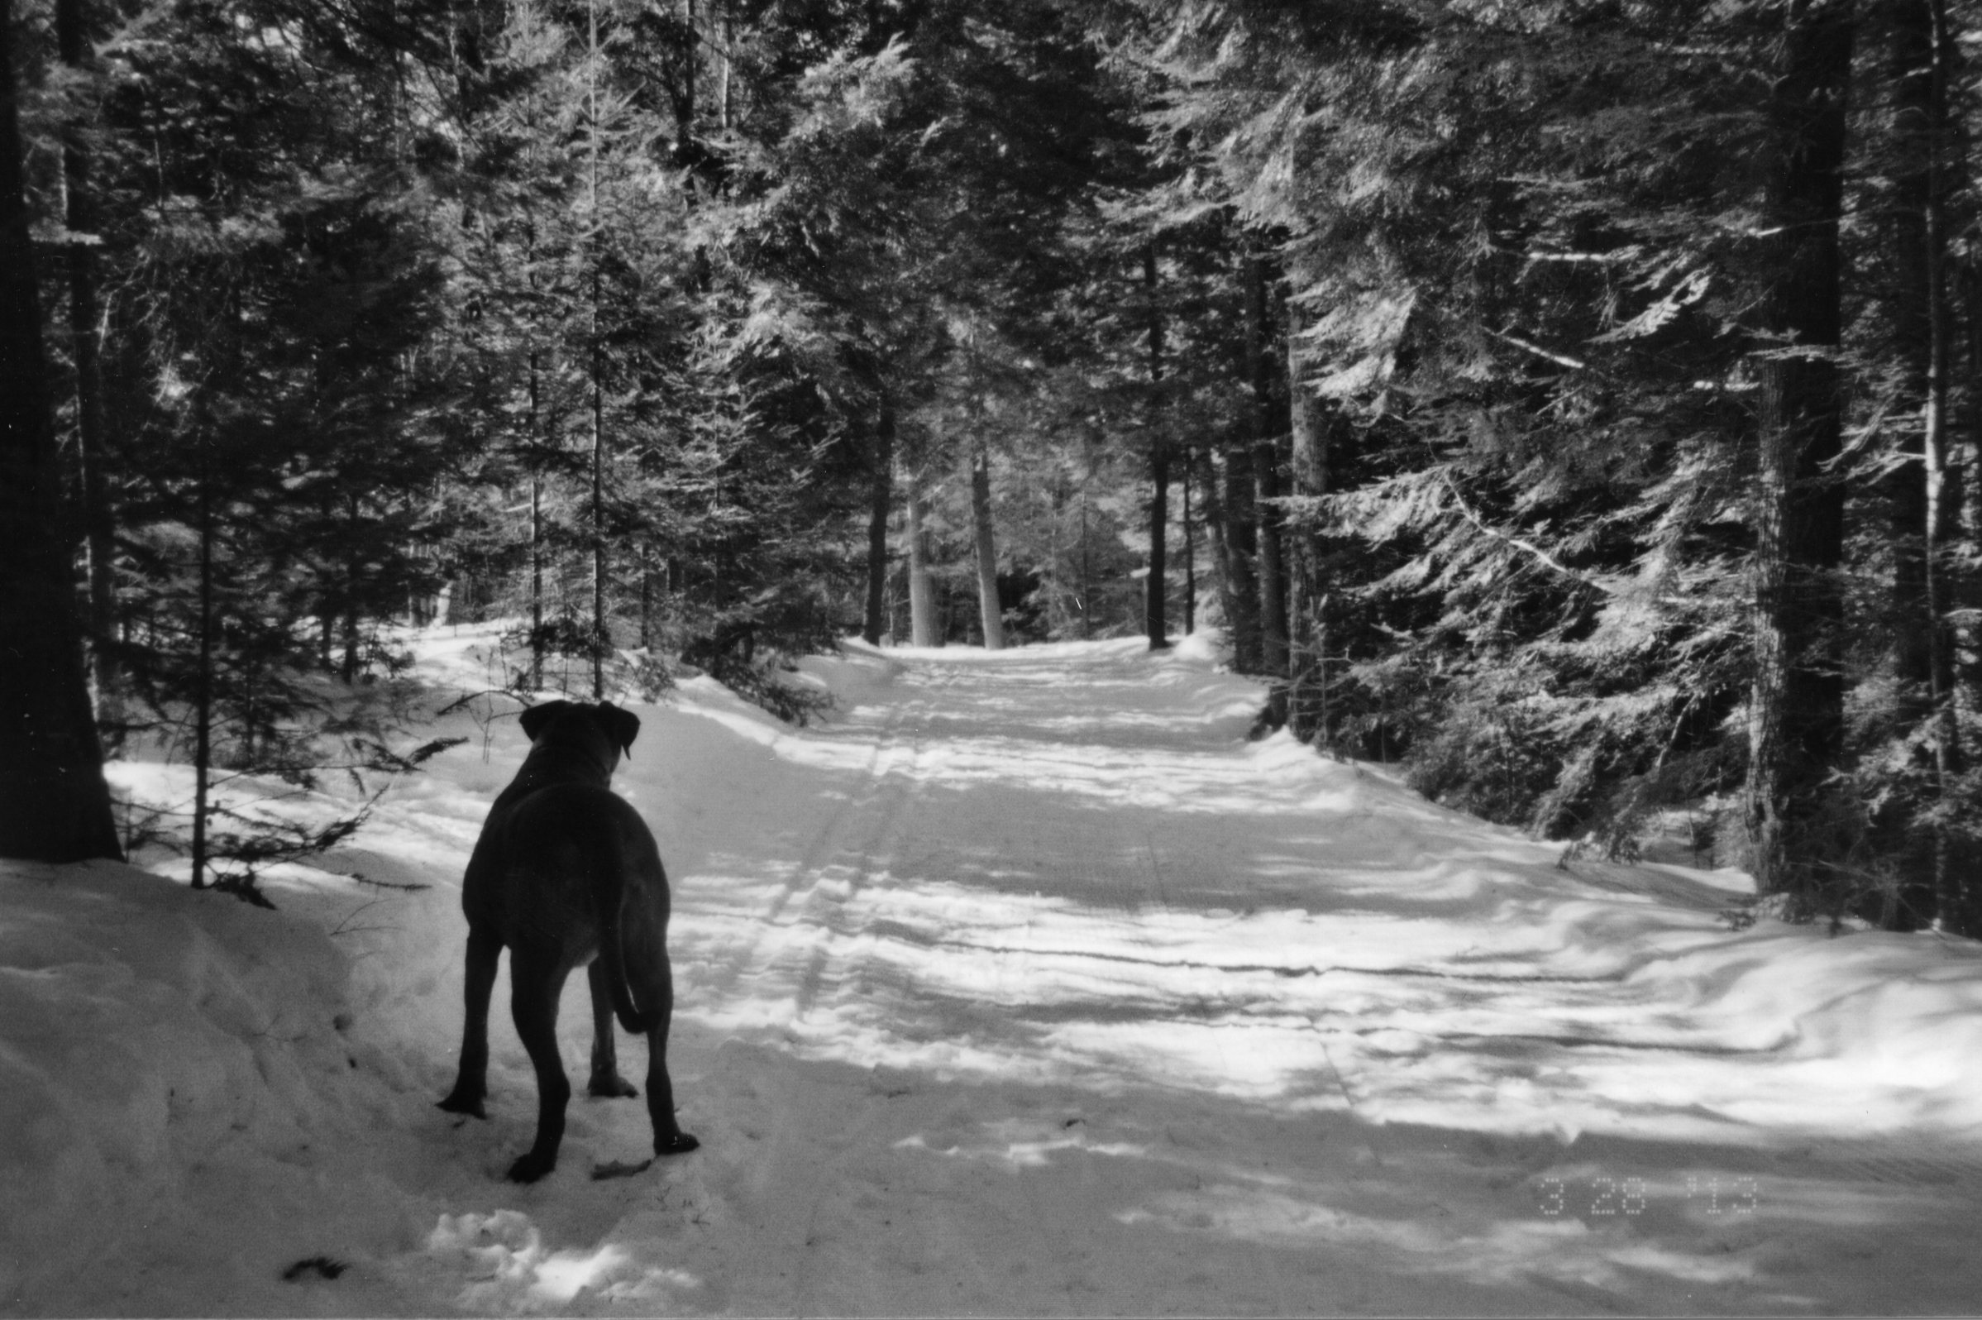 | Pictured is a Rhodesian Ridgeback, “Rosie,” a family pet owned by Steven Peters. The dog is standing on the Timms Hill National Trail in Section 1, Town 33 North, Range 2 East in the Town of Rib Lake.  Note the thick stand of hemlock that clothes the trail.
2015 | 2015 Annual Conference Yearbook, Ice Age Trail Alliance | 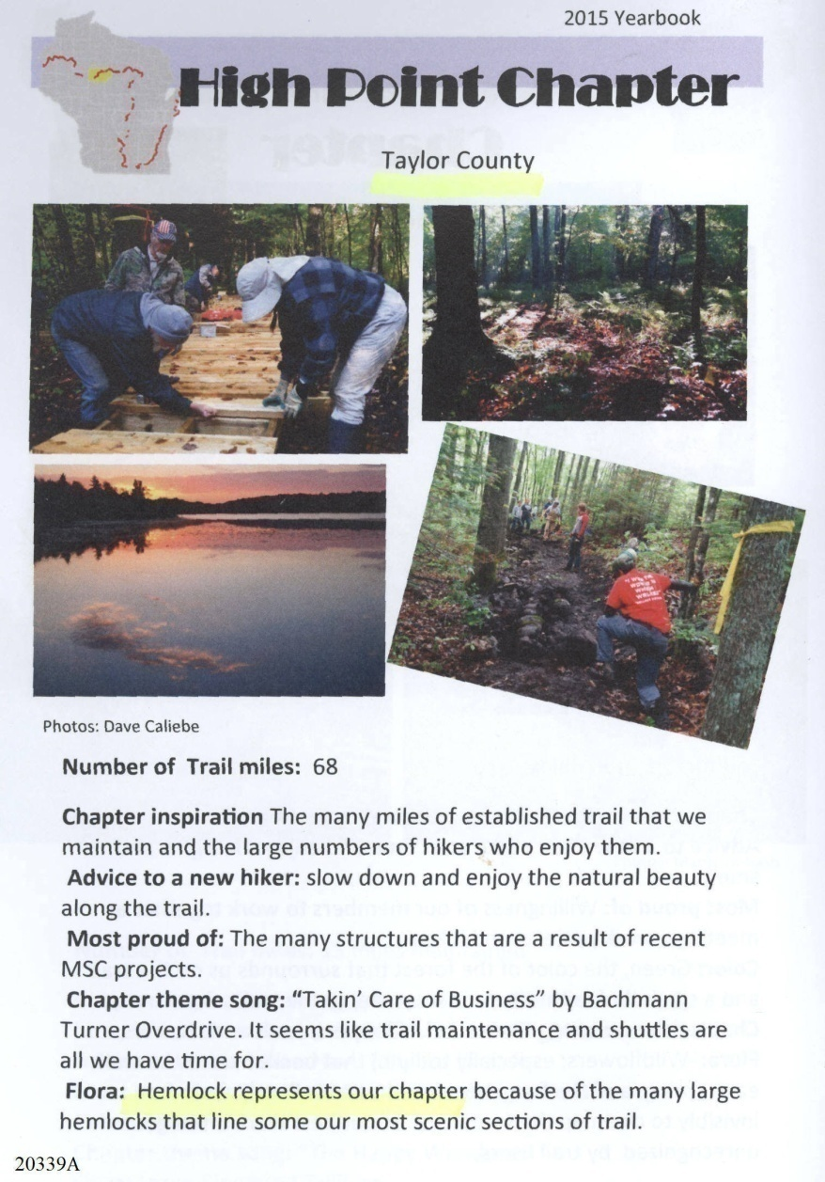 | Over large portions of northern Wisconsin in the year 2017 one cannot find a hemlock tree of any size, even though one is in an area that was dominated by hemlock in the virgin forest. Several factors contributed to the extirpation of hemlock in north Wisconsin. First was the loss of seed sources as a result of tree cutting. Secondly was the destruction of seedlings due to widespread, uncontrolled fires. Thirdly was the loss of seedlings due to foraging animals, especially white-tailed deer. Fourthly and perhaps most importantly, was the fact that hemlock needs shade conditions to exist while a seedling and sapling.  The good news is that, in 2017, there are truly spectacular, large groves of healthy hemlock along miles of the Ice Age National Scenic Trail within the Chequamegon-Nicollet National Forest in Taylor County. I particularly recommend the IAT between Taylor County Highway M northward to the Mondeaux Recreation area.  The Ice Age Trail Alliance owns the 50 acre “Rusch Preserve” trailhead in the Town of Rib Lake. It includes an old growth forest which the Alliance is managing to replicate the original, virgin hemlock-hardwood forest. On April 26, 2017, Ryan Strobach and his grandfather, Robert P. Rusch, transplanted hemlock in along the Ice Age Trail in this special woodland. Signs will explain to hikers the history of the hemlockery.
7/20/2016 | Photo taken by R.P. Rusch | 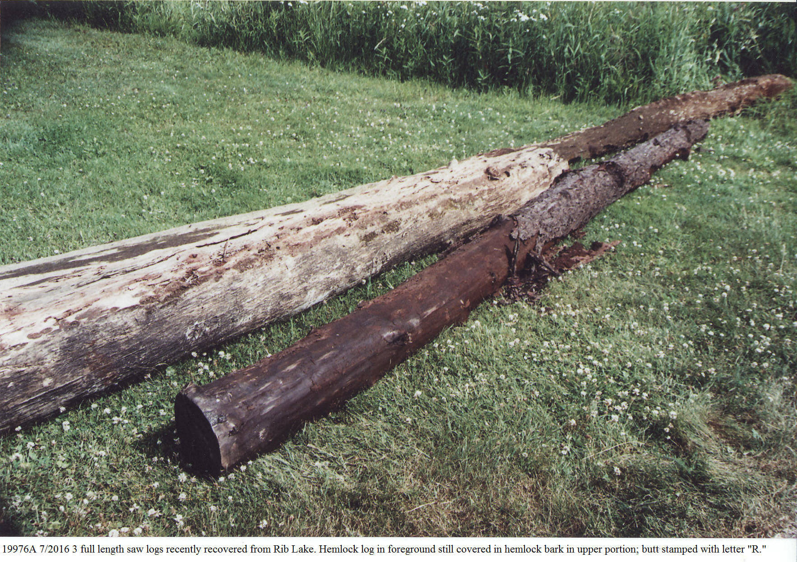 | The possibility of lost saw logs in Rib Lake continues to be an attraction. The Rib Lake Lumber Company sawed its final log on June 4, 1948.  Following the closure of the RLLC sawmill, dozens of efforts have been made over the years to recover lost logs from the lake; these are logs that became waterlogged and sunk. In July, 2016, Steve Cihasky led the effort to search for more logs, which resulted in recovering the logs pictured here.  The log in the foreground is hemlock.
7/20/2016 | Photo taken by R.P. Rusch | 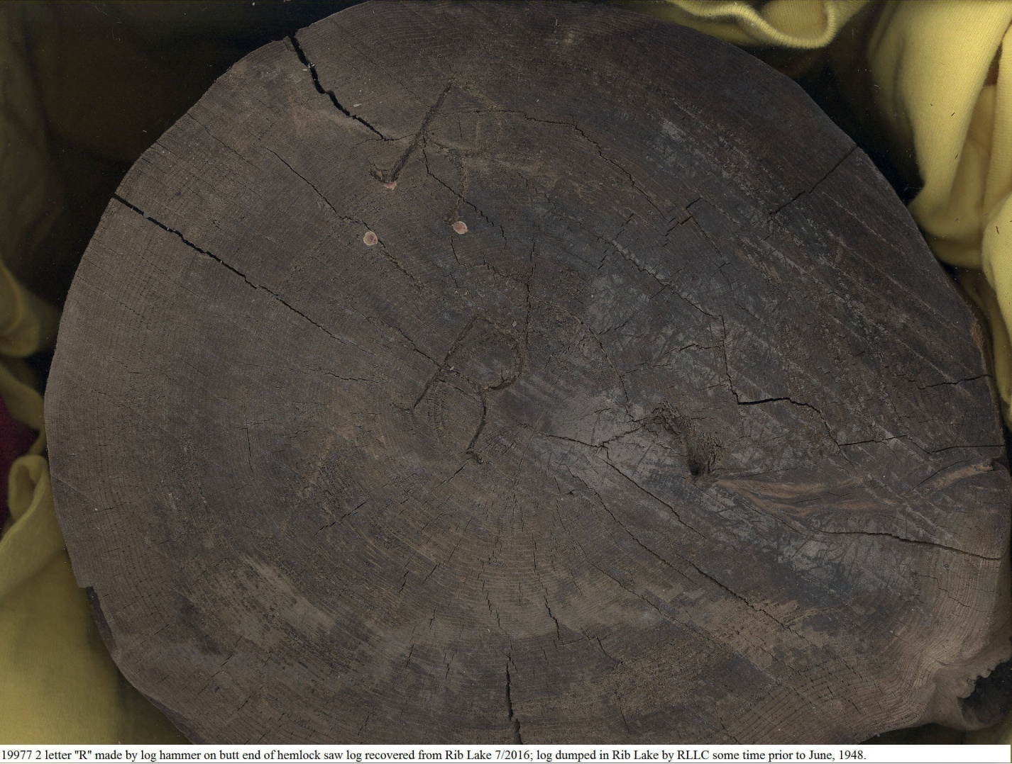 | Multiple letter “R” were found on both the butt and top end of a hemlock log recovered from Rib Lake in July 2016.  The Rib Lake Lumber Company and its predecessors never used streams or rivers to convey saw logs to its sawmill on the west side of Rib Lake. Typically, the letters and symbols left by logging hammers were the way to identify ownership of logs during water transportation or storage. There was no need for this at Rib Lake since no sawmill used the lake other than the Rib Lake Lumber Company and its predecessors. So what was the purpose of the “R” stamps shown here? The answer is not known for certain.  The stamp may have been used to identify RLLC logs that were harvested outside of Taylor County, Wisconsin. One of the new owners of the RLLC in 1936 was John “Jack” Mylrea, who embarked on an ongoing aggressive effort to secure additional timber to supplement that owned by the RLLC. He purchased such timber near Rice Lake, Wisconsin, at several locations in the Upper Peninsula of Michigan and in northern Minnesota. The Minnesota timber was dumped into Lake Superior at Hovland, Minnesota and rafted to Ashland, Wisconsin, where it was transported via Soo Line to the Rib Lake mill. The “R” stamps may well have been used to identify ownership in any of these operations.
8/2018 | Photograph of Ann K. Rusch by Bob Rusch on the Rusch tree farm. | 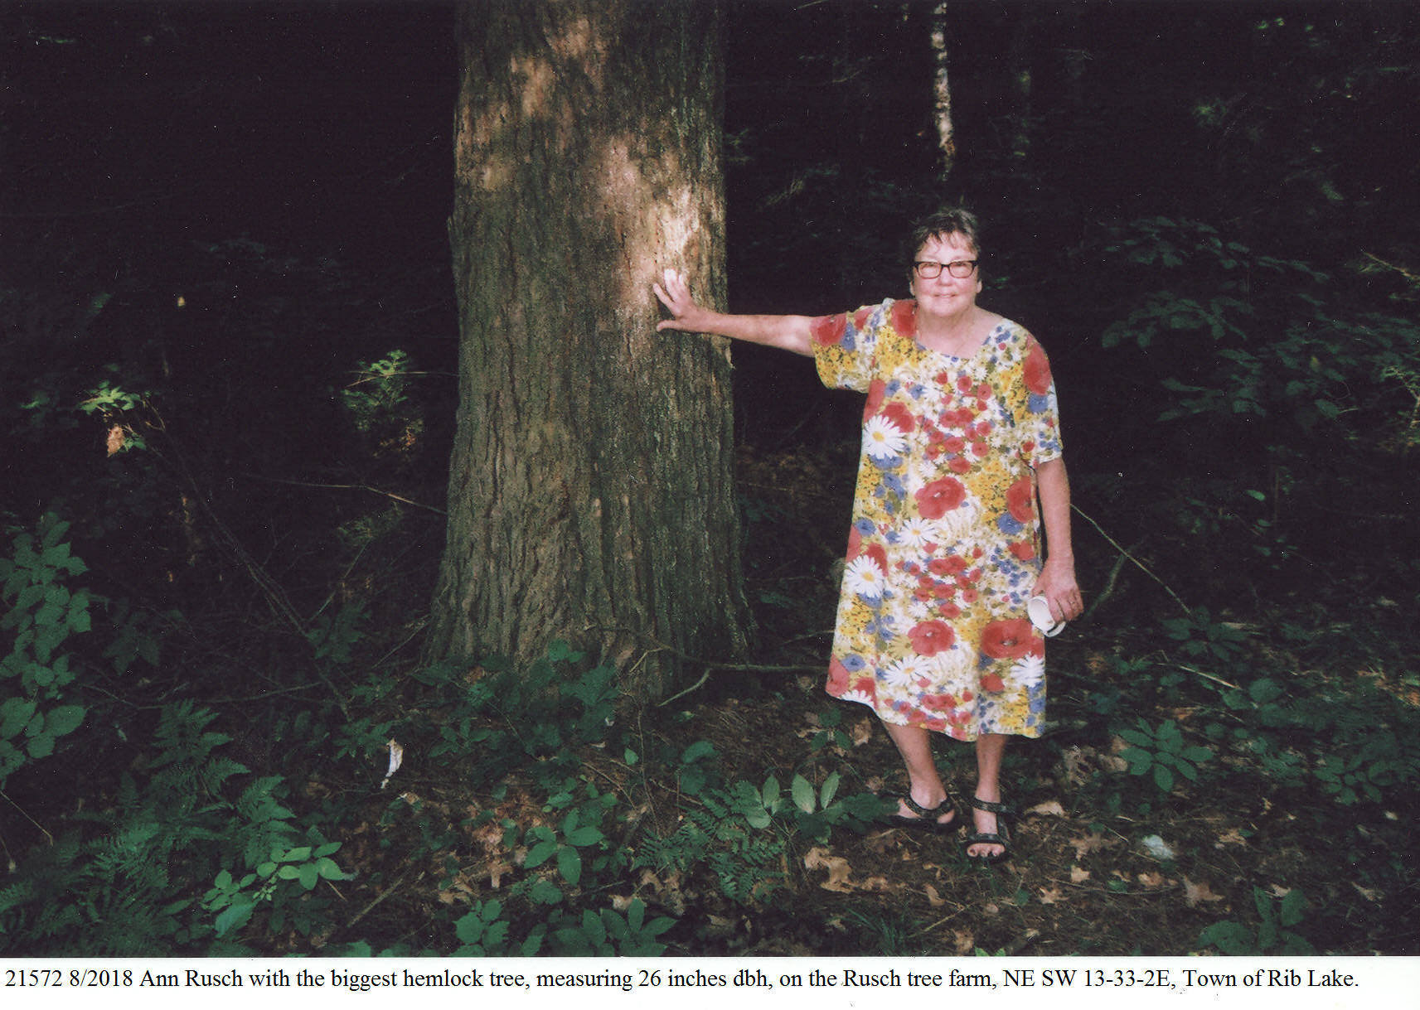 | Ann is standing next to the largest hemlock tree growing on the Rusch tree farm in 2018; it stands 100 feet east of the Nordic Ski & Snowshoe Trail on the NE SW 13-33-2E. Note how the dense shade of the hemlock and surrounding trees dims the light, producing the shade for which the hemlock is genetically perfectly well suited.

ERNST EDWARD GERSTBERGER

In 2014, probably the single most impressive stand of hemlock in the Town of Rib Lake flourishes at the Gerstberger Pines County Park. The Document & Photo Collection of the Rib Lake Historical Society includes an impressive collection of photographs of that old-growth forest and of Ernst Edward Gerstberger, the savior of Gerstberger Pines. For example, image 18510 is a 1920 photograph of Ernst Edward Gerstberger.

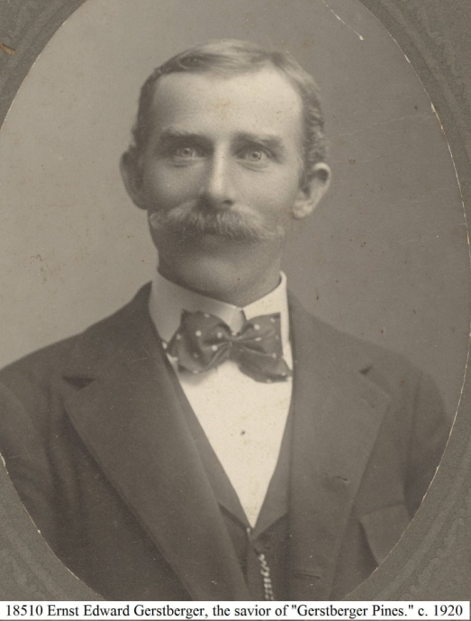

Tribute to Ernst Edward Gerstberger, the Savior of Gerstberger Pines
Following his immigration from Germany as a child with his parents, Ernst Edward Gerstberger got married, bought 80 acres of land in the Town of Rib Lake, started a large family, of which ten children survived, and, with them and his hardworking wife, Gertrude, created a prize dairy farm featuring Guernsey cattle. But there was one thing remarkably different about Ernst Gerstberger; he loved trees so much that he single-handedly preserved a magnificent stand of old growth forest on a portion of his dairy farm. He alone preserved a small bit of the virgin forest in contrast to all of the others in Rib Lake and environs, who felled their trees for profit.
Little is known about his motivation to preserve a stand of trees. When his daughter, Betty Jane Quednow was asked on November 8, 2014, why her father saved the trees, she jokingly replied, “Because we were all too busy picking stones to make a farm.” But upon further questioning, she said that the stand of trees was her father’s favorite and something that he invited any visitor to the farm to walk through and admire.
Ernst Gerstberger took his own life by suicide at the family farm in the 1980’s. No one knows why. What is known is that the farm was quickly sold “to settle the estate.” In the 1990’s the new owner decided to raise money by having the woods on the farm logged off; this was not to be a select cut, rather, a clear cut to maximize profit. The landowner asked Goodrich logger Herbert Bergmann to do the job.
After Herb Bergmann had a chance to walk through the forest, he came to an unprecedented conclusion: this beautiful old-growth stand was so special that he would notcut it and he urged the owners to preserve it. Herb used his position on the Taylor County Board of Supervisors to convince the county to create “Gerstberger Pines County Park.”
Robert P. Rusch was a member of the ad-hoc committee working for the public purchase. He created the term “Gerstberger Pines” to provide a name for the site and to celebrate the dozen or so lofty white pines there which tree tops rose 30 or more feet above the forest canopy. White pine was, in fact, a small component of the forest. The most common tree there was eastern hemlock, tsugacanadensis, a shade tolerant conifer which had dominated the local virgin forests on high ground sites in Taylor County.
Taylor County has served as a good steward of Gerstberger Pines, constructing a half-mile long wood-chip covered trail through it. Interpretive signs, an illustrated trail booklet and Leopold benches welcome visitors.
Dated: November 23, 2014.
Robert “Bob” P. Rusch, Manager, Rib Lake Historical Society, LLC.

HEMLOCK LATH

Prior to the advent of sheet rock, lath and plaster was the common way to finish interior walls in houses and offices. Thin strips of hemlock, “lath” were nailed horizontally to the 2x4 walls, leaving a 1/4” gap between lath. Plasterers would trowel on a wet plaster using the lath for support. The photo below, image #18551, Rib Lake Historical Society Document & Photo Collection, is a photo of the side view of hemlock lath probably manufactured by the Rib Lake Lumber Company and used at a Rib Lake home until 2013.

The Rib Lake Lumber Company and its predecessors under J.J. Kennedy made lots of lath. Since it was typically made in 4-foot lengths and was only 1 ½ inches wide and ¼ inch thick, it could be made from short pieces of lumber, which would otherwise be thrown away. At the Rib Lake Lumber Company it was tied into a bundle of 50 or more lath and sold in a bundle. R.P. Rusch 12/6/2014.

